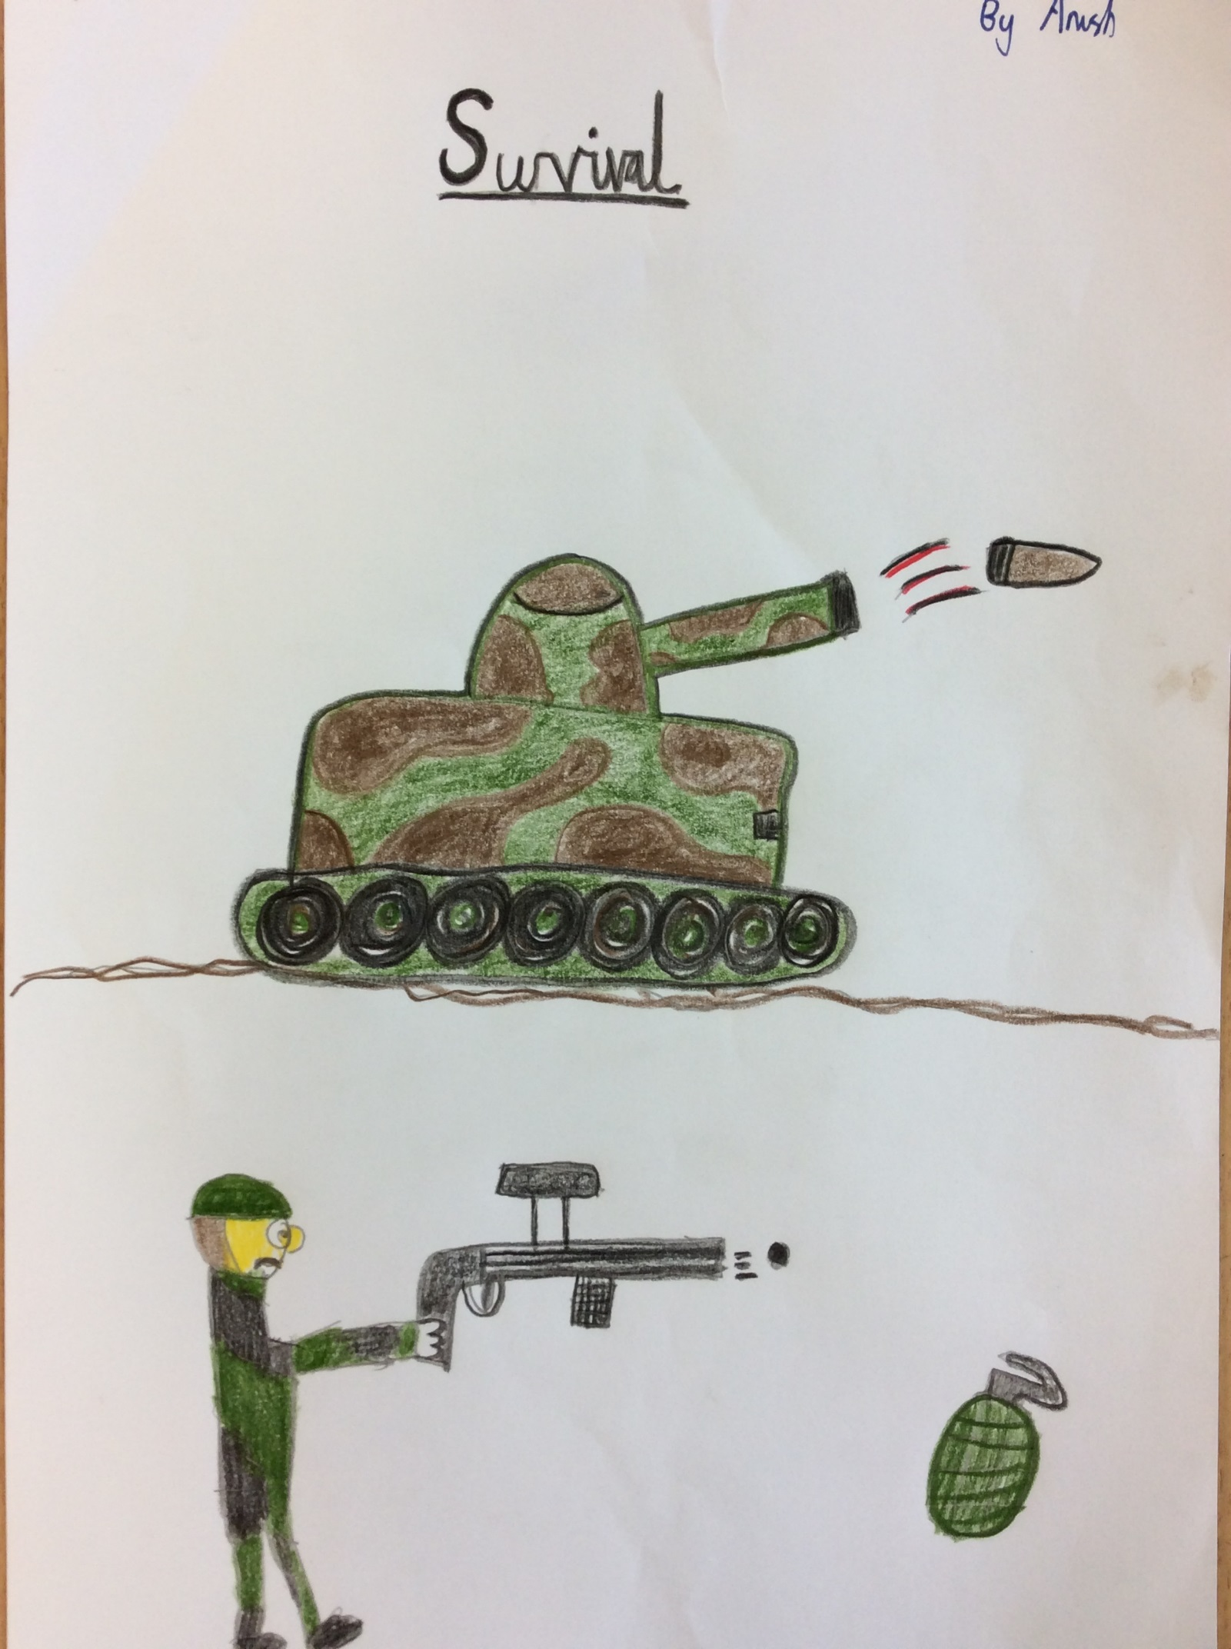

Survival
Tony’s smile lit up a silent, desolate street in the heart of Warsaw. Normally his smile would only last a few seconds, as the war was so horrible, but this smile was going to last. His dad, Erik Jefferson, was a sergeant in the Polish Army, and he had sent him a message saying that he must deliver food to the British army. He had also sent him the food that he must deliver to the British.
Tony set off, keeping to the dirty, rat infested back streets, so as not to be seen by anyone. He ambled around alleys, scuttled on sidewalks and marched on the main streets. He quietly, quickly kept to the shadows. If a suspicious looking person came by, he would disappear into the dusty rubble. His legs ached, with cuts and scars. His small feet made a pattering sound on what was left of the cobbled streets. The soles of his worn-out shoes flapped on the streets. The cut on his wrist burned in the strong, midsummer’s day sun. He was told to keep some fake food in his backpack, in case he was caught. The real food, Swiss cheese, was sewn into his jacket lining.
Tony was taking a break on a dark, water-logged alley when a loud, clear voice broke the silence.
“Tony, is that you?” the voice belonged to a tall, but relatively round body, Joe, Tony’s best friend when he was five.
Tony’s only reply was a long intake of the polluted air. Finally he managed to say, “Joe, is that actually you?” Tony was in shock as he hadn’t Joe for several years! The two boys had been friends for a long time as their mothers were at school together. They happily chatted away talking about how they had survived during the treacherous war. Joe had been living a cellar a few streets away from where Tony had been staying. The cellar Joe had been staying in, was part of an abandoned house, partly due to bombing. He had been staying there for only a matter of weeks.
It turned out that Joe’s older brother, Petr, was a soldier in the Polish Army, so Joe was allowed in on some secrets.
Joe was a very well fed boy so the war had taken quite a toll on him. His cheeks which had once been round and red, were now thin and his bones were visible. He had once been one of those chatter boxes at school but now he rarely spoke and if he did it would be the meekest of mutters. Since Joe’s brother was in the Polish Army, he too had heard about the food delivering mission. They were discussing about the best route to get to the British Army. Joe had suggested a very short way but it was a dangerous way and the chances of being caught were high. Tony preferred the way down Buckworth Street, as it was quiet, and Nazi patrols were only in the afternoon. They agreed on a deal that they would go onto Buckworth Street, but then they would take a shortcut onto the alley that Joe had suggested, Doghouse Alley.
Doghouse Alley was once a pound where dogs that didn’t have leashes went. They were so busy in their top secret conversation that they forgot that it was classified information. Their voices echoed around the alley they were hiding on. The alley was almost deserted, almost deserted apart from one man who was passing by…
The man was actually a spy for the German Army. He was Herman Scheffer, Germany’s star spy. He thought Tony and Joe were messing around and pretending to be spies, until he heard Tony mention the Polish Army’s General.
“So they are actually on a mission!” thought Herman, peeping out from the shadows. He quietly made a call on his walkie-talkie, except it was real, to the German Army’s General. He sent for a road block and several jeeps, so the two children would be stopped. Herman had a lot of power, so jeeps and a road block was considered “minor authorities” by him, and him only. He crept after Tony and Joe so that if they changed their plans he could alert the German Army. Herman was becoming increasingly frustrated, because Tony and Joe were very tired so breaks were becoming regular. Herman had a very big road block, but he never intended to hurt them. Tony and Joe were nearing the road block so Herman switched off his hi-tech, super flashy walkie-talkie. However, Herman forgot to tell the army to switch off their jeep engines, so when Tony and Joe were near they heard a very loud sound.
Herman had ran ahead so he could order the soldiers to search Tony and Joe. Joe was just about to turn onto the corner of the street which the road block was on, when Tony quickly grabbed him by the scruff of his sea-blue shirt collar.
Joe was about to yell at Tony for grabbing him but Tony silenced him by putting a sweaty hand on Joe’s mouth. “Joe listen to me, I think there is a spy ahead of us because he has been following us since we met up, and there is no time to actually explain what to do just copy what I do.” Joe was so baffled but he knew that Tony was smarter than him as Tony had been at school for six years where as he had only been at school for a small minimum of four years!
Tony and Joe entered the street with the road block acting like nothing had happened. As soon as they walked on the pavement they heard a gruff, “Hands up, you little runts!”
They acted shocked even though they knew this would be coming. Several troops grabbed their arms while other troops searched their backpacks. Herman and the troops didn’t know that they had hidden the real food in their jacket linings. So when the troops finally found food in the backpacks it was fake! Herman was so happy with himself that he didn’t notice that the food was fake. He pictured Hitler awarding himself, the great Herman Scheffer, with a knighthood and perhaps an Iron Cross (Germany’s most prestigious medal). He would be Sir Herman to the troops, oh how great it would be! His train of thought was broken by a soldier’s voice “What shall we do with the kids, now that we ‘ave their food?”
“Release them, they look young enough!” said Herman, he only said that because if he took the kids to Germany they would be useless. Tony and Joe walked away pretending to be so distraught. Tony patted Joe heartily so the Nazis were truly believing that they were sad. As soon as they turned the corner, Tony and Joe started to laugh mercilessly. After they had walked down a few streets they heard, “Psst, are you two kids Tony and Joe?”
“Yes, we are, are you the British Army’s general?” replied Tony, still laughing.
“I am the General, I heard you have some food to give to me!” said the General holding out his hand to receive the food. When Tony had given the food to the General, the General said, “I have something to give to you two!” The General pinned two heavy pieces of gold to their chests. Medals! Tony and Joe, were so surprised they barely managed to say thank you to the General. A few years on, and Tony and Joe were grown men. They always reflect on their struggles in the war.

By Anish

