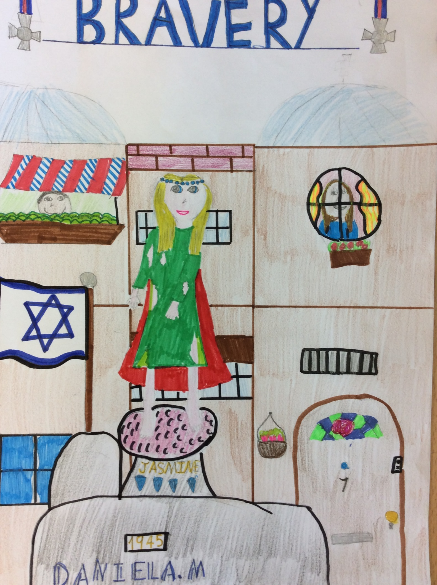
BRAVERY

Jasmine crouched behind the market stall, trembling with fear. Her pale face had terror sketched all over. All she could hear was the bargaining of stall owners and the loud clip-clopping of horses’ hooves on the moss-covered cobblestone. However, a strong feeling was surging deep in her bones, saying that they were coming. The Nazi Guards were coming. A distant thudding grew louder and louder and louder. It stopped. A hoarse voice said from only a few paces away, “Check behind all the food stalls for the filthy wretch!”
Jasmine’s heart sunk. She clutched the borrowed loaf of bread to her chest whilst her heart pounded rapidly. Thoughts rushing to her head alongside doubts and fears. She could feel the blood flowing absently around, swimming through her showing veins. Jasmine had two options. She could run, or hide. Either way she would probably get caught because of the harsh conditions she was in.
Jasmine bolted! She darted here and there, left and right. Anywhere, as long as she was safe. Unfortunately, swift steps were coming up behind her! “You won’t escape us!” came a deep, gruff shout from her chasers. The Nazi Guards’ uniform was meant for this type of thing and they were gaining on Jasmine very quickly. Stupidly, Jasmine made a grave mistake. She rounded the corner into a dead end alleyway. She was busted…
… Jasmine searched frantically for footholds on the brick wall that was blocking the alleyway, but there was nothing to help her climb up.
“Well, well…”
“Well!”
“Yes, thank you.” Said a strong and sarcastic German accent.
The two Nazi Guards had each a navy-blue uniform that they were wearing, accompanied with shiny badges opposite the Nazi flag stitched on with strong thread. They both stepped forward until Jasmine could smell their revolting breath. It stank of strong whiskey and beer.
“Shouldn’t you be ashamed of how much alcohol you drink?!” said Jasmine smugly.
The guard smirked, embarrassed, but decided to ignore the way she was rudely interfering with his own business. Suddenly, one guard revealed a toothless, frightening smile, before taking a bat out of nowhere and swinging it proficiently. THWACK!
The room was dark when Jasmine awoke. She coughed and sneezed several times, causing a little struggle when she tried to relax a bit. Dust filled the air, forming grey cloud-like shapes. When Jasmine looked at the floor, she could see a thick carpet of dust and grimy, unwashed bowls buried in it. Around her, there were bars made of iron and nickel. Where was she? She felt like an animal in an empty cage, apart from the people all cramped in a corner with frightened, grubby faces.
“Who are you?” came a quiet voice from the corner of the room.
“Ummm… I can’t remember! Well…”
Mutters came from the shadows and several women stepped forward.
“Hush little child, don’t fear. Lots of us have forgotten our true identity.” soothed one of the women, calmly. Her face was skull-like and her eyes were a withered green, but she brought a comfortable warmth to Jasmine. The woman let Jasmine call her Greta.
“I overheard the guards talking. They said something about hitting P4903 and they also mentioned something about a young girl.” said Greta, “P4903 is probably you, check your arm.”
Jasmine was confused, but she looked at her arm and saw P4903 burnt on to it. “I must escape, and you will come too. All of you! Everyone will come…”

2 Years Later

After a year, Jasmine remembered her name, but most importantly, she spread the word about THE GREAT ESCAPE! Jasmine told everyone, “Midnight on the dot, be ready, the doors will unlock automatically when I set off the fire alarm. Make lots of sounds of fright and distress to confuse the guards then run fast to the main gate when you hear my false announcement saying, ‘All guards report to kitchens. Collect all food!’ ”
Jasmine then prepared herself for what was to come. Will this go well? I don’t want to let everyone down. Jasmine thought, doubts filling her head.
TICK. TOCK. TICK. TOCK. 12 o’clock. Ring, Ring, Ring…RING RING RING RING RING RING …! The fire alarm rang deafeningly, continuously. Convincing shrieks and cries came from ALL the cells and the strong, barred doors swung open. Masses of prisoners flowed out of their cells and created a chaotic river in the concentration camp grounds. Bullets rained into the sky, and the only sounds were guns firing, guards yelling orders and grenades exploding. Fiery red and orange explosions formed breath-taking fireworks in the cool air. Flames! This was unplanned! However, this was more convincing!
“All guards report to kitchens and collect all food!” came a voice through the speakers, “No eating just packing,” it added.
Instantly, the guards created a troop and marched obediently to the kitchens. Jasmine sat down in the leather chair, inside the Announcement Room and slammed her little fist on a huge red button with the label ‘Emergency Gate, Do Not Touch Unless Emergency Occurs.’
DRRRRRIIIIIINNNNNNNNNNGG!!! Jasmine felt like one of those business men that she saw in ripped, crumpled newspapers.
The main gate rapidly opened, sending swarms of people flying out. Literally, flying! Emergency jets were zooming out of the camp! Jasmine could see them soaring wildly. Well, this wasn’t planned, but cool! thought Jasmine. The prisoners all ran out of the gates and started packing themselves into trucks so they could escape more swiftly. They were driving clumsily along the uneven, damp soil track, bumping up and down repeatedly. Jasmine stood up and switched the kitchen door lock on. She locked the door of the Announcement Room behind her as she ran out into the gloomy corridor, making sure that she took the keys with her.
Jasmine ran as quickly as a cheetah would. Her legs were throbbing with violent pain, but she ignored them and kept running. Left. Right. Right. Left. Back. Right. Right. Left. Guard. GUARD! Jasmine entered the daylight and looked up at the Nazi Guard innocently.
“Excuse me Sir, what’s going on here?” Jasmine asked, as she battered her eyelashes foolishly.
“Child, go save yourself. I am not true Nazi! Do not fear!” he said to, Jasmine’s surprise!
Jasmine nodded seriously and thrust the keys into the Nazi Guard’s hands.
“Thank you! Please unlock the kitchen doors. Save the others!” she whispered, and flung herself onto the kind man.
There and was an awkward silence and the soldier stiffened a bit, until he broke into a gentle laugh.
“Go now, save yourself!” he said and ran towards the dark corridor.
Jasmine promised herself that she would not leave until she saw the soldier was safe, so she ran to sit in the dilapidated corner, by the walls. Coming to think of it, that man gave me a strange warmth that felt special and comforting. thought Jasmine. Suddenly, the Nazi soldiers came sprinting out of the kitchens, all of them coughing and wheezing, due to the gassy fumes. Jasmine looked at them guiltily, and made a huge mistake.
“Follow me, go escape!” she shouted to them, whilst running towards the gates and waving her arms in the air.
Just then, she felt a tight grip on her shoulders. She thought she would die of a panic attack, or severe pain. But I helped them, what are they doing?! Jasmine sensed that she was in trouble. Deep trouble! Jasmine screamed. She fell, blood staining her shirt where her pierced heart was. The bullet, lying on the ground beside her, blood covering the blunt tip. It had done its horrid job. The guards around the dead body, laughed, satisfied. Apart from one. Jasmine’s long lost DAD! He silently wept. Glimmering tears cascaded down his smooth, pale cheeks. The war was finally over, a time of uncontrollable despair…

3 Years Later

After all the traumatizing years of war, the Allies had finally won their tranquillity. Lots had died, and lots injured. Nobody had a full, joyous smile on their face, even though the war had ended. All the smiles were sad ones and only happy by a touch because all the chaos had ended.
Through the war, the citizens of Poland had hope in their eyes and hope in their hearts. Hitler, the famous leader of the Nazis, had committed suicide. Nobody knew why, the truth was hidden. Despite that though, the people tried to forget the despairing event and started celebrating on VE Day. The war was over!
Muslims made flags and sewed the Star of David in the middle as a strong sign of faith, peace and good victory. They were put up along the exploded houses and were waved with pride outside the safe, untouched houses. Everyone sat down at a huge oak table with a picture of Jasmine skilfully carved into the top of it. It was a huge feast, there was chicken, potatoes, carrots, tomatoes, cucumber and boiled eggs. There was even a huge, three tier cake made of milk chocolate and it was even covered freshly whipped cherry icing!
There was one rumour that was spread round throughout the land; It was said, that because of the bravery of Jasmine Brochette Dethroath, (yes, they found her name) that Hitler killed himself to show that the child was more worthy than him and had a strong, pure heart. It was also said that Hitler felt guilty of the terror he spread and the way he drove people into patronizing danger.
Due to this, a gold statue was put up in remembrance in Jasmine, it had rare sapphire studs around the head, like a crown. From that time onwards, Jasmine was known as Queen of Bravery! She would be a role model, an idol, someone of peace!
Jasmine’s dad became a well-known citizen and was rewarded with a silver medal, shaped as a cross. The Queen gave it to him and he became the Major of London when he moved to live in there. Everyone had lost something in the war and things were changing, but houses were being built again and a new life was beginning to form.
By Daniela

