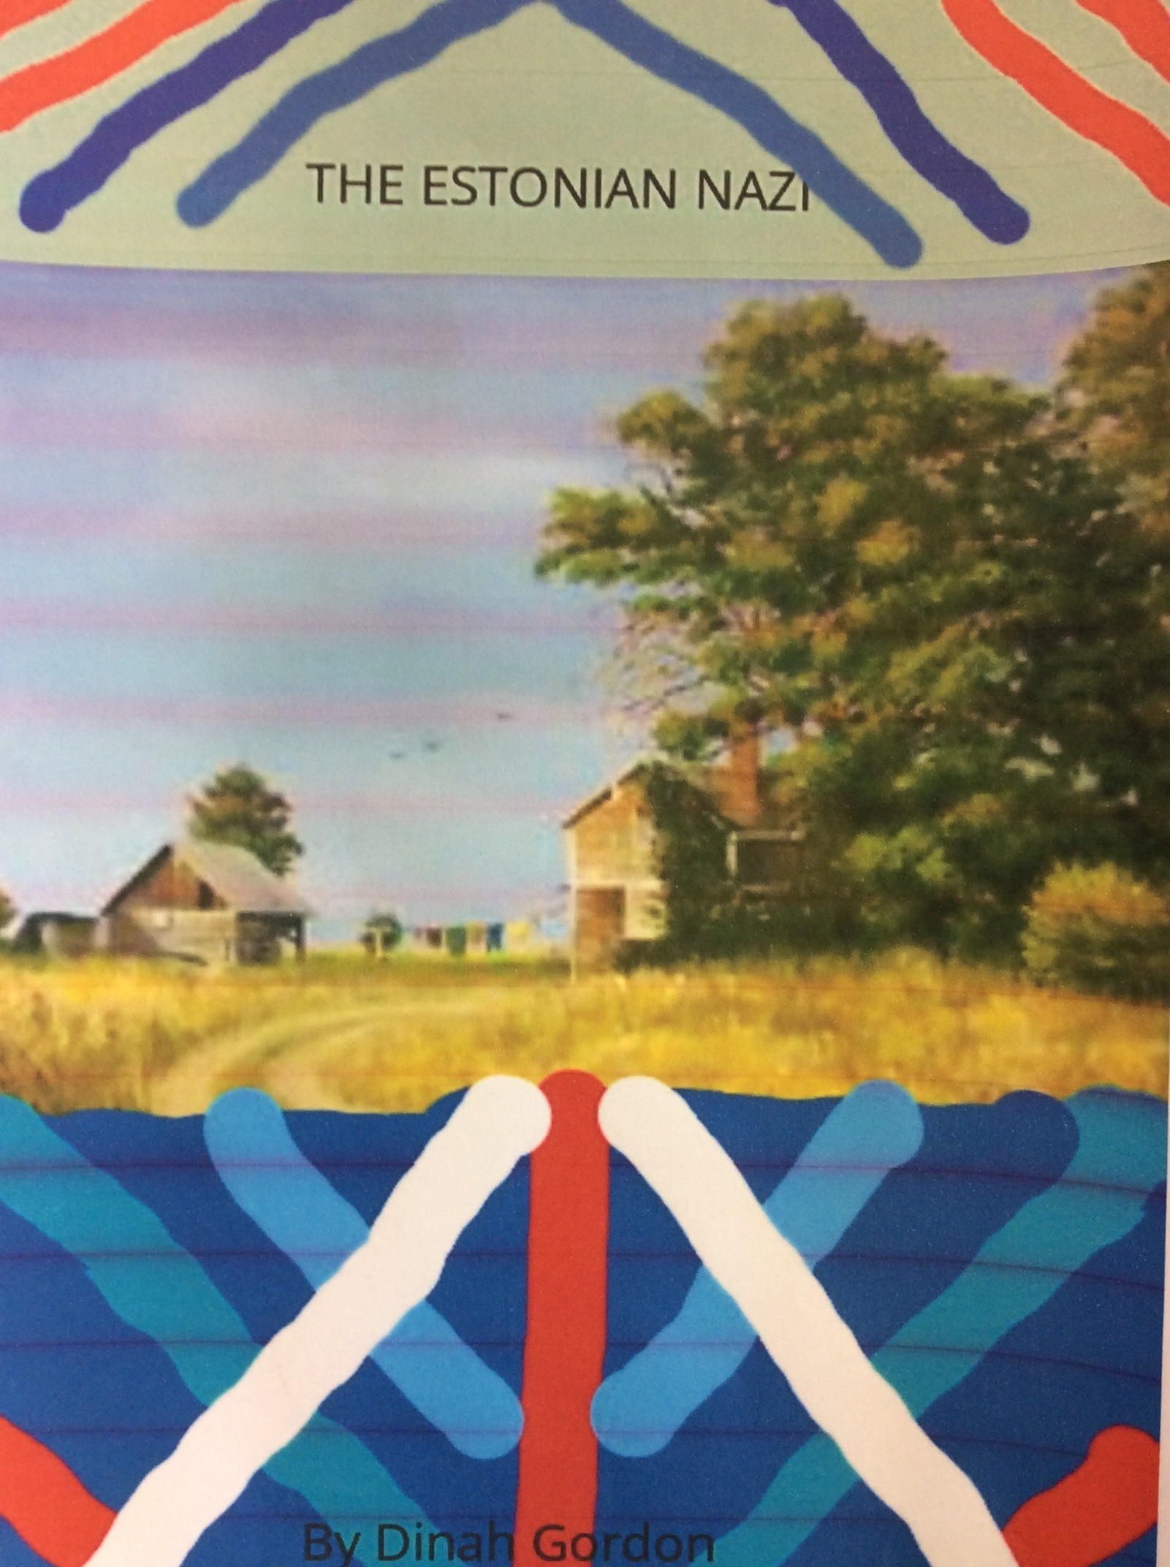

The Estonian Escape
Ando’s chocolate hair was matted with sweat. But even in the difficulty of farm work, he loved it.
“Ando! Theo is with a lamb. I think Lisa gave birth to it. Come quickly!” called Aino, his loyal wife. She had blonde hair which sparkled in the sunlight, as well as warm emerald eyes. His long legs carried him to the lamb pen. He gasped with adoration at the sight of the fluffy baby.
“When was it born?” he asked, his glacier blue eyes wide with wonder.
“Around five in the morning,” replied his wife. They both smiled softly at the new born. It was definitely a special lamb, they could see it in those brave eyes.
Suddenly, shouts of “HEIL HITLER!” echoed through the village. It was just as they feared, the Nazis had come for them.
“Where is Ando Aksberg?” they asked, German accents blaring. Worriedly, Ando clasped Aino’s hands in his.
“Look after the farm. I’ll come back,” he whispered. Tears were falling down her cheeks. But she understood. He would have to escape the Nazis again. He put his arms up and walked into the local hamlet on the outskirts of Tallinn.
The commander grinned, “Aksberg, my friend. Come and join us.” He was holding a grey Nazi uniform. Ando winced at the commander’s blackened gums and teeth like gravestones. The once happy villagers pressed their lips together, waiting for Ando’s reply.
“Take me and never come to our country again,” was all he said, his voice surprisingly calm. The officer grabbed his back with a disgusting hand and shoved Ando into their unwelcoming boat.
A guard was told to hold Ando still. The only sound that he could hear was his own heart pumping against his ribs. But then he recognised the familiar strawberry blonde hair and deep amber eyes, sparkling with fear. No mistake.
“Arvo?” asked Ando, his heart soaring with hope.
“Ando! At last a trustful friend in this war, we shall escape to Estonia again!” Arvo answered. The two were so excited to see each other they did not realise the boat pulling into Latvia.
“Lieutenant Arvo and Prisoner Aksberg, come out of that boat,” called a commander. Before the friends knew it, they were running through the boat. Straight to the wheel. If the captain was there, then the two of them would be shot on sight. However, there was no captain. They could sail to Estonia again.
“Yes!” grinned Ando. The captain was on the deck. With nimble fingers, Arvo got the boat started and the ship ran smoothly through the port. Shouts from the deck surrounded them but the boat had already disappeared into the thick fog.
“Full speed ahead!” whooped Arvo, “the Nazis do not even know where we are going, ESTONIA!” Ando just stood there with a stupid grin.
“We need to pick our passports and family, we have to get to Stockholm,” said Ando. Arvo nodded. Ando found tinned beans and a loaf of bread. The two ate a tiny snivel of each and discovered a lump of Gouda to save for later. Ando and Arvo’s home town shook with worry, the people were praying that the two would come back alive.
Two days later, they arrived at their hamlet. The villagers cheered and filled the boat, but none were as enthusiastic as Aino who charged into Ando’s arms, drenching his shirt with happy tears and flattening him with a wild hug. The lamb was put in the cabin with Ando and Arvo and was given oats to nibble on. Even in their happiness, the villagers knew that there were to be more wars in life and the journey would be rough with the Baltic Sea. Yet, even in that thought, the proud Estonians would end this war alive and happy. Tougher than before. Slowly, the boat glided of the beautiful beach. Ando shared a lap of milk with his friends in the captain’s deck. The people looked ahead at the Baltic Sea, they were coming for Sweden…
A few days later, the Estonians were at a small port in Lidingo and ready with their best Swedish.
“We come Estonia. We escaped the Nazis,” explained Ando, surprised at his own good Swedish.
A Swede in a navy uniform nodded, “We do not get many Estonians here. Awful this war and I would do anything to stop it.”
Some hours flew by as the villagers were given two blocks of flats to live in. Ando and Aino settled down comfortably, the lamb now in a local farm which they could visit. The two found jobs, and soon, moved out to a beautiful house with red carpets and an elegant garden. Here, they lived happily with their three children Anna-Karin, Annika, Johan. They were stronger and braver than ever before. The war had served the Estonians well.
By Dinah

