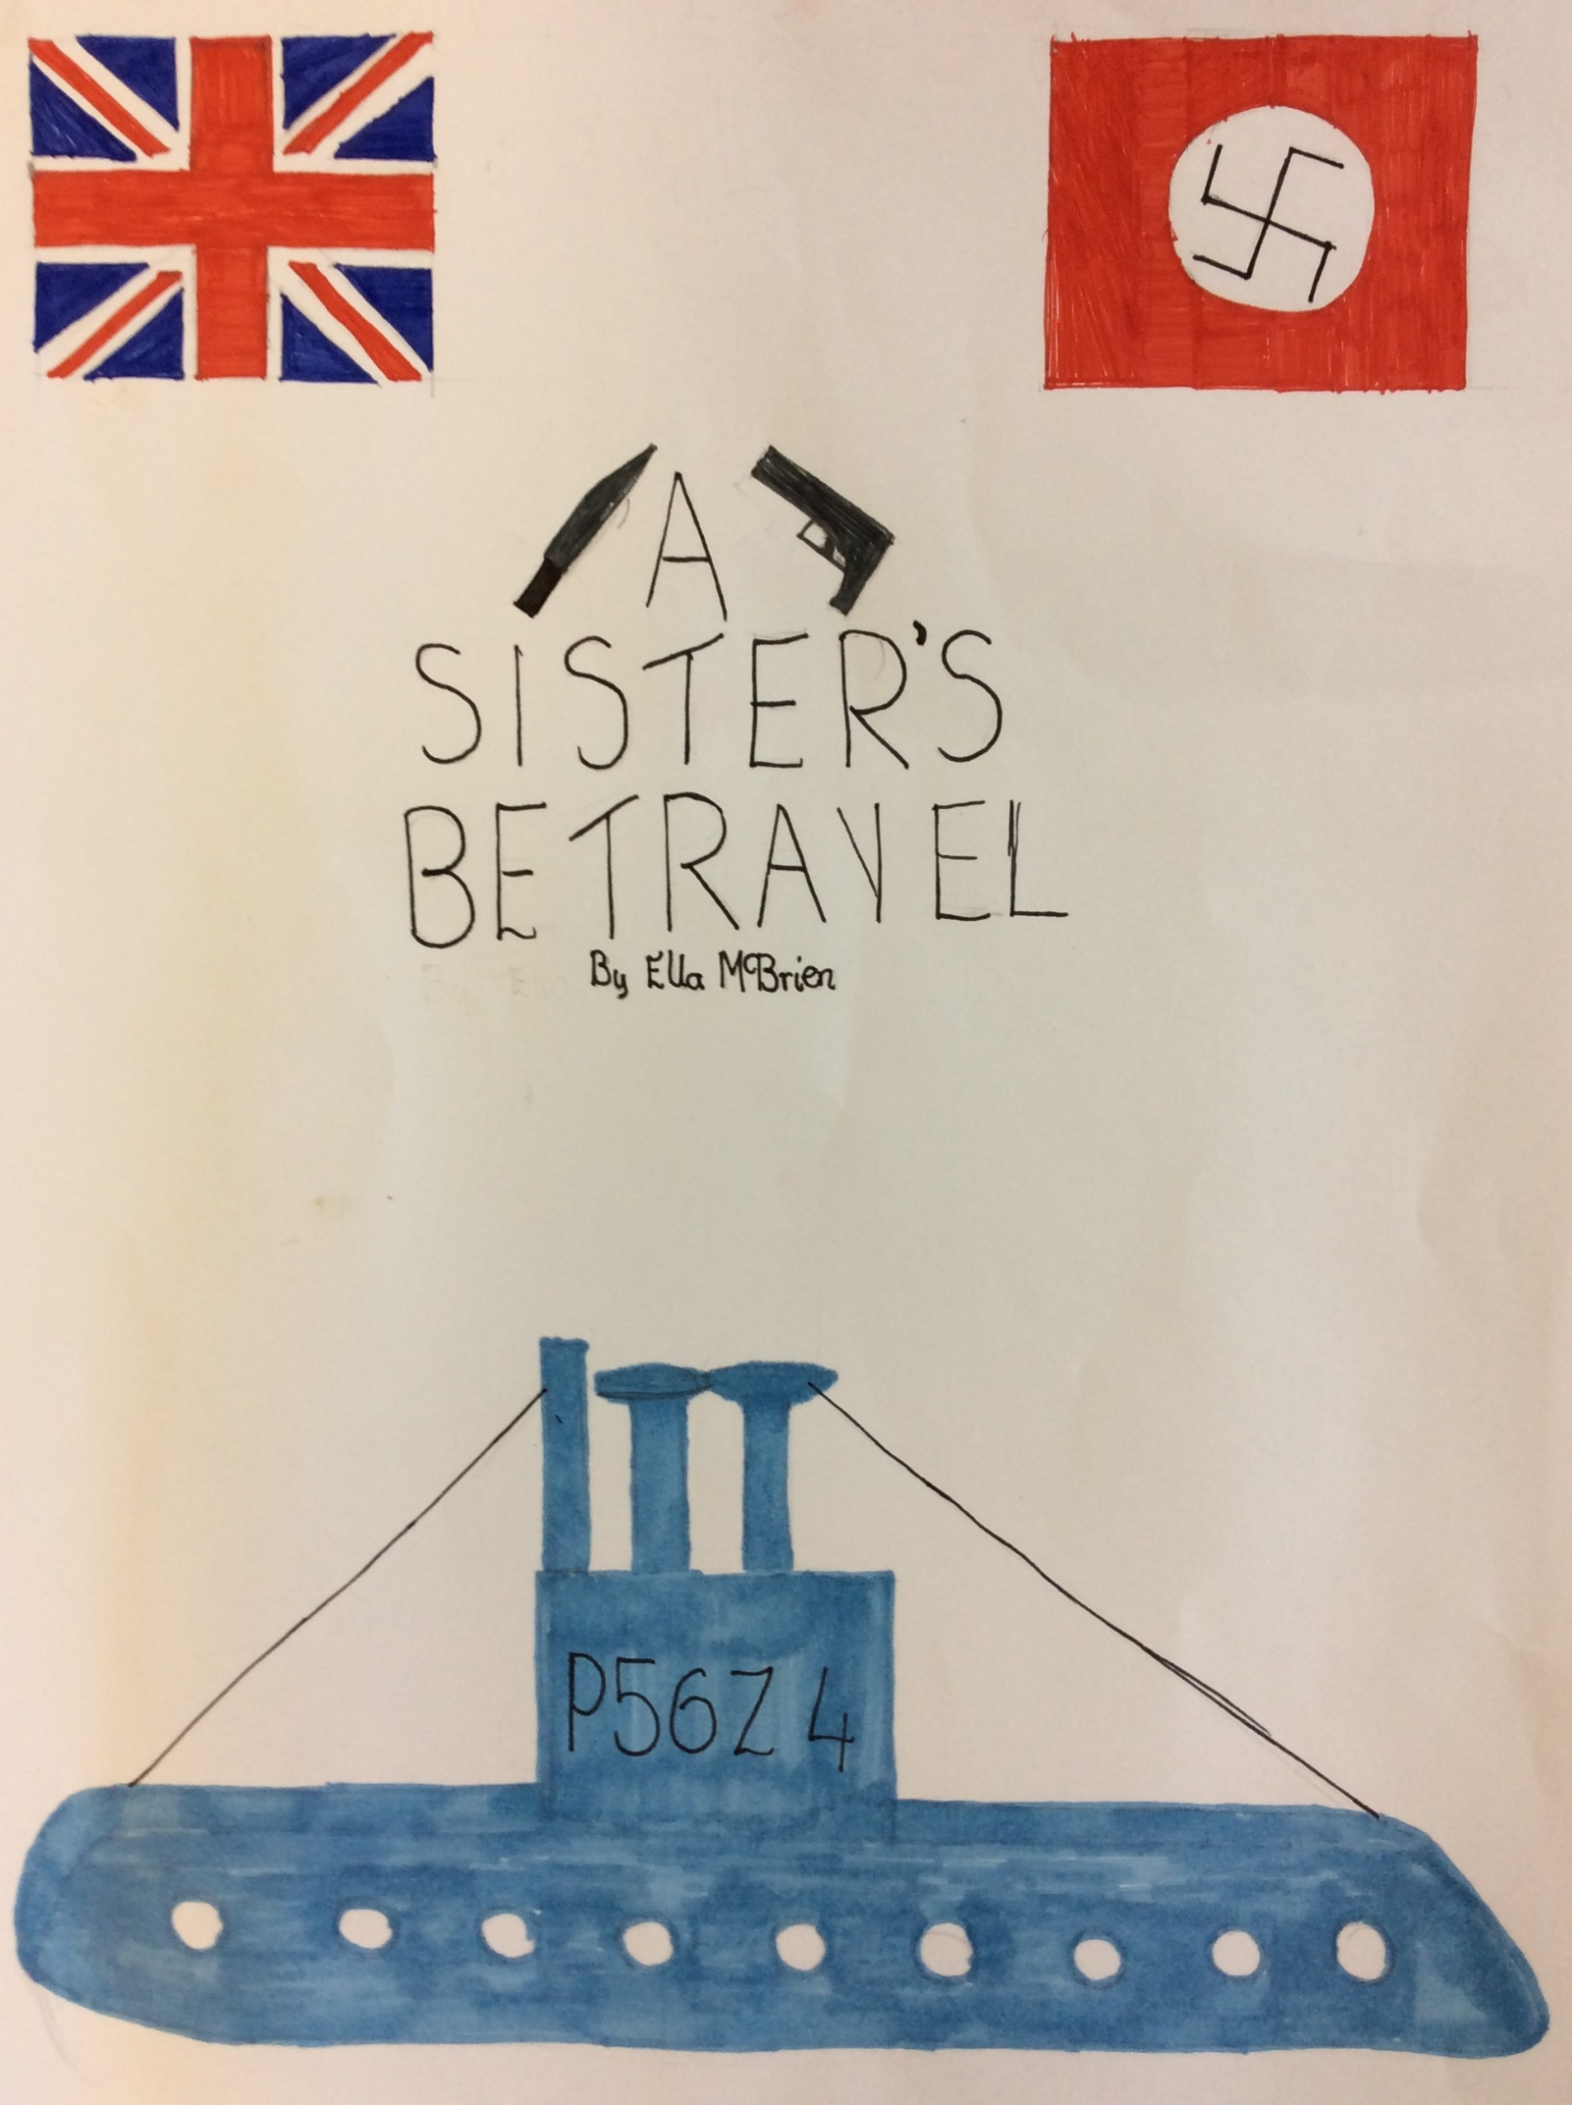

A Sister’s Betrayal
“Report to the bridge,” a voice said over the loudspeaker. Kathleen jumped up, out of her daydream and ran to the bridge, her grey woollen jumpsuit itching her as she went. She was so transfixed in getting to the bridge she did not realise a cabin door open and a man step out. CRASH! The sound bounced off the walls of the corridor. She collided with the man and there were murmurs of “ows” and “get off mes” as they scrambled to their feet and their gazes met.
“Um sorry, I have to get to the bridge!” said the strange man and he ran off. Kathleen stood there for a moment dazed and wondering who the man strange man was. She had not seen him at emergency training, and that was the most important training in the naval. As she pushed the strange man out of her mind, she headed towards the bridge.
She went up the steel stairway, carefully making sure her hands did not touch the railings because out here on the South Pacific Ocean, her hands would freeze onto them if she did. When she reached the bridge, the Captain of the vessel was going to give a welcome speech, but unfortunately what he said was something that shook everyone’s confidence. He said: “we’re going down,” then he said something that rattled people’s bones: “we’re going down, because we’re approaching Japan.”
The whole crew except Kathleen and the strange man were running round screaming “I don’t want to die!”
The strange man approached her and said, “Hello my name is Joseph Stower. I am very glad to be of acquaintance to you.” He put his hand out and expected her to shake it so Kathleen did.
“Hello, I am Kathleen.” she said.
“Any last name?” asked Joseph.
“No I don’t give away any unnecessary information.” Replied Kathleen.
“Well I had better show you the plan room,” Joseph said walking off.
All that while, somebody had been listening and somebody was watching them walk off, out of the bridge, down the stairs, then that person, ran faster and faster heading to the plan room and running quicker until they reached it and opened the door…
“Well here we are!” Joseph ended the awkward silence with that comment and then rather awkwardly he said “I will be out here if you need me”
“Ok, thank you.” Kathleen replied rather unsure what to say to that comment. Kathleen stared at the black forbidding door, imagining the room beyond it. She placed her hand on the door handle and pulled it. All that while, somebody was waiting for it to open. With a pistol in one hand and a dagger in the other and they were not afraid to use it…
Kathleen opened the door stepping inside the cold room, a black cloud following her as she shut the door. She looked around, unsure where to go or what to do. Then out of the shadows crept a woman who Kathleen vaguely recognised. “Do you remember me Kitty?” the woman asked.
“No.” Kathleen replied.
“Well I’m tired of no-one knowing me! I am your sister!” shouted the woman.
“Oh Jane is that you?” asked Kathleen.
“Yes, it is me and I am going to kill you!” screamed Jane.
A sheet of terror spread across Kathleen’s face and she screamed! Jane put her bony fingers on Kathleen’s mouth and gagged her so she couldn’t scream. Jane loaded her pistol and sharpened her dagger so that it could blind you if you looked at it to closely.
“You’re going to give me the diamond necklace mum gave you or I will shoot you!” shouted Jane
“Why do you need it?” asked Kathleen as she ripped off the gag.
“Because… because…” Jane was lost for words
“Because you’re in debt!” Kathleen replied coolly. “To a man by the name of Fletcher and you met him at a casino playing roulette and now you owe him money.”
“How… how… do you know?” asked Jane surprised.
“You’re my sister for goodness sake! You don’t think I look at what you’re are doing every so often, I also know you’re a Nazi!” Kathleen said trying to keep her cool.
“Well then if you know my secret then you need to die!” snarled Jane.
Kathleen watched as Jane reloaded her pistol and aimed at Kathleen’s forehead. Then she screamed, it echoed across the room bouncing off the bare walls and making the door rattle.
Joseph heard the scream and came rushing in to the room holding a gun pointing it at Jane’s head, “Don’t move.” Joseph calmly said.
Jane dropped her pistol and followed him to the bottom of the vessel. “Well, how did you like your first submarine ride?” asked Joseph with a hint of a cheeky smile.
“What did you do?” asked Kathleen sensing the cheeky smile becoming larger and larger.
“Oh, Nothing,” Joseph’s smile becoming larger.
“Ok, what did you do to my sister?” asked Kathleen becoming concerned.
“I chucked her overboard the ungrateful little maggot!” shouted Joseph.
“You do realise that that is not my sister. My sister is married to Lord Johnson and is currently in India!” Kathleen replied trying to stifle a laugh.
“Then who was that?” asked Joseph bewildered.
“That was your sister!” Kathleen replied calmly.
“Oh, God! She’ll kill me!” Joseph looked as he was going to faint.

By Ella

