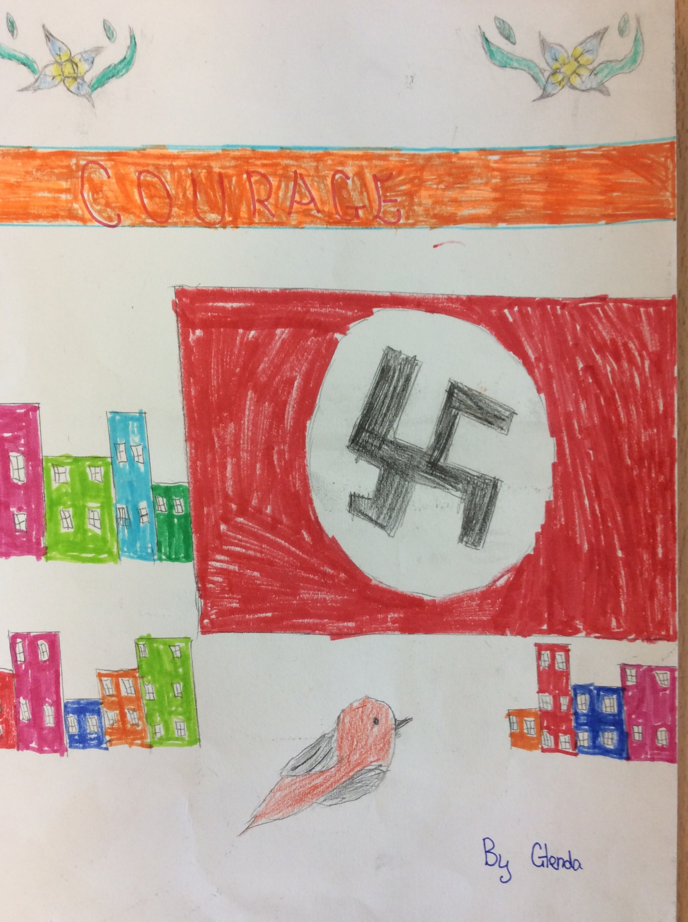

Courage
He didn’t have to do it, but he knew the consequences. Louis had locked up a group of Jews with his delicate hands that had veins like a river on a map. He was a concentration camp guard and hated to see the Jews suffer. Louis was forced to treat them as if they were smelly mud on the bottom of his smooth boots. The thought of that always made him feel like his heart was swollen and bruised. Since Louis never smiled, his lips had became dry and flaky.
“God help me,” muttered Louis, whenever he was alone. Although, by all means he wasn’t Adolf Hitler’s favourite, he wasn’t exactly the least favourite and was fed much more than the Jews.
Despite that, in the dusty town house, Louis was famished and his stomach was rumbling so loud it sounded like an avalanche. His tongue felt thick and heavy. As a twenty year old soldier, he had to do risky long work and today his job was to keep watch. Just then, he saw a thin, tall man leaving the building. Blood surged around Louis’s body with trepidation. The soldier that had left, had cold sweat dripping down his rough forehead. Where could he be going?
Before dinner, Adolf Hitler always went to every soldier so he could watch them do their job. Last week, Hitler was so infuriated, that half of the soldiers who worked for him were sent to Poland to kill all families of any Jews. When you are not there, and Hitler needs you, he will give you a frightening punishment. Louis couldn’t bare anyone getting punished, even if it wasn’t him. Whoever left the building, shouldn’t be alone. With a blizzard of nerves and confusion, he stepped out of the house and followed him.
Everywhere Louis went, was silence. His emerald, green eyes, looked like a green flamed candle in the jet-black street. He was lonely and deeply depressed, since he didn’t have any companionship or an old friend to talk to. Louis ran through his auburn hair like liquid copper with his hand (which was filthy with dirt and grime) and had jagged, sharp fingernails. Then he heard footsteps growing louder. His ears that looked like mini satellite dishes pricked up quickly. He looked behind his bony shoulder. Could it be? It was Liezl. They were great friends in the past, also neighbours.
Louis was aware that Liezl was still looking at him. Liezl had coal black hair, with hollow cheeks.
“Is that you Liezl” asked Louis. Although they had not seen each other for four years, he was hoping they could be friends again.
“Yes, and I am on the run,” replied Liezl.
“What do you mean you are on the run?!” gasped Louis, clearly shocked, “When Hitler finds out you will be in for it,”
“I know, but all these years I have been suffering and now I am free,”
“Alright, but I am coming with you,” said Louis
Round the corner of the nearest house, was Liam. He had become Louis’s enemy and had hated him since. Liam had always been Adolf Hitler’s favourite. He had blonde hair with blue eyes as bright as the sky during daylight. He had heard the entire conversation. If he told Adolf Hitler the conversation he heard between Louis and Liezl he would believe him, since Hitler thought that everyone with blue eyes and blonde hair was a perfect role model. Liam knew he had no time to waste so he raced to Hitler’s office. Knock, Knock, Knock.
“Come in,” ordered Hitler, he was positively not in the move for nonsense. Liam stepped in obediently.
“Sir, Louis and Liezl are planning to go on the run!” blurted Liam.
“What!” shouted Hitler, “Come Liam, and bring the strongest soldiers you know with you so you can take me to them.” Quicker than a violent wind, they were gone.
“So you are on the run are you?” asked Hitler. Louis was shocked, how did he get such information? Beside Hitler was Liam, smirking. Of course thought Louis, Liam was the only person he truly hated. Liezl stood as still as a statue, barely able to speak. Hitler took a profound interest in what was going on. Then Hitler heard a husky mumble, making him feel indignant.
“Speak up.” demanded Hitler, whilst his cheeks turned from pale white to blood red. There came no answer. “That is strange coming from you, since you are on the run with Liezl,” snapped Hitler.
“No, I wasn’t” said Louis, who had never meant to cause trouble with Hitler at all, “I was capturing him since he was escaping,”
“Oh really,” commented Hitler, feeling guilty, “Well then, congratulations, as for you Liezl. You shall be killed at dawn.” Two muscular soldiers took Liezl away.
Louis felt downhearted in his bunker. Liezl was gone. He breathed slowly out of his window and saw a letter in the shape of a paper aeroplane. It was for him. From Liezl. It said.
To Louis
I am sorry that you almost got into an argument with Hitler. It was my fault that you got into this mess, I shouldn’t have left the bombing shelter that afternoon. My life has been nothing but miserable whilst working for Hitler. I guess I shall be killed at sunrise for my punishment.
You see, ever since you left to work for Hitler at the age of twenty, I made a lot of foolish mistakes and got whipped, leaving me with red marks on my arms, legs and my face. This made me want to run away for good. I missed my parents and my brother Gilbert.
Now, I have found a way to leave this place, but I need your help. Hitler is going to kill me in the armour room, third floor. There is a window near your bunker (that is how you got this letter). In the morning there will be a rope from your bunker to the armour room. You will need to climb across it until you get in the armour room. I have left the armour room window open so you can jump in. When you get there, you could use the sharpest sword to set me free since I have heard I will be tied to a piece of wood with metal chains. Hope you can help me.
Liezl
Louis felt like a coward. There was no way he could do anything about it. Liezl will be killed tomorrow. However, he never knew that Liezl had a brother called Gilbert. In fact, he did not know that Liezl had a brother at all! Louis’s eyes began to water so much that his eyes were twinkling green. In a little wooden box, were pictures of Louis’s family. At the bottom was a picture of Louis and Liezl, when they were young. Louis never knew it was still there. At the back it said Best Friends Forever. If only that was true. Louis was never brave and he couldn’t save him. But no, Liezl was the only friend he and was not going to lose him. Whilst a hostile breeze swept through his glass window, he slept, hoping to feel much better in the morning.
Almost unbelievably, morning came quicker than expected. Louis, who was light-headed, gave a low, gurgling groan. He looked through his window. There it was, a rope. Before he climbed on he whispered something that gave him self-assurance because if he fell off that rope he would have died. “This is for you Liezl,”
Sick with fear, Louis went on the rope with belly first to the amour room, where Hitler was known to be with a stern grin. His legs trembled when he saw Liezl.
Frantically, Louis cautiously jumped into the armour room hid behind the collection of swords, which made a clink.
“Who’s there?” asked Liezl apprehensively.
“It’s me, Louis, I am coming to save you so pretend you did not see me,” responded Louis. After a while, Adolf Hitler walked in with a bunch of soldiers including inquisitive Liam.
“Today we are gathered here to kill Liezl,” remarked Hitler, with an impish grin, “but first, we must say a prayer on how we hate him.”
As Hitler closed his sapphire eyes with the other soldiers, Louis and Liezl knew this was their ONLY chance to escape. Louis tip toed to Liezl and cut him free with a swish of his sharp sword. Then, they ran away from all the Nazis (including Hitler), as quick as a flash. Louis felt like acid was burning in his stomach. They were saved. Liezl’s dull heavy blood shot eyes slowly turned back into its ordinary colour. Louis felt more alive than ever.
Louis also felt a glow of happiness in his poor heart. He had a friend that he could trust. A beaming smile grew across his face. Liezl had a two jagged rows of rotting brown teeth like a crumbling tombstone smile. They both felt braver than before.
“Thank you for everything,” said Liezl.
“It was nothing,” replied Louis as they walked into their future, wondering what would happen next.

By Glenda

