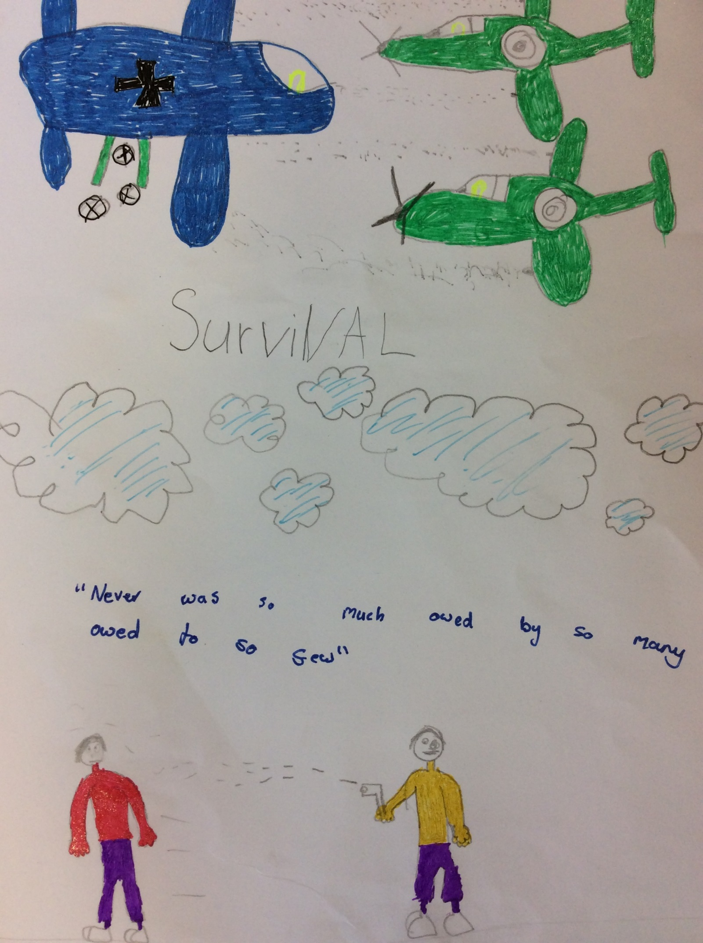

DANGER
As the birds cheeped over the constant rumble of Jan’s belly, his cat ran rings around him - desperate for food. He stroked the thin bony cat under the tree where he had made shelter in. As the rain dropped upon the city, Jan sat there looking at a picture of his car from when he was little. The cat looked at Jan in a way that implied how long is this war going to go on for?
“Come on, “said Jan, over the loud pattering rain. He was going to find food. The cat was buried under the thick long grass. Only his tail was sticking out.
Jan ran to the German camp and hid in the bushes. He saw a truck coming with new food and supplies. He jumped out from the bushes and bumped into a Nazi soldier. The cat jumped on the solider and knocked him over, whilst Jan grabbed a box of food and ran off.
As Jan was making his escape, he ran into a familiar figure. He looked closer and realised it was James - his old neighbour. He was standing there, bellowing over him.
“James” whispered Jan.
“Jan,” said James. “I have not seen you in years.”
They both went silent. “Look they made me a spy for them.” whispered James.
“Who? What? Where? When?” Shouted Jan.
“Not so loud, “said James looking at the giant German Camp. “Come on, come with me and escape.” said Jan.
“OK,” James considered it. “Come on then, let’s go”.
BOOM!
“Sooooo many bombs,” Said Jan looking at Squishy (his cat).
“Where do we go now?” said James in a worried voice.
“Don’t worry. I’ve made a shelter, “said Jan. He seemed proud of what he had done. Quickly, they rushed up the hill and into the little shelter Jan had made. James looked scared as he saw two Nazi soldiers walking up the hill with guns in their hands.
“Look, let’s climb that tree,” said Jan. They both climbed up the tree and onto a branch. They saw the Nazi guards walking away. They got down off their tree and ran in the wild. Every day, they reflected on what a near escape they had had.
Ten years later, they went outside and looked at the city. It still showed signs of the destruction which the Germans had made. There were still lots of little and big pot holes in the ground.
“At least it’s over now,” said Jan looking at James.

THE END by Samuel C

