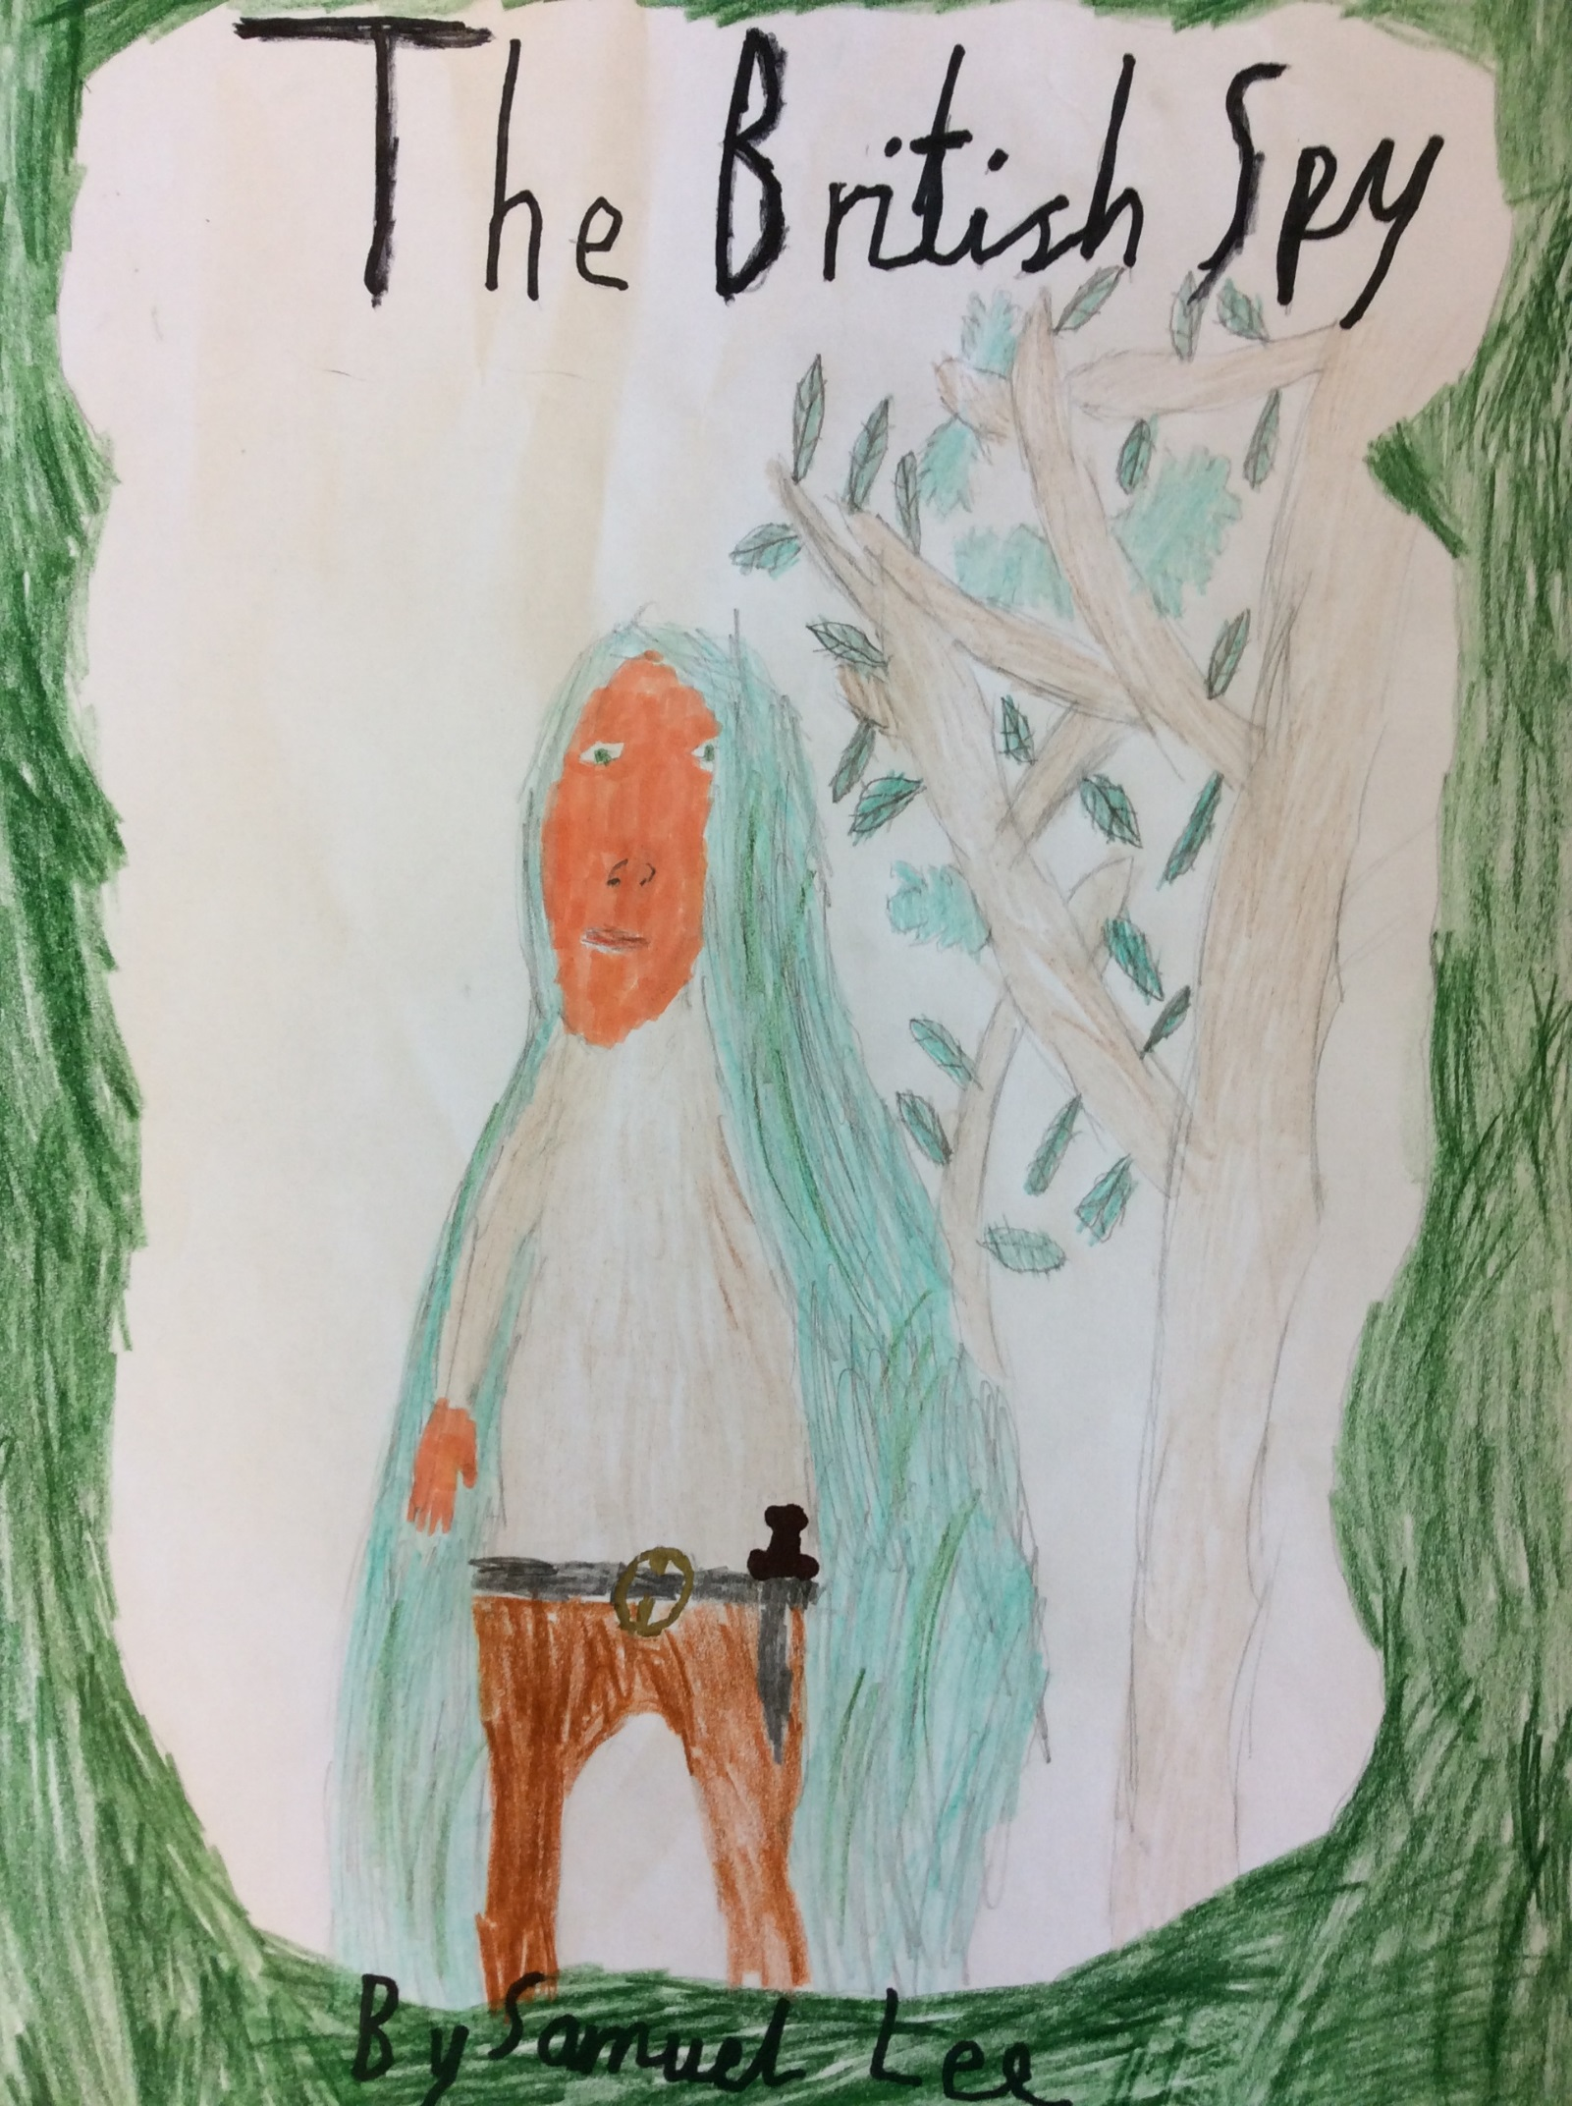

The British Spy
Thomas was just packing up his camp when he saw movement in the trees. Suddenly, a man seemed to materialise out of thin air, as soon as he was seen, Thomas stood to attention. It was the MI5 spy leader. Why he had come was beyond Thomas, however he soon found out.
“Thomas, I want you to go to the German training camp over there,” he said whilst pointing, “I want to know how many there are and how good they are. Ok?”
“Yes sir,” said Thomas.
“Off you go then,” the spy ordered.
Thomas set off into the forest using his pocket compass to guide him in the right direction. It was very thick undergrowth and he had to keep going off course to get round it. He sometimes had to spring up a tree on one side and climb down the other side. He cursed for the fourth time when he cut his face on a sharp plant.
Finally, he broke out into more open ground. It was much easier running in the open ground, even though he was more obvious to anyone looking for him. Once he thought he had been seen, but he stood as still as a rock and they turned and carried on walking. Like most members of MI5, he had had thorough training in the unseen movements.
A bit further into his journey he yet again saw movement in the hedges. Thomas said “who is it this time?” A man seemed to materialise out of thin air again. This time, the man was taller and carried a throwing knife just like Thomas did.
“Hello Thomas, “said the man, “I found your horse and wondered where you were. I’ve been looking for you since. What are you doing?”
“Sondo, that would have been fine without the question,” spoke Thomas frustrated.
“Sorry,” said Sondo.
“I’m going to the German base over there,” he said, nodding in the direction, “Can I have my horse?
Sondo said, “You just asked a question, but yes you can have Abalard.” He whistled and from a big hedge two horses came, one grey and one bay. Nether were the size of the historical battle horses, but they were very intelligent creatures. The grey one ran to Thomas and nuzzled him gently.
“Is Blaze all right?” asked Thomas.
“Why can’t I say questions when you can?” Said an annoyed Sondo.
“Because you’re not second in command of MI5,” answered Thomas.
“Ok, yes Blaze is as fine as I am,” muttered Sondo.
“Right let’s get onto the best way to the camp,” Thomas said rounding off the conversation.
They talked about it for a while. Sondo was talking most. As they talked, a little downhill out of the scent of the horses, unfriendly eyes watched them. They had been there for a while and now they turned and headed away. He had heard their whole conversation and was going to report to his dad. Thomas was in danger.
Thomas crept through the trees towards the German camp. Thomas was suspicious because there weren’t any German guards round the back to make sure no one got through the multiple fences of barbed wire. Like always there were patrols round the inside of the camp and he guessed the building with loads of guards was probably the headquarters.
His eyes fixed on two tents side by side. He knew this would be where he would find the goods because it was known the Germans kept their food in tents, also they were the only tents.
Thomas thought that tonight he should go and find a vantage point inside the camp where he watch the training in the morning. He should also look to see how much food they had and how long it would last. Then Thomas realised he would have to take most of the night to find a safe vantage point because if he was noticeable then he would be dead. There would be no second chance.
It was almost pitch black now and Thomas slid out of the trees becoming practically invisible to any watching eyes. He covered ground quickly and silently. He reached the fence in a matter of seconds.
Suddenly, right next to him some one whispered, “follow me if you want to hide safely in the camp, in day light.”
“Who are you?” asked Thomas almost unbearable.
“I’m Zanday,” Zanday answered.
Judging by the voice he was young, probably a boy, and why would a boy be lying?
“I’m Thomas and where is this place?” said Thomas again in that quiet voice.
“Follow and I shall show you,” answered Zanday.
Thomas followed. He was glad he didn’t have to find it himself, but he didn’t feel safe. He decided he would be on his highest gaurd as long as he was with the boy.
Suddenly a soldier appeared holding a pistol. Thomas kicked himself because he had trusted the boy. He guessed this would be his father or his father friend. Now he thought about it, Zanday sounded pretty German. His father’s uniform had a little tag with a name. It said Zino!
Thomas swore that he had heard that name before, but where? It might have actually been back in Britain. Then he thought that must have been impossible because MI6 would have picked up on it, or at least they should have.
He was brought back to Earth when he noticed a small detail on the gun. It had a silencer! Not only would he probably die but no one would know, so MI5 might think he had sided with the Germans!
“Surrender now or die now,” said Zino, “there is no escape.” Sadly Thomas realised this was true, but he would fight to the end!
Thomas dodged the first shot and sprang on Zino, taking him to the ground. They wrestled over control of the gun. Zino fired another shot but it flew harmlessly into the wall. There was one bullet left loaded!
Thomas tore the pistol out of Zino’s hands and pointed it at him! As he was about to pull the trigger, Zanday aimed a kick and hit Thomas squarely on the wrist! The gun flew seven metres before clattering to the ground!
Zino jumped at the chance! He knocked Thomas off him, jumping after him! He took out his knife and pointed it at Thomas’s throat! Thomas relaxed, he knew the battle was over so just lay, waiting for death!
But it never came! Zanday had shouted and Zino turned in time to meet a bullet to the heart! Zanday wasn’t dead like his father but he had been hit in the calf – a very painful wound! He was screaming like he had just eaten fire!
Who was this mystery rescuer and would he die as well was what Thomas was thinking about.
“Who are you and what’s your name?” Thomas asked. A figure stepped forward, revealing itself from its concealed position! He was wearing a cloak like Thomas was, but his face was in shadow!
He pushed back his hood to show his face which was otherwise black.
“Sondo, I should have known,” Thomas muttered shaking his head, annoyed with himself.
“It’s a lot easier to hide from people who are in the middle of a battle. Anyway why on Earth did you trust that boy? Wasn’t it obvious he was up to something?” asked Sondo.
“You wouldn’t have done better,” Thomas answered gruffly.
“I would…” said Sondo then decided to change the topic, “let’s get out of here before the Jerry guards are alerted!”
“Ok, but can you stop calling the Germans what the army privates call them please?” Thomas whispered.
Sondo hadn’t heard a word of it, he had heard “ok” and had ran to the fence to start climbing. Thomas followed him and skimmed up and down the fences, trying not to touch the barbed wire to much in case they got stuck.
When they reached the forest the seemed to melt into the trees, invisible to the untrained eye. Next time Thomas went spying he didn’t take any one for help. As for Zanday, he was sent to England and was taken in by a happy family and never got associated with war again.
Thomas and Sondo’s friendship grew as hard as a swords edge and they helped each other on countless more occasions.

By Samuel

