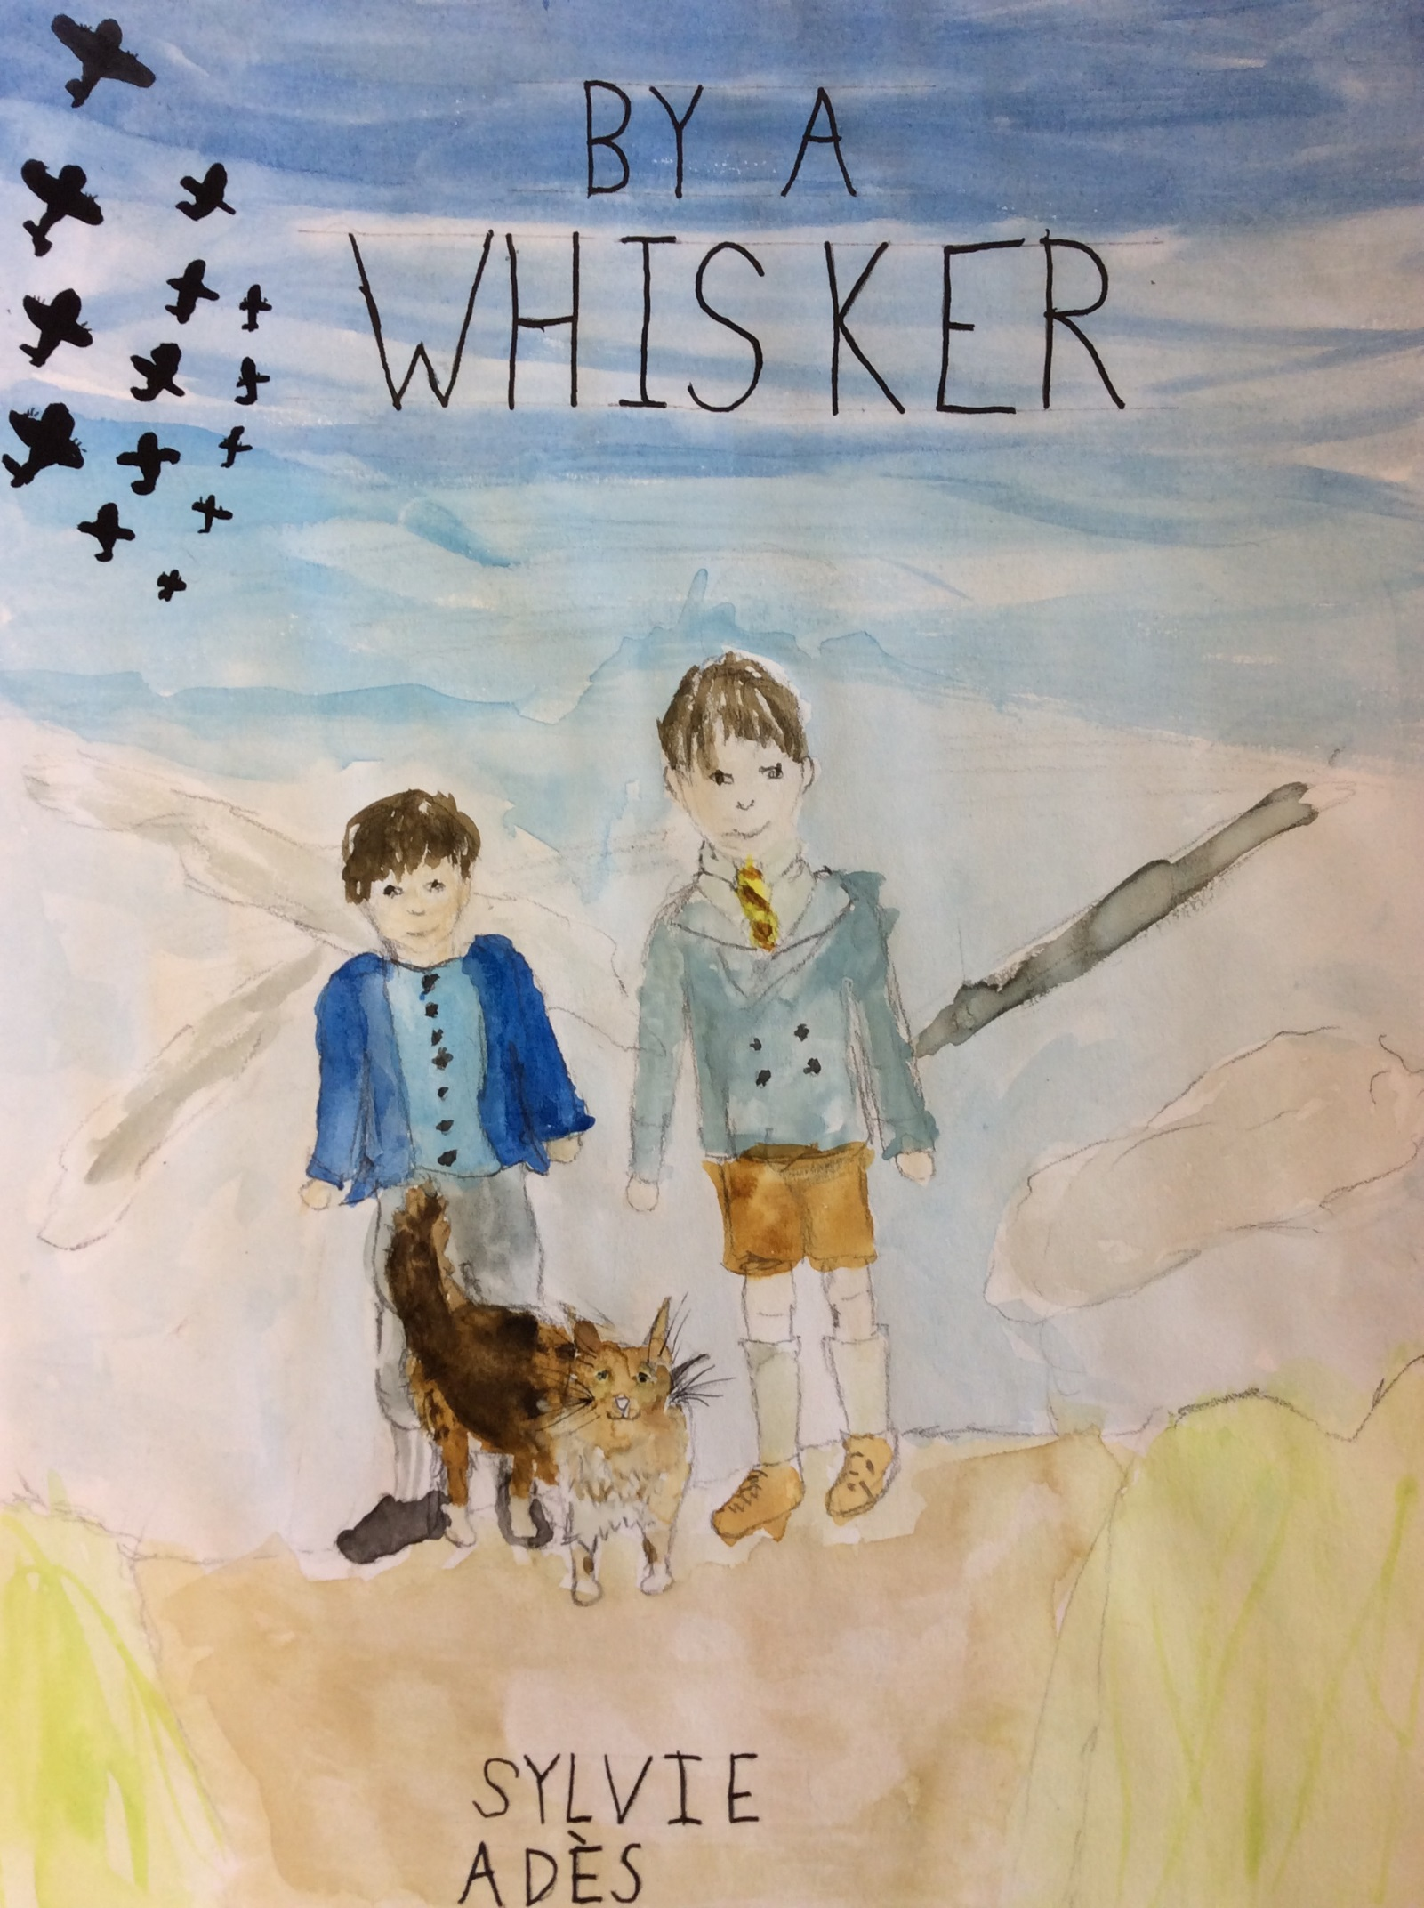

BY A WHISKER
Gilbert could hear angry voices in the room below his. They were not his father’s or his mother’s. The voices were harsh and furious. They were the voices of Nazi’s.
“Get into the van!” There was a scream, a door slammed shut, and a car’s motor started. Gilbert ran over to the window. He saw his parents being taken away. A Nazi looked up. “We have left the boy!” he shouted.
“It’s okay,” another shouted back “We can bomb the house later. Gilbert froze in terror.
Carefully he opened the window and climbed onto the sill. Gilbert hauled himself onto the wall. A freezing gust of wind blew around him. Gilbert climbed onto the roof. He ran. The stars glared down on him with no mercy. There were no houses left to run to. Gilbert looked down. It did not seem so high. Gilbert jumped. He banged his head on the edge of the wall and everything went black. The birds tweeted in the sky and a stream of sunlight covered the ground.
Wearily, Gilbert opened his eyes. A caring face was looking down at him. “Where am I?” asked Gilbert, “What happened?”
“You were running on the rooftops, remember, and you jumped. A bomb exploded. A piece of wood hit your head. You fell in my rubble heap. It was Whiskers that found you”
Gilbert sat up. A small long haired cat sat next to him, sucking in attention like a sponge. He remembered the terrible events that had unfurled so fast late last night. “So I have no home?” mumbled Gilbert.
“You can live with us,” offered the boy, “My name is Jan.” Jan and Whiskers took Gilbert down into their home. It looked like a rabbit burrow from the outside, yet once you had climbed down the claustrophobic mud tunnel, you ended in a very cosy little room. A double mattress took up the whole of the floor and cushions and blankets were strewn everywhere.
“This is amazing!” gasped Gilbert. Whiskers was already lying on the blanket, purring as if there had never been a terrible war.
“I’m hungry!” remarked Gilbert, “Is there any food down here?”
“Me and Whiskers have to steal food from the enemies. We creep into the camp at night time,” explained Jan. “We did well last night, didn’t we?”
Whiskers ears pricked at the mention of food and she walked round them in circles. Jan rummaged in amongst a blanket. He produced a canvas drawstring bag. Out of this, he took a loaf of stale tiger bread and two pieces of some cheese that looked like brie.
“Water is not hard to find at this time of year!” laughed Jan, glancing at a bucket of rain water. Whiskers had already started on the cheese. That night they slept happily on the bed of mattress and cushions. At midnight, Gilbert woke to find an icy cold hand shaking him.
“Who is there?” shouted Gilbert.
“Just me and Whiskers,” said Jan. They crept out into the night to steal from the Nazi camp. They crept past the snoring guard and found the food. And so life carried on like that for a month.
Early one morning, when Gilbert and Jan woke up and went to survey the damage, they found another person their age on a heap of rubble. They looked up and their blue eyes brightened.
‘Why don’t you come and join us?’ offered Jan.
‘Thank you,’ they said, ‘my name is Louis.’
Gilbert did not trust him but he said nothing. They took him back to the borough and showed him around. Whiskers was not there but often went exploring. That night, they went in search of more food. The last supply of oats had run out that morning.
‘Louis, we are going to get some more food,’ explained Jan. ‘You wait here.’
‘Oh no!’ exclaimed Louis with a look of disgust. ‘I’m coming with you.’ Gilbert scowled.
Jan was first to come out of the hole. Then Louis and Gilbert. The area seemed to be deserted, save the wind which slowly shook the trees to life. The three boys scrambled through the hole and under the barbed wire. Very carefully, Gilbert and Jan tiptoed into the supply tent. Louis wandered somewhere else. Gilbert smirked to see him go, hoping that he would get caught. In the tent Gilbert took some cheese and Jan took the bread. Then there was a shrill shout, “Edic”, closely followed by, “Oi you!”
Gilbert and Jan spun round. In front of them stood a man. He glared furiously at them and stamped his foot. Traitor cried Jan! Louis, who had been standing next to the man for all this time now laughed. He had smile of pure hatred sketched across his face. The guard strode over and grabbed Gilbert and Jan both by the scuff of their necks so if they tried to escape they could not run.
Jan tried to bite his hand but there was nothing he could do. Gilbert felt sick with fear and he felt as though it was so terrible that it had to be a dream. However Jan’s eyes were so distant. He was hatching a plan. His eyes brightened. Gilbert felt suddenly safer. At least Jan knew what he was doing.
“What is the meaning of this?” hissed Edic the Guard.
“Of what? Now would you kindly put us down and we’ll be on our way” said Jan – not exactly innocently.
“Why are you here?” barked the Guard.
“We were coming to …um” he glanced round the room and racked his brain for an excuse!! See how mighty your camp is. It is all anyone can talk about.” The guard grinned boastfully. For a moment he was lost with pride, but soon he came back to his senses.
“It is true that it is amazing,” said the guard, “but I am not sure that is the reason of why you came”. He gestured to the bread and cheese in their hands. The guard began to take them away. Louis chuckled in a nasty way.
“Come on Jan,” whispered Gilbert urgently, “think of a good plan”. There was a rustle and a strange hiss. Gilbert saw a smile of relief flood across Jan’s face. “What is it?” he whispered, but Jan seemed to be too busy looking to see where the noise had come from. Jan put two fingers to his mouth and whistled. There was another rustle from a tin of molasses. In a flash, Whiskers came leaping over three boxes of bread, all piled up on each other. The long haired little cat came leaping up to Louis and leaped onto him.
“Arhhhh,” screamed Louis, falling to the ground and struggling under the weight of the cat which was now licking him furiously. Louis’ eyes were streaming and he was wheezing terribly. Edic the guard spun around letting go of Jan and Gilbert.
“Louis!” Edic shouted, removing Whiskers. Jan and Gilbert began to run.
“They’re getting away,” croaked Louis desperately.
“I’ll go after them” said Edic, “you stay here!” The two boys were already out of the camp but being a fast runner Edic was in hot pursuit. Whiskers was racing after them. Soon they came to the heap of rubble. Whiskers was the first to leap down the hole. She was followed by Gilbert who was mightily glad to be home. Meanwhile, Jan had tripped over and Edic was getting nearer and nearer every second. Gilbert couldn’t watch. Jan scrabbled to his feet but he had twisted his ankle and could no longer run. Limping, he staggered nearer to the hole.
A tight fist clenched around Jan’s collar. He struggled desperately but Edic would not let go. Gilbert felt something brush past his side and out of the hole leapt Whiskers. She bounced over to Jan and jumped over to Edic. She clawed at him desperately and she let go. Edic eventually got Whiskers off him, but by the time he had done this, Jan was in the hole. Whiskers ran after him. Edic’s hand slammed down on her tail but Whiskers fur was so silky that Edic’s hand slipped off it.
Down in the hole, the boys and the cat lay on the mattress breathing quickly. “I’m never letting anyone live with us again,” laughed Jan.
“I did not think we would escape,” admitted Gilbert. Whiskers just purred in agreement.
“You are a fantastic cat!” said Jan ruffling the fur under her chin, “You saved us all!”

By Sylvie

