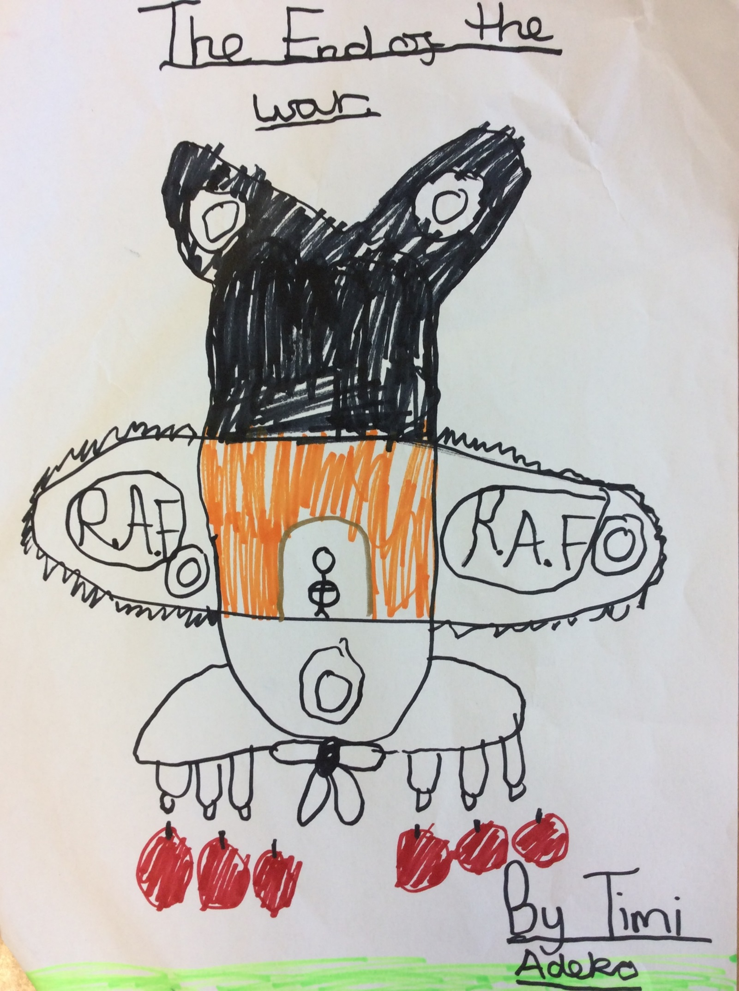

THE END OF THE WAR

As Charlie walked down the dilapidated streets of London, he saw on top of him a billion beads of cold sky slant down through the night. He was cold, poor and willing for food. He then felt happier than he had done for a while, but still lonely. All of a sudden, he saw a blinding and stunning light which was vivid, but annoying at the same time. He finally realised people were having a party- he didn’t normally see parties in London. The rain began to get heavier until it was turning the mud to rock pools, and then to rivers. As lightning struck from the sky, the raindrops dropped constantly like heartbeats, and he realised that he should go under the mini shelter of his that he created with sticks to keep him safe from the dark. BOOM! Another crash thunder came again.

In a blink of an eye, his legs took him to the party door which was open. In his head, he knew it was the wrong thing to do. He took a glimpse outside to see thunder crash and roll through the night, making the windows rattle and to see the smaller orphans shriek. Cautiously he crouched and then continued to walk. The place was decorated with costumed fairy lights, where the people were seated in the dining room. There were delicious miniature pork pies, cucumber sandwiches, and chocolate pudding with tomato sauce and cups with cold iced pims which he loved. Just then he saw someone rapidly running towards him in the tall cramped corridor.

“Who you are, “said the broad old man.

“I am poor and I’m willing to eat these scrumptious food of yours.”

But as soon as he admitted that, he turned his back on the man, and ran out timidly and worried. He looked back to see the little cottage house lay statuesque in the bright white beam of the midnight moon.

As quick as the wind, he was sprinting through the stars towards his tiny shelter made of twigs. He was thinking about his family in sorrow, wishing he could find them as he had been sent away on the train to London’s countryside from America. Always having a picture of his family to look at, Charlie never cried but it was his day to cry today. Without warning, he heard the loudest bomb go off beside him. It shook through the city like a volcano erupting.

BOOM! BOOM! BOOM! The strongest missile had landed where Charlie was thinking. It pierced his skin, as Charlie felt pain like never before. He cautiously tried to move but he knew his leg was certainly broken. As a nurse walked by, she told him to drink the alcohol in her hand to calm it down but he did not listen. His mum had told him to never drink it or else he would go mentally crazy. As he waited for the ambulance, the hours ticked by, and he began to regret not having the alcohol to make him feel warm. The ambulance eventually arrived and took him to the hospital.

When Charlie got there, on the ceiling there were 21 tormented spider eyes looking strangely at him. He was so scared that he fainted on the first time that he entered the room. He was pushed into the room by the nurses who were wearing a purple and blue, uniform.

He saw soldiers who were sent from war with their hands missing, and legs broken. When would this war end?

A year had passed, and Charlie continually breathed in the dirty chemicals that were poisonous into his nose .The air began to turn bitter then lemony, and finally mintyer than the mintyest sweet into his mouth, as he walked down the familiar streets.

Charlie slept through to the next morning, whilst the sun’s beam was cascading down into London. He saw the dark green grass with velvet flowers surrounding it. The weather was good and the skies were vivid. Finally, it was the end of the war.

By Timi