Book Bingo Year 5 and 6 Book List
A
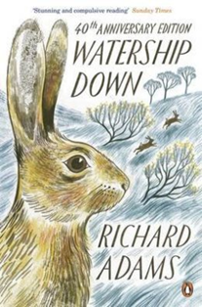 | 11+ | Young rabbit Fiver is convinced that a great evil is about to befall the warren where he lives - but no one will listen to him. At last he manages to persuade his brother Hazel and a few other brave rabbits to leave behind the safety of the warren, before its too late. Chased by former friends, under threat from humans and hunted by dogs and foxes, their journey is a dangerous one - but the rabbits can still dream of a peaceful and safe new life at Watership Down.  In spite of its rabbit characters, there is nothing fluffy or gentle about this gripping tale of perilous adventure which won both the Guardian Children's Fiction Prize and the Carnegie Medal. Beautifully evoking the Berkshire countryside in poetic language, it is an exciting, moving and powerful novel.
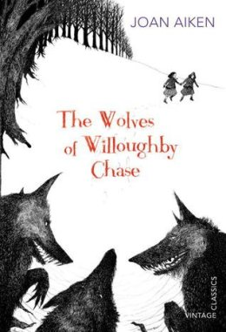  CHALLENGE READ | 9+ | There are wolves outside the walls of Willoughby Chase, but for cousins Bonnie and Sylvia, the real danger lies inside. Their wicked governess Miss Slighcarp is working with a network of criminals, forgers and snitches to carry out a terrible plan. Bonnie and Sylvia must use all their wits if they are to escape their cruel governess - and the wolves.  Set in an alternative 1832, in which Good King James III is on the throne, and Britain is ravaged by wolves which have migrated through the newly-opened Channel Tunnel, The Wolves of Willoughby Chase is a brilliantly inventive and imaginative offering from classic children's author Joan Aiken. Young readers who enjoy this story will relish the other wonderfully idiosyncratic stories in this series, which continues with Black Hearts in Battersea.
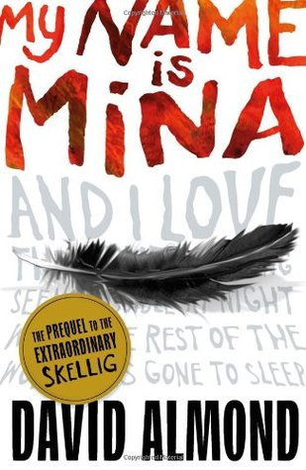 | 9+ | Through a collection of stories, journal entries and meandering thoughts, Mina tells the story of her life so far; of grief, marginalisation, bravery, self- knowledge and love.  Revisiting a character he first introduced in his bestseller, Skellig, over 12 years ago, David Almond explores Mina's background and eccentricities to reveal a complex and resilient spirit who is as endearing as she is infuriating.
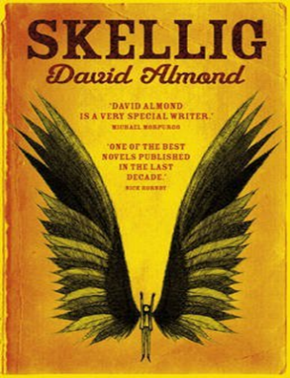 | 10+ | When a move to a new house coincides with his baby sister's illness, Michael's world seems suddenly lonely and uncertain. Then, exploring a ramshackle garage with new-found friend Mina, he finds something magical. A strange creature - part owl, part angel, a being who needs Michael's help if he is to survive.  With Mina's help, Michael nourishes Skellig back to health. The creature is ill-mannered, with questionable personal hygiene, but persevering in their kindness towards him, Michael and Mina find a bond forms betwen them that will change their lives forveer.  This unusual and captivating novel from critically-acclaimed children's author David Almond won both the Carnegie Medal and the Whitbread Children's Book Award. A contemporary classic, it has the power to captivate both adults and children alike.
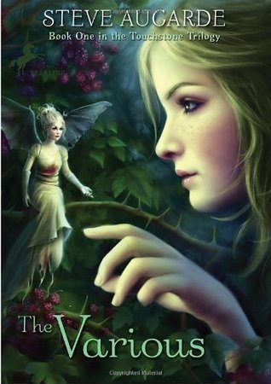 | 10+ | A captivating story of courage and strength against terrible odds, this is the story of Midge, left to stay with her eccentric uncle during the holidays, and her adventures with the Various, a band of fairies. The existence of the Various, who are strange, wild, and sometimes even deadly, has been kept secret since the beginning of time, but when their world begins to clash with the human world, they are threatened with extinction.  Book 1 of the ‘Touchstone Trilogy’
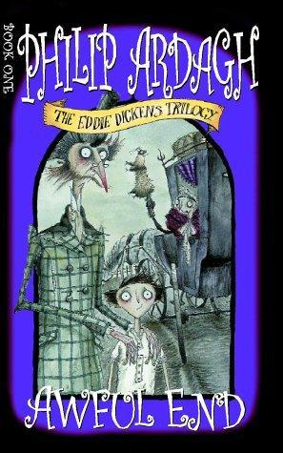 | 9+ | The first book in a hilarious, action-packed trilogy.  Eddie Dickens is sent off to stay with his aunt and uncle and a riotously funny comedy of errors ensues.  When both Eddie Dickens's parents catch a disease that makes them turn yellow, go a bit crinkly around the edges, and smell of hot water bottles, it's agreed he should go and stay with relatives at their house, Awful End. Unfortunately for Eddie, those relatives are Mad Uncle Jack and Even-Madder Aunt Maud. . . .  Book 1 of the Eddie Dickens Triology
B
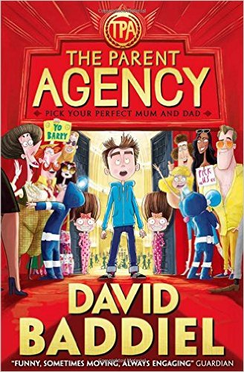 | 9+ | Barry Bennett has a long list of things he dislikes about his parents: being boring; being too tired, not letting him play video games and getting a limo to take him to see the latest James Bond film on his birthday (and naming him Barry) being just some of their deeply heinous crimes. But what if the tables were turned and children could choose their parents? What would Barry do?  With a thoughtful look at just what might happen in an alternative world, David Baddiel explores what most children will probably have considered at some point in their lives - trying out different parents - with hilarious results.
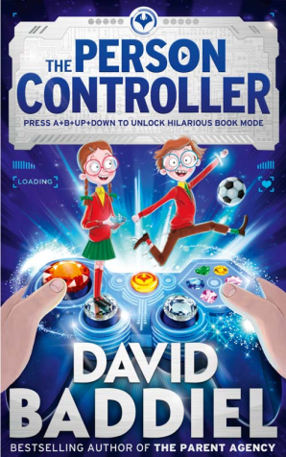 |  | From the author of THE PARENT AGENCY comes a thrilling, funny and touching new adventure.  Fred and Ellie are twins. But not identical (because that's impossible for a boy and a girl). They do like all the same things, though. Especially video games. Which they are very good at. They aren't that good, however, at much else like, for example, football, or dealing with the school bullies.  Then, they meet the Mystery Man, who sends them a video game controller, which doesn't look like any other controller they've ever seen. And it doesn't control any of their usual games. When the twins find out what it does control, though, it seems like the answer to all their problems. And the key to all their wildest dreams. At least it seems like that.
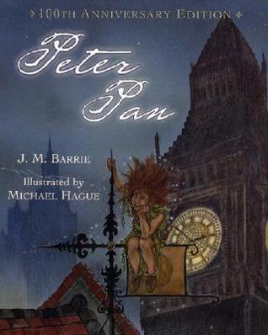 | 9+ | Peter Pan, the book based on J.M. Barrie's famous play, is filled with unforgettable characters: Peter Pan, the boy who would not grow up; the fairy, Tinker Bell; the evil pirate, Captain Hook; and the three children--Wendy, John, and Michael--who fly off with Peter Pan to Neverland, where they meet Indians and pirates and a crocodile that ticks. Renowned children's-book artist Michael Hague has brought the amazing adventures of Peter Pan to life. His beautiful illustrations capture the wild, seductive power of this classic book. This newly designed edition will be enjoyed by fans young and old alike.
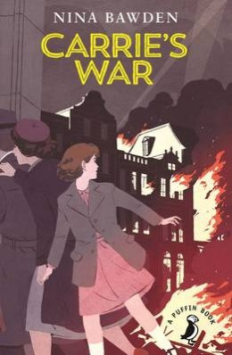 | 9+ | During World War II, Carrie and her younger brother Nick are evacuated to Wales and billeted with the fierce old shopkeeper Mr Evans and his mousy sister, Louise. Unhappy in their new home, they are delighted to have the chance to visit fellow evacuee Albert Sandwich at Druid's Bottom, the strange household of Hepzibah Green, who knows magical stories, and Mister Johnny, who speaks a language all his own. But then Carrie makes a mistake - which has terrible, unforseen consequences.  Inspired by Nina Bawden's own experiences of living as an evacuee in a Welsh mining valley as a child, Carrie's War is now considered a modern classic. Funny, sad and thought-provoking, it provides young readers with an insight into some of the complexities and ambiguities of the adult world - albeit with a heartwarming happy ending.
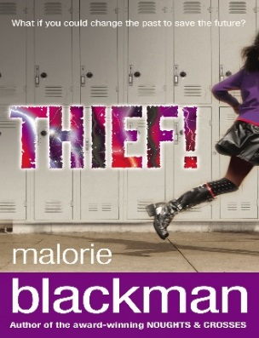 | 10+ | You're the new girl in school. You're just trying to fit in - and it's not working. Then someone accuses you of theft, and you think things can't get any worse. Until you get caught in a freak storm . . .  The next thing you know, you're in the future. Being shot at for being out after curfew. You don't even recognise your hometown. And you're heading for a confrontation from your worst nightmare.  What if you could change the past to save the future?
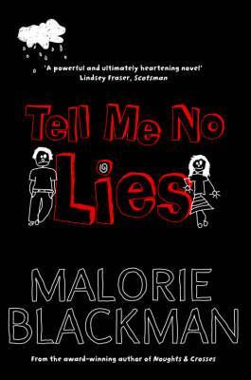 | 9+ | Gemma longs for her lost mother, taking comfort from the cuttings in her scrapbook; pictures of mothers who loved their children come what may.  Mike is new to the area; a boy with a terrible secret to hide. A secret about his missing mother.  Gemma and Mike - two kids hurt by their past and now inextricably linked. Their effect on each other's lives will be explosive.
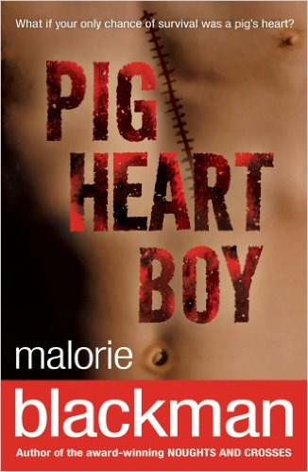 | 11+ | Cameron desperately needs a new heart when he is offered the opportunity to take part in a radical and controversial experiment involving the transplant of a pig's heart. While Cameron soon comes to terms with the idea, he finds the world around him less accepting. A powerful and thought-provoking read.
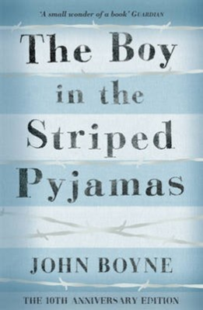 | 11+ | Bruno has a happy life in Berlin, so is shocked when he learns his family are moving to 'Out-With'. One day Bruno is out exploring the bleak surroundings of his new home and befriends a boy of his own age: Shmuel, who lives on the other side of a fence which surrounds a large camp in the grounds.  Shmuel and the other inmates of the camp are all under-nourished and wear a uniform of striped pyjamas. Bruno is not sure why they are there or why he is forbidden to mix with them but the boys friendship grows.  Their friendship sustains them both but ultimately ends in tragedy when Bruno crawls underneath the fence to help Shmuel search for his missing father. Suitable for readers older than the book's nine-year-old protagonist, the story serves as a compelling and shocking symbol of the futility and horror of the holocaust.
C
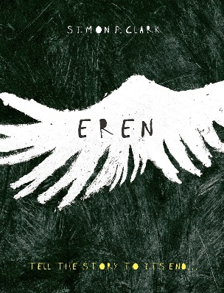 | 11+ | ‘Tell the story to its end,’ says Eren with a grin. His yellow eyes are glowing like embers in the night.  People are keeping secrets from Oli - about where his father is, and why he hasn't come to join them at his uncle's house in the country.  But Oli has secrets too.  He knows what lives in the attic. Eren - part monster, part dream, part myth. Eren who always seems so interested, who always wants to hear more about Oli's life. Eren, who needs to hear stories to live, and will take them from Oli, no matter the cost.
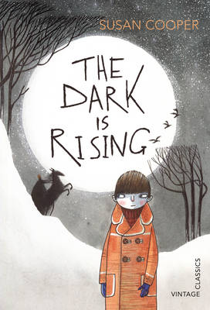 | 11+ | It is Midwinter's Eve, the night before Will's eleventh birthday. But there is an atmosphere of fear in the familiar countryside around him. Will is about to make a shocking discovery - that he is the last person to be born with the power of the Old Ones, and as a guardian of the Light he must begin a dangerous journey to vanquish the terrifyingly evil magic of the Dark.  This is probably one of the greatest fantasy sequences ever written. Darkly magical and intense Cooper weaves her storytelling wonder over fully realised characters and worlds, drawing in the reader and leading them on a journey that will leave them clambering for the rest of the series.
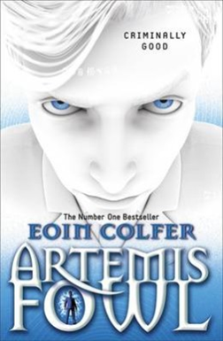 | 9+ | Twelve-year-old criminal mastermind, Artemis Fowl, hatches an ingenious plot to steal all the gold in fairy land. Although a little dubious about the plan - indeed not even quite believing in the existence of fairies - his trusty bodyguard and companion, Butler, is on hand to help. However, they have not reckoned on Captain Holly Short, who as first female officer in the Lower Elements Police Reconnaissance unit, or LEPrecon, has much to prove. When she is kidnapped by Artemis, she is determined to stand her ground and protect the fairy secrets.  This hilarious and exciting adventure story is a deserving favourite with young readers. The unscrupulous Artemis Fowl is such a likable character that you will almost will him to succeed in his dastardly schemes - whilst also rooting for the bold Captain Holly. Colfer's explanations of the structure and technology of his spin on fairy land are absolutely believable, creating an amusing and highly imaginative vision of fairies, dwarves and trolls that is just right for 21st century readers.
 | 8+ | What do you do when you come home one day and discover that your parents have been kidnapped? Well, if you're a brave young guy named Charlie Ashanti, you go off in search of them. And since you happen to know how to speak Cat, your feline friends—the stray cats of the city and the caged lions on a magnificent, astounding floating circus—rally around you, bringing help, advice, and occasional special deliveries. Little do you know that in this search of yours, the fate of the world is at stake.  From an exciting new mother/daughter writing team comes this captivating adventure full of heroes, villains, and astounding events. Set in a near future that blends the familiar and the new in unexpected, intriguing ways, Lionboy is an exhilarating, suspenseful whirlwind of a novel—a book destined to become a classic.
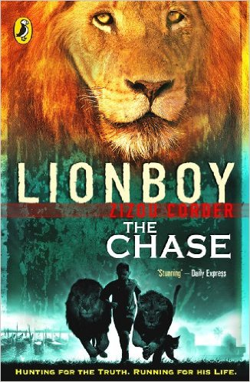 | 8+ | Charlie and his lion friends have made it safely to Venice, but it turns out that their journey has only just begun. King Boris's palace was meant to be a haven, but it's starting to feel more like a prison. When word arrives from the cat grapevine that his parents are not being held in Italy after all, Charlie knows he must take fast action. Luckily a new ally has come on the scene - and just in the knick of time: Rafi is in hot pursuit.
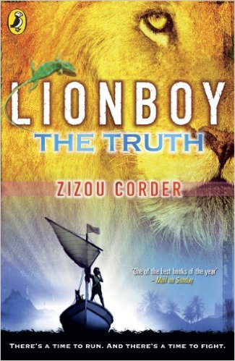 | 8+ | The second volume in the Lionboy series ended with Charlie Ashanti, the Catspeaker, finally reunited with his parents. The evil lion trainer Maccomo has gotten his comeuppance, and only troublemaking Rafi Sadler left to worry about. Everything is great, right?  Not for long, as Charlie is soon kidnapped, and he and his parents become involved in a high-speed Atlantic Ocean pursuit. Charlie's beloved lions get in on the act, and Charlie finally has his chance to confront the powerfully evil Corporacy --- but not before he must make some tough choices.  There are plenty of surprises along the way, including more discoveries about Charlie's family, some of them not entirely welcome. Charlie also learns more about his past, and even has an emotional --- and surprising --- reunion with the leopard responsible for his ability to speak the language of cats.
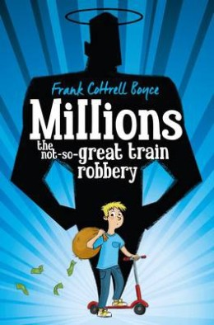 | 9+ | Since the death of his mother, Damian has become obsessed by saints. In order to escape the trappings of the material world, he builds a hermitage out of cardboard boxes near the railway line.  One night, a bag containing £229,370 falls from the sky and flattens the hermitage. Damian is convinced it is a gift from God, and contemplates with his older brother Anthony the best way to spend it. But with only 17 days left before the national currency switches to Euros and the money becomes worthless, this proves to be much more difficult than they had anticipated...  Funny, thought-provoking and thoroughly entertaining, this outstanding novel was a deserving winner of the 2004 CILIP Carnegie Medal
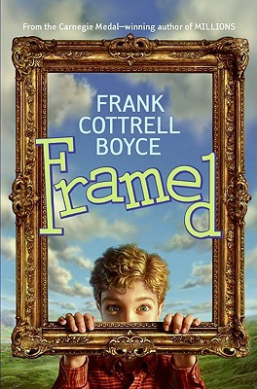 | 9+ | A few things to know about Dylan  He is the only boy in his entire town—so forget about playing soccer.  His best friends are two pet chickens.  His family owns the world's only gas station/coffee house—their pies are to die for, but profits are in the hole.  Criminal instincts run in his family—his sister is a mastermind-in-training, and the tax men are after his father for questioning.  And one more small thing about nine-year-old Dylan—the crime of the century has just fallen into his lap.
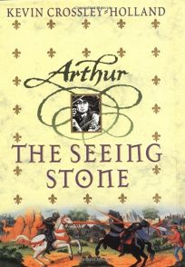 | 10+ | The year is 1199, the place the Welsh Marches. Young Arthur de Caldicot is given a magical shining stone in which his legendary namesake is revealed. In 100 short chapters that brilliantly evoke life in a medieval manor, stories of the boy King Arthur begin to echo - and anticipate - the secrets and mysteries that emerge in his own life . . .  "As bright and as vivid as the pictures in a Book of Hours. Deep scholarship, high imagination, and great gifts of storytelling have gone into this; I was spellbound." - Philip Pullman, The Guardian
D
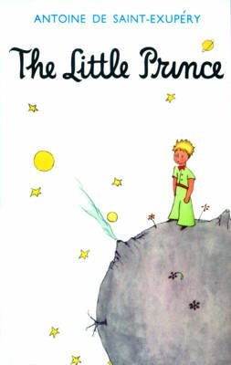 | 8+ | An air pilot makes a forced landing deep in the Sahara Desert. There, he makes a mysterious Little Prince, who tells him a series of wise and enchanting stories.  This simple, beautiful fable has captured the imaginations of both adults and children ever since it was first published in the 1940s. Now considered a contemporary classic, it is a book to share and to treasure.
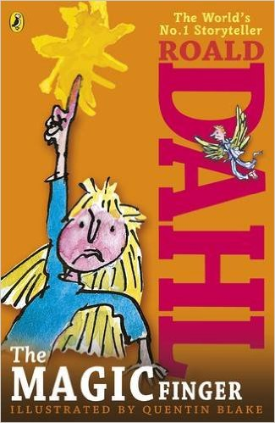 | 6+ | When the girl in this story gets cross, strange things start happening. Above all, she can't bear it when people are cruel to animals. So when her neighbours the Greggs go shooting, her magic finger teaches them a lesson they'll never forget...
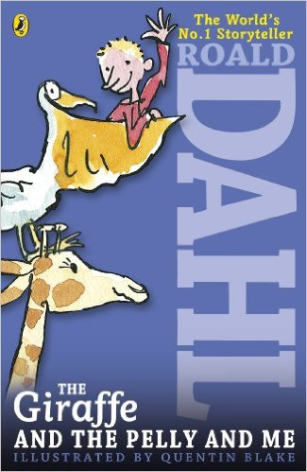 | 7+ | The Ladderless Window-Cleaning Company has just moved in to the old wooden house not far from where Billy lives. He'd rather have a wonderful sweet-shop, but when he meets the members of the Company - the Giraffe, the Pelican and the Monkey - he can't believe his eyes.
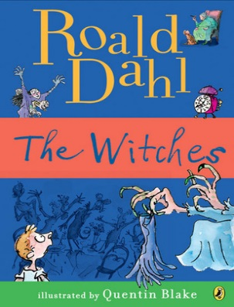 | 10+ | Real witches disguise themselves as lovely ladies, when secretly they want to squish and squelch all the wretched children they despise. The Grand High Witch of All the World is the worst of them all - and now she has gathered together all the witches of England for an annual conference at the Hotel Magnificent in Bournemouth to plot to eliminate all children. Luckily, one boy and his grandmother know how to recognise these vile creatures, and have a plan to get rid of them for good...  This deliciously dark offering from beloved children's author Roald Dahl is a firm favourite with young readers. Attracting some controversy in terms of its depictions of women, it nonetheless remains a brilliant blend of Dahl's trademark humour with the spine-tingling and scary.
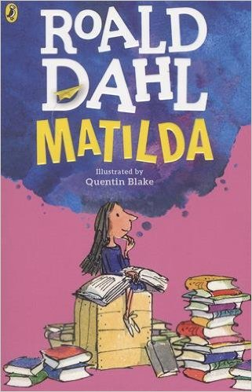 | 8+ | Matilda is not yet five years old, and already she is a very unusual child. Teaching herself to read, she works her way through all the books in the children's library and then gets started on the adult section, to the amazement of the librarian. Her narrow minded parents don't notice that they have a genius in their midst - but is soon becomes clear that underestimating Matilda is a big mistake.  When she starts school at Crunchem Hall, Matilda meets the frightening and bullying headmistress, Agatha Trunchbull, and witnesses her terrible temper. Soon, she puts her very special talents to work to get the better of Miss Trunchbull and the other unpleasant grown-ups around her - as well as to help warm-hearted class teacher Miss Honey.  This modern fairy-tale with a brilliantly inspiring young heroine is one of Roald Dahl's best loved stories. Full of magic and mischief, children will love witnessing Matilda pit her strength, courage and cool intelligence against the nasty and spiteful adults in her life, and ultimately coming out on top.
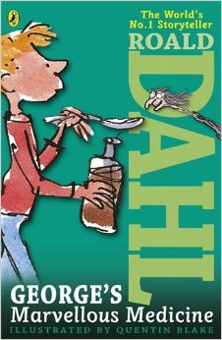 | 6+ | George's nasty old grandma needs teaching a lesson. George decides the best remedy for her grumpiness is a special home-made medicine. But Grandma gets more than she bargained for!  In George's Marvellous Medicine, published in 1981, George Kranky's Grandma may not anticipate the results of the medicine fed to her by her grandson, but like George, Roald Dahl also had fun mixing marvellous concoctions. He called them witches potions and delivered them to his children just before bedtime. They included ingredients like tinned peaches blended with milk and either pink, blue or green food colouring. His were put together carefully, though - none of the nasty side effects George's Grandma experienced..
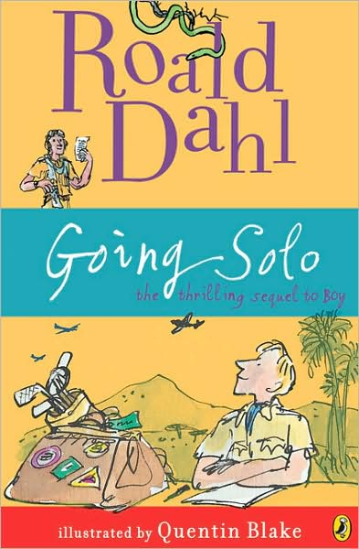 | 8+ | Going Solo tells of how, when he grew up, Roald Dahl left England for Africa - and a series of daring and dangerous adventures began...  Continuing from where he left off at the end of Boy: Tales of Childhood, Going Solo focuses on Roald's adult life before he began his career as a writer. From plane crashes to snake bites, it takes us through some of the amazing things he experienced while living in Africa, to his time as an RAF pilot during the Second World War.
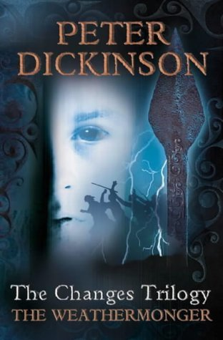 | 10+ | England in the future – but an England that is less rather than more civilised. This is the time of The Changes – a time when people, especially adults, have grown to hate machines and returned to a more primitive lifestyle. It is a time of hardship and fear…  When 16-year-old Geoffrey, a “weathermonger” starts to repair his uncle’s motorboat, he and his sister Sally are condemned as witches. Fleeing for their lives, they travel to France – where they discover that everything is normal. Returning to England, they set out to discover why the country is under this mysterious spell. Only discovering the origin of the deadly magic will allow them to set the people free of its destructive influence.
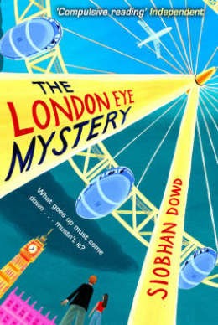 | 9+ | Ted likes the weather, he also likes statistics and routine but his life is thrown into disarray when his Aunt Gloria and cousin Salim arrive, like a hurricane, to stay in London en-route to a new life in New York.  Ted and his older sister Kat arrange to take Salim on the London Eye but although they watch him go up in a pod, he never comes down again. Salim is missing. Ted's analytical mind becomes an asset as he and Kat piece together the information surrounding their cousin's disappearance and begin to unravel the mystery.  Ted is an endearing character and the focus of the story is on the solving of a mystery rather than his Asperger's syndrome. This is a beautifully written and engaging book.
E
F
 | 8+ | First published in 1941, Walter Farley’s best-selling novel for young readers is the triumphant tale of a boy and a wild horse. From Alec Ramsay and the Black’s first meeting on an ill-fated ship to their adventures on a desert island and their eventual rescue, this beloved story will hold the rapt attention of readers new and old.
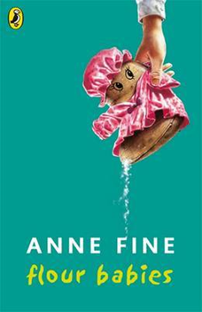 | 9+ | As part of a Child Development project, each boy in Class 4C is given a 'flour baby', a sack of flour which must be looked after for three weeks, ensuring it does not get lost or dirty. Simon becomes unusually attached to his flour baby - and soon begins to appreciate some of the sacrifices his mother has made for him as a single parent.  This funny story from former Children's Laureate Anne Fine is an established favourite of classrooms and homes everywhere. Thought-provoking and unusual, it cleverly balances episodes of laugh-out-loud humour with some very touching moments.
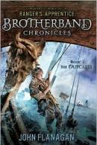 | 10+ | They are outcasts. Hal, Stig, and the others – they are the boys the others want no part of. Skandians, as any reader of Ranger’s Apprentice could tell you, are known for their size and strength. Not these boys. Yet that doesn’t mean they don’t have skills. And courage – which they will need every ounce of to do battle at sea against the other bands, the Wolves and the Sharks, in the ultimate race. The icy waters make for a treacherous playing field . . . especially when not everyone thinks of it as playing.
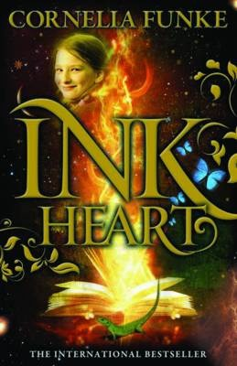 | 9+ | Cornelia Funke's magical fantasy adventure more than fulfils the promise of its prize-winning predecessor, The Thief Lord.  12-year-old Meggie and her father, Mo, a bookbinder, both love reading, but since the mysterious disappearance of Meggie's mother, they no longer read together.  One night a stranger knocks at their door, prompting Mo to reveal his awful secret: he has the ability to breathe life into stories and literally bring their characters alive. Years ago, he accidentally conjured up a terrible villain called Inkheart, who now threatens to destroy him.  Only Meggie can find a way to change the course of the story and save the father she loves, but can she do so in time?  This brilliantly told and gripping tale is part of a best-selling series.
G
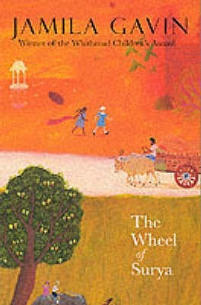 | 11+ | A brother and sister's epic journey to independence spans India and England in war and peace.  India, August 1947: Fleeing from their burnt-out village as civil war rages in the Punjab, Marvinder and Jaspal are separated from their mother, Jhoti. Marvinder has already saved her brother's life once, but now they both face a daily fight for survival.  Together they escape across India and nearly halfway around the world to England, to find a father they hardly know in a new, hostile culture...  This book was runner-up for the Guardian Children's Fiction Award.  First book in the Surya Triology
 | 10+ | Felix has lived in a Catholic orphanage for over three years but always hopes that his Jewish bookseller parents to come for him. Alarmed by the sight of what he assumes are official 'librarians' burning Jewish books in the orphanage, he sets off in search of his parents to warn them of the danger.  On his travels Felix uses his natural optimism and storytelling gift to explain away the horrific events he witnesses in Nazi-occupied Poland. His stories bring hope to the children of a ghetto and ultimately comfort to them on their final train journey.  Morris Gleitzman brings heart and humour to the difficult subject of the Holocaust in this ground-breaking children's book. Told in simple yet powerful language, his story reveals the redemptive power of stories and the potential for humanity and hope even in the most tragic times.
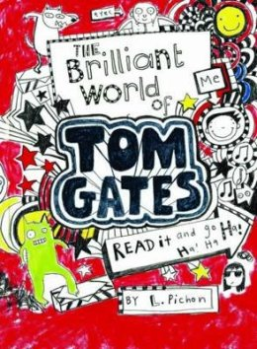 | 9+ | The hilarious homework diary of Tom Gates charts his progress through the trials and tribulations of school and home life, including a disastrous camping trip, his vexed relationship with nosey teacher Mr Fullerman and that perennial domestic trial - parents’ evening. Luckilly Tom’s appetite for humour means he can take such trials in his stride and mine them for comic potential. They also inspire some brilliant cartoons for the reader enjoy.  Tom scribbles the world from his point of view, each page is an explosion of hand-written rants, funny stories and dynamic cartoons. 'All I want to do is get tickets to see the best band ever, DUDE3, when they come to town. It’s not easy when I’m up against Delia, my weirdo big sister, and all my plans seem to get me into MAJOR TROUBLE…' This book oozes personality and with so much going on it promises to maintain the attention of young readers for hours at a time.
H
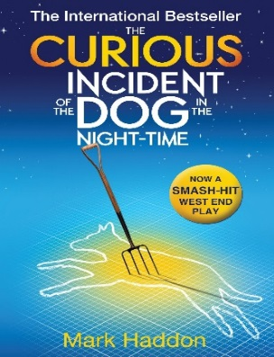 | 12+ | Seen through the eyes of Christopher, a mathematical genius and Sherlock Holmes fan, who also has Asperger's syndrome, this bestselling novel opens with the discovery of a murdered dog on the neighbour's lawn.  In his search to discover the identity of the killer, Christopher uncovers some disturbing information about his own family, which throws his ordered world into chaos, and he embarks on a journey to London to find the mother he thought was dead.  This funny, touching and compelling novel was the winner of the inaugural Booktrust Teenage Prize. A must-read for adults and children alike, it is an adventure story unlike any other
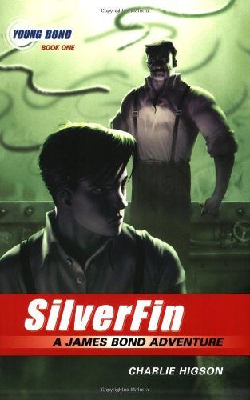 | 9+ | Meet Bond. James Bond. But not as you will have seen him before... James is a recently orphaned boy starting his first term at Eton. He is popular and adept at school but his only stumbling block is the bully George Hellebore, son of the boorish Lord Hellebore.  When James goes to stay in rural Scotland with his Aunt and Uncle, he befriends ‘Red’ Kelly, who is in Scotland to investigate the mysterious disappearance of his young cousin, last seen fishing in Lord Hellebore’s nearby estate.  James sets out on a path of investigation which soon leads him to Hellebore’s castle and the terrifying experiments happening within…  This book weaves a fascinating back history for the world’s most famous spy and contains plot twists and action that will delight boys and girls too.
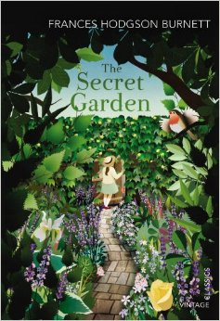 | 9+ | When the spoilt and bad-tempered Mary is orphaned at the age of ten, she is sent from India to live with her hunchback uncle on the Yorkshire Moors. At first, she is utterly miserable, but gradually the frienship of her maid and the discovery of a secret garden in the grounds of the house begin to change her.  Then she finds another secret in the house - Colin, her sickly cousin, who is as self-centred and disagreeable as herself. This classic novel is a satisfying and absorbing read, and demonstrates the resilience of children even when they are surrounded by uncaring and flawed adults.
 | 12+ | Fourteen-year-old Alex Rider finds his life turned upside down on discovering that his late uncle wasn't a mild-mannered banker, but instead a field agent for MI6. Soon, Alex himself is dragged into the world of espionage and intrigue.  This well-written and action-packed story is the first in the bestselling Alex Rider series about a daring teenage spy. Cleverly plotted and full of excitement, the combination of spy gadgets and undercover escapades will ensure this story is completely irresistible to young fans of action and adventure.
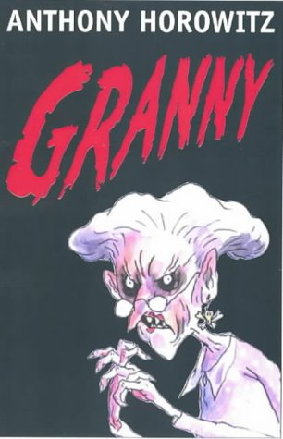 | 9+ | Twelve-year-old Joe Warden isn’t happy. Sure, he’s rich, but his parents don’t care about him. His grandmother should make everything better, except that Joe’s granny is a nightmare. She’s not just physically repulsive, she’s horribly mean. Everyone thinks she’s just a dotty old woman, but Joe knows the truth. He’s seen behind her mask and glimpsed the wicked glimmer in her eyes—she is pure evil. And now she’s out to get Joe, unless he can stop her and her band of nasty grannies first.
 | 10+ | MI6 assigns Alex Rider, 14, undercover at an elite prep school for teen rebels after two fathers are assassinated. Principal Dr Grief and vicious cigar-smoking Mrs Stellenbosch are the only teachers. All the students act studious, perfect - and identical. When Alex finds the plot, the villains find him, and the mountain peak has only a black ski run escape.
I
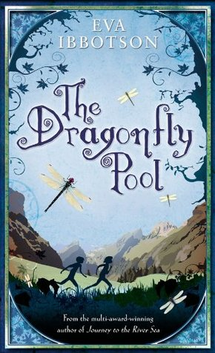 | 9+ | Tally Hamilton is furious to hear she is being sent from London to a horrid, stuffy boarding school in the countryside. And all because of the stupid war. But Delderton Hall is a far more" "unusual and " interesting" place than Tally ever imagined, and she soon falls in love with its eccentric staff and pupils. Now she's even organizing an exciting school trip to the kingdom of Bergania . . . although Tally never expected to meet the "prince."  Prince Karil hates his life at the palace and he is only truly happy when he escapes to the dragonfly pool, a remote spot in the forests of Bergania. Then Karil meets a feisty English girl who brings the promise of adventure. But his country is under threat, and the prince soon looks to his new friend Tally for survival as well as friendship . . .
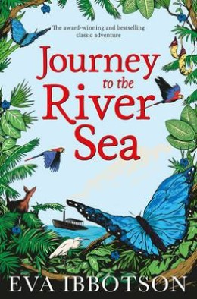 | 9+ | This satisfyingly old-fashioned story is set in the early 1900s. Orphan Maia is thrilled to learn she is to live with relatives in South America. She cannot wait to experience the sights, sounds and smells of the Amazon and is particularly looking forward to meeting her twin cousins.  When Maia arrives, however, the family is far from welcoming and she is saddened to see that they have blocked out all evidence of the rainforest from their stuffy home. Maia turns to her strict yet kindly governess, Miss Minton, for company, and strikes up some unusual and rewarding friendships.  This enchanting story has all the trademarks of Eva Ibbotson's writing. Maia is a wonderful heroine, and Ibbotson weaves a charming, compelling and warm-hearted tale of friendship, our responsibility to those around us, and the importance of the natural world. As well as being an exciting adventure story, this award-winning contemporary classic will leave readers with plenty to think about.
J
K
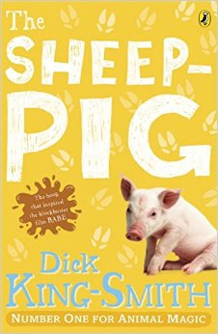 | 7+ | When Farmer Hogget wins a piglet at the fair, he is amazed that Fly, his sheep-dog, welcomes him as one of her own pups. Fly names the piglet Babe and teaches him all he needs to know about the farm and its animals.  As he watches his 'mum' round up the sheep, he decides he would love to try too. However, his legs are too short and he is far too plump to run around after a flock of sheep. He then tries a different tactic; politely asking the sheep to form an orderly line! The sheep are so surprised to be treated with respect that they happily oblige and Farmer Hogget soon notices that Babe has a certain knack with them...  One of Dick King-Smith's best-loved tales, this wonderful book is full of gentle humour. The short chapters make it ideal for early confident readers, and it will be especially adored by young animal lovers.
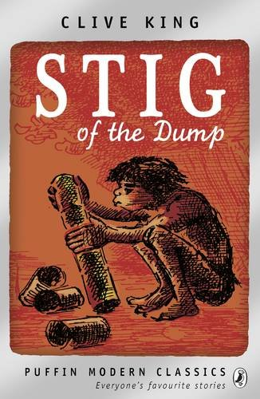 | 8+ | Barney is a solitary little boy who often wanders off by himself in the countryside. Exploring an old chalk pit, he finds himself in a cave where he meets a strange boy who wears a rabbit skin and speaks in grunts. His grandparents don't believe Barney when he tells them about his new cave boy friend - but nevertheless, the two enjoy plenty of fun together.  This lovely story about the unlikely friendship between Barney and stone-age Stig has stood the test of time. Although it is now over 50 years old, contemporary children will love reading about the pair's lively adventures. Clive Kings' story is perfectly accompanied by Edward Ardizzone's classic illustrations.
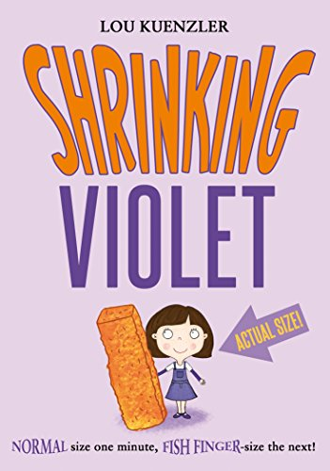 | 9+ | It's the BIGGEST day in Violet's life. She is finally TALL enough to ride Plunger, the scariest rollercoaster around. But just as Violet is about to climb on, she shrinks! She never wants to shrink again... But then Granny is accused of stealing, and tiny Violet is the only one who can catch the thief.
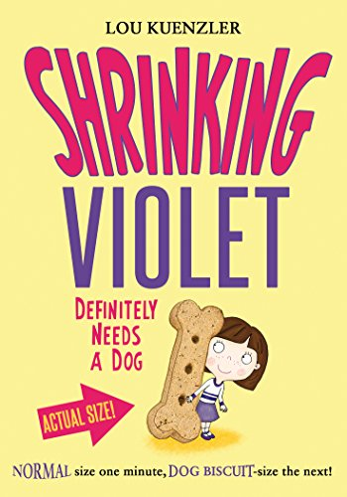 |  | Violet is desperate for a dog, but she's not allowed one. Luckily there's a dog walking scheme that she and her friend Nisha can join. The girls love playing with their designated puppy. Until Violet shrinks to the size of a dog biscuit! But then disaster strikes at the dog show, and Violet discovers her small size might win her a prize...
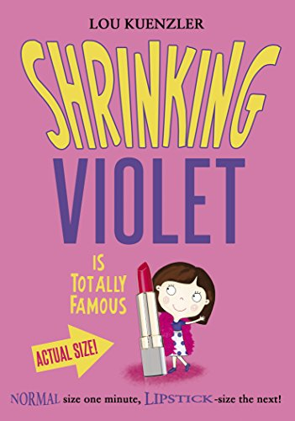 | 9+ | The third book in this hilarious new series - with lovely illustrations throughout. Violet loves the milkshakes at Udderly Perfect, the coolest cafe around. But Udderly Perfect is threatened with closure, all because of a mistake Violet made. She must find a way to keep it open. Perhaps she can persuade her favourite celebrity stunt woman, Stella Lightfoot, to join the campaign when she comes to town on a book tour? But when Violet shrinks and ends up in Stella's luggage on location, she finds out that her idol is not who she thinks she is. Shrunken Violet might just be the only one who can save Stella's reputation ... and in turn, Stella might be willing to help save Udderly Perfect, too.
L
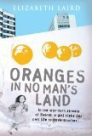 | 11+ | Oranges in No Man's Land tells the riveting story of ten-year-old Ayesha's terrifying journey across no man's land to reach a doctor in hostile territory in search of medicine for her dying grandmother.  Set in Lebanon during the civil war, this story is told by award-winning author Elizabeth Laird and is based on personal, real-life events. Elizabeth stayed on the green line in Beirut in 1977 in a war-damaged flat with her husband and six-month-old son. Memories of her son sleeping in a suitcase on the floor, taking his first steps on the bullet-riddled balcony, playing with the soldiers on the checkpoint, and her husband racing through no man's land in the buildup to a battle have all inspired this gripping and moving story.
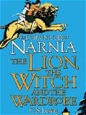 | 8+ | When the Pevensie children - Peter, Susan, Edmund and Lucy - step through a wardrobe door in the strange country house where they are staying, they find themselves in the land of Narnia. Frozen in eternal winter, Narnia is a land of snow and pine forests, and its creatures are enslaved by the terrible White Witch.  Tempted by the promise of endless Turkish Delight, Edmund becomes the White Witch's servant - and its up to his brother and sisters to release him from his enchantment and to rid Narnia of the witch. But just when it seems that all hope is lost, the Great Lion Aslan returns to help the children to save Narnia.  This classic story is certain to capture young imaginations, cleverly blending elements of fairy-tale and fantasy to create a wonderfully engaging adventure. Adult readers will be quick to spot the Christian symbolism woven through C S Lewis's story, which some critics have found problematic - but children will enjoy the magic of this spellbinding adventure in its own right.
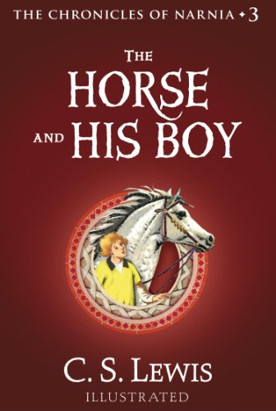 | 8+ | Narnia . . . where horses talk . . . where treachery is brewing . . . where destiny awaits.  On a desperate journey, two runaways meet and join forces. Though they are only looking to escape their harsh and narrow lives, they soon find themselves at the center of a terrible battle. It is a battle that will decide their fate and the fate of Narnia itself.  The Horse and His Boy is the third book in C.S. Lewis’s The Chronicles of Narnia a series that has become part of the canon of classic literature, drawing readers of all ages into a magical land with unforgettable characters for over fifty years. This is a novel that stands on its own, but if you would like to return to Narnia, read Prince Caspian, the fourth book in The Chronicles of Narnia.
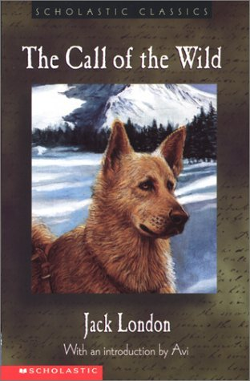 | 9+ | Follow a dog named Buck through violence and hardship, loyalty and loss, finally finding himself and his home in the Yukon wilderness. Truly a must-have for London fans, book lovers, and adventurers.
M
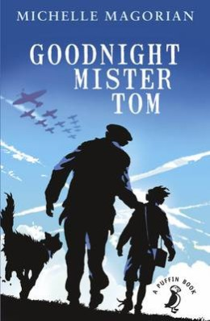 | 9+ | Willie Beech is evacuated to a tiny English village in the country just before the outbreak of World War II. A lonely and deprived child, he finds himself living with the reclusive, gruff old widower, Thomas Oakley. Although the two find it hard to adjust to their life together at first, they gradually develop a strong, mutual bond. Willie begins to enjoy life and make new friends in the village.  However, everything is thrown into confusion when Willie is suddenly recalled to London by his neglectful and abusive mother. After several weeks with no letter from Willie, Tom Oakley becomes concerned for his welfare and sets out to London in search of him.  Michelle Magorian's classic wartime story is a superbly written and deeply moving tale, which shows that even the most unlikely people can become exceptional parents.
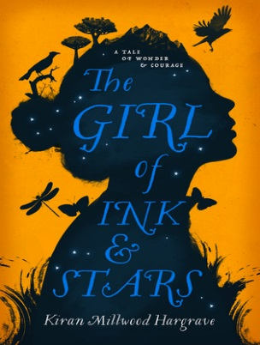 | 9+ | Forbidden to leave her island, Isabella Riosse dreams of the faraway lands her father once mapped.  When her closest friend disappears into the island’s Forgotten Territories, she volunteers to guide the search. As a cartographer’s daughter, she’s equipped with elaborate ink maps and knowledge of the stars, and is eager to navigate the island’s forgotten heart.  But the world beyond the walls is a monster-filled wasteland – and beneath the dry rivers and smoking mountains, a legendary fire demon is stirring from its sleep. Soon, following her map, her heart and an ancient myth, Isabella discovers the true end of her journey: to save the island itself.
 | 9+ | Set during World War I, Private Peaceful charts eight hours in the life of Tommo, a young soldier at the Front, as he looks back over the formative events of his life: his father’s early death, his relationship with his loving mother and brothers, Big Joe and Charlie, and their beloved schoolfriend Molly – all set among an evocative and beautifully realised rural landscape.  Passionate, beguiling and moving, this award-winning story is also an unflinching examination of the horrors of war and the injustice surrounding the execution of soldiers by firing squad, on the – often false – grounds of desertion or cowardice. Former Children's Laureate Michael Morpurgo uses all his superb storytelling skills to weave this powerful, poignant tale of the horrors of World War I, which will touch readers of all ages
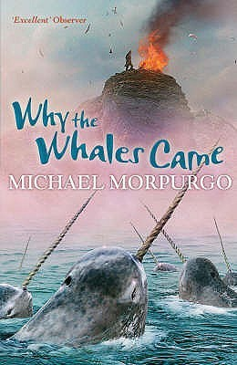 | 9+ | The Birdman puts spells on people. We mustn’t talk to him. We’re not supposed to.  Gracie and Daniel have been warned to stay away from the mad Birdman - but the message in the sand tells them that the Birdman isn't what he seems.  Then they get lost in the fog and stranded on Samson Island. Should they believe the Birdman's story that the island is cursed?
 |  | Life on the Scilly Isles in 1907 is bleak and full of hardship. Laura's twin brother, Billy, disappears and then a storm devastates everything. It seems there is little hope... that is until the sailing ship the Zanzibar is wrecked on the island’s rocks and everything changes...
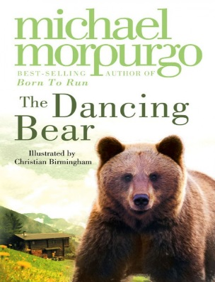 | 7+ | High in the mountains, in a tiny village, an abandoned bear cub is adopted by a lonely orphan child. Soon they are the best of friends, beloved by the whole village – safe, until the arrival of a glamorous film crew who need a dancing bear…
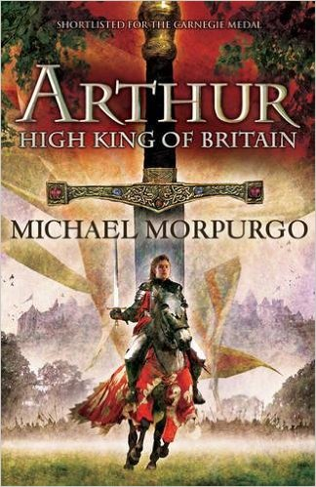 | 9+ | Marooned on a sandbank, the boy faces certain death. With the sea closing in and the current about to drag him to a watery grave, his final wish is to see heaven. But, waking in a strange bed, the boy meets an old man sitting by the fire with his dog. It is Arthur, the great warrior king of legend, who tells the boy of Camelot, magic, evil and betrayal.
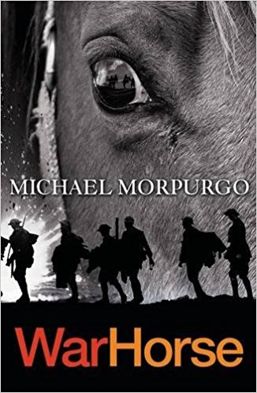 |  | In the deadly chaos of the First World War, one horse witnesses the reality of battle from both sides of the trenches. Bombarded by artillery, with bullets knocking riders from his back, Joey tells a powerful story of the truest friendships surviving in terrible times. One horse has the seen the best and the worst of humanity. The power of war and the beauty of peace. This is his story.
N
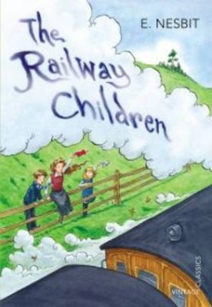 | 9+ | This story centres on the lives of three children whose comfortable, middle-class existence ends when their father has to go away unexpectedly.  Roberta, Peter and Phyllis leave their London home and move with their mother to a small cottage in the country where life is very different. With their mother now busy writing to earn money, the railway becomes a source of fascination and solace to the children.  They make friends with Perks the Porter and the station master, and discover new and exciting things about the trains. However, mystery remains - where is their father? Then the terrible truth is discovered.  This charming story deals sensitively with the subject of an absent parent, and the challenges of living in changing circumstances.
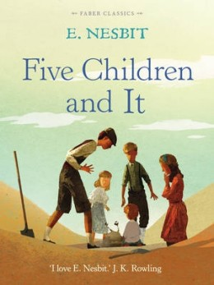 | 9+ | When five siblings - Cyril, Anthea, Robert, Jane and their baby brother, the Lamb - discover a sand-fairy in their gravel pit, they are jolly surprised and a little delighted. Even better, the Psammead is able to grant them wishes, although the magic wears off at the day's end. Unfortunately, all of the wishes the children make go hilariously wrong and they soon learn that their foolish desires are more likely to get them into trouble than get them what they want!
 |  | The Phoenix and the Carpet is a fantasy novel for children, written by E. Nesbit and first published in 1904. It is the second in a trilogy of novels that begins with Five Children and It (1902), and follows the adventures of the same five children: Cyril, Anthea, Robert, Jane and the Lamb. Their mother buys the children a new carpet to replace one from the nursery that they have destroyed in an accidental fire. The children find an egg in the carpet, which hatches into a talking Phoenix. The Phoenix explains that the carpet is a magic one that will grant them three wishes a day. The five children go on many adventures, which eventually wears out their magic carpet.
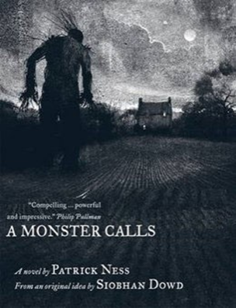 | 10+ | Connor's mum has cancer and life is irrevocably, disturbingly changing. First there is the nightmare, filled with screaming and falling; then there is school, where people avoid him (not knowing what to say), or persecute him.  There is his enforced, combative intimacy with his distant, spiky gran. And then there is the Monster, immense, tree-like, mythic.  He comes at night, makes Connor listen to un-story-like stories, pushes him to the edge of what is bearable - because 'you know that your truth, the one that you hide, Connor O'Malley, is the thing you are most afraid of'.  Visceral, dark, sad, beautiful, hopeful and really, really angry, this is a beautifully structured, dense, layered novel about the monster that touches us all at some point. This extraordinary book was the first ever to win both the CILIP Carnegie and the CILIP Kate Greenaway Medals.
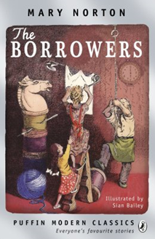 | 9+ | The Borrowers are tiny people who live in the secret places of old houses - behind the mantlepiece, inside the harpsichord, under the kitchen clock. They borrow everything from humans, existing on the scraps they collect from the homes they live in.  Arriety Clock's father, Pod, is an expert borrower, able to scale curtains using a hatpin, and bring back a doll's teacup without breaking it. Girls aren't usually supposed to go borrowing, but Pod makes an exception for Arrietty, who can't wait to explore the house and gardens that lie beyond her cramped home. But when she is at last allowed to accompany Pod on one of his borrowing expeditions, something terrible happens - she is 'seen' by a human boy.  This beautifully-written story will enchant young readers, who will love the idea of the Borrower's hidden 'wainscot world'. Exciting, mysterious and with a hint of sadness, it has a deserving reputation as a classic of twentieth century children's literature.
O
P
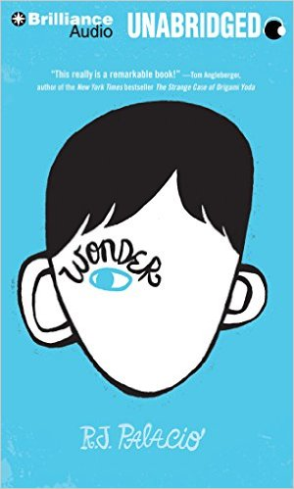 | 10+ | August Pullman was born with a facial difference that, up until now, has prevented him from going to a mainstream school. Starting 5th grade at Beecher Prep, he wants nothing more than to be treated as an ordinary kid--but his new classmates can't get past Auggie's extraordinary face. Wonder, a #1 New York Times bestseller, begins from Auggie's point of view, but soon switches to include his classmates, his sister, her boyfriend, and others. These perspectives converge in a portrait of one community's struggle with empathy, compassion, and acceptance.  In a world where bullying among young people is an epidemic, this is a refreshing new narrative full of heart and hope. R.J. Palacio has called her debut novel "a meditation on kindness" --indeed, every reader will come away with a greater appreciation for the simple courage of friendship. Auggie is a hero to root for, who proves that you can't blend in when you were born to stand out.
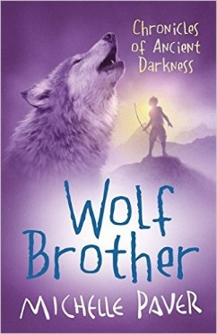 | 9+ | Thousands of years ago, the land is a dark forest, peopled by hunter-gatherers who know every tree and herb. Then a dark, malevolent force conjures a demon contained in the body of a ferocious bear that will slay everything it sees - a demon determined to destroy the world.  Twelve-year-old Torak sees his father murdered by the bear. With his dying breath, Torak's father tells his son that he is the only one who can stop it - he must lead the bear to the mountain of the World Spirit, and beg the spirit's help to overcome it. But Torak does not want to be a hero - frightened and alone, he must set out on a terrifying quest which will see him tricked and betrayed and every turn. Thankfully he has the company of a young wolf cub, whom he seems to understand better than any human.
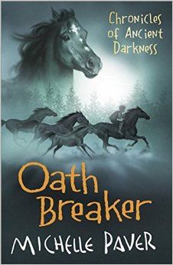 | 9+ | When he was outcast, Torak was the hunted one.  The following spring, he becomes the hunter when he swears to avenge the killing of one of his closest friends. To fulfil his oath he must brave the hidden valleys of the Deep Forest, where the clans have reverted to the savagery of an earlier time. Here, Torak finally learns why he is the Spirit Walker – and discovers the true cost of revenge…
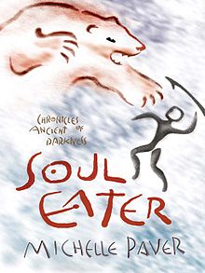 | 9+ | Thousands of years ago an orphan boy and his wolf cub companion challenge a demon bear that threatens to destroy their world forever. With the help of the World Spirit, Torak destroys the bear, but his beloved Wolf is lost in the ensuing avalanche.  And Torak's quest is far from over. A strange, creeping sickness, silent and deadly, is threatening the Ravens, whose leader Finn Kedinn has told Torak something of his history. Word arrives that the Seal Clan have the cure and Torak must face a lonely journey across treacherous terrain alive with menace and danger to find it. He must search for the rare herb which is part of the cure and find it by Midsummer. On the Seal's Island he stumbles into a world utterly unlike his own. And here Torak is welcomed by the kindly Seal Mage, Teneris, and kinsman, Bale. But all is not as it seems, Torak must keep his wits about him to judge who might be friend or foe, to face the dark art of the Soul Eaters, who haunt him even in his dreams, and to master his fears.
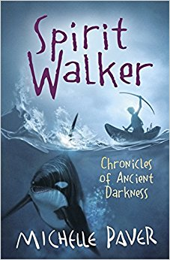 | 9+ | Thousands of years ago an orphan boy and his wolf cub companion challenge a demon bear that threatens to destroy their world forever. With the help of the World Spirit, Torak destroys the bear, but his beloved Wolf is lost in the ensuing avalanche.  And Torak's quest is far from over. A strange, creeping sickness, silent and deadly, is threatening the Ravens. Word arrives that the Seal Clan have the cure and Torak must face a lonely journey to find it. On the Seal's Island he stumbles into a world utterly unlike his own. Here life moves to the rhythms of the sea, the Seals build shelters from whale bones and skim the waves in fast, beautiful kayaks. And here Torak is welcomed by the kindly Seal Mage, Teneris, and kinsman, Bale. But all is not as it seems - Torak must keep his wits about him to judge who might be friend or foe.  As in 'Wolf Brother' Michelle Paver's sheer passion for her story set in a world of myth and natural magic, shines through in this skilfully woven, exciting and brilliantly satisfying second instalment of the Chronicles of Ancient Darkness.
 | 9+ | In this excellent football story, set in modern-day South America, a hackneyed football reporter sits down with El Gato (the Cat), a World Cup-winning goalkeeper, to look back on his amazing life and career.  The story begins in a jungle near El Gato's home town and tells of his tough early training with a mysterious former goalie on a ghostly, perfectly-cut pitch, surrounded by trees. As well as charting El Gato's meteoric rise to fame, Keeper also has plenty of football action to keep enthusiasts happy.  This title was shortlisted for the 2004 Nestle Smarties Book Prize (age nine to eleven category).
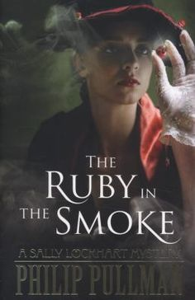 | 11+ | After the sudden death of her father, Sally Lockhart is forced to go to live in London with an obnoxious cousin. There, she receives an anonymous letter containing a warning so dire that it makes a man die of fear at her feet. Determined to discover the truth about what happened to her father, Sally is soon plunged into a dangerous and terrifying adventure that takes her to the dark heart of Victorian London.  Inspired by the tradition of the Victorian melodrama, Philip Pullman's first Sally Lockhart story is a cracking adventure. Cleverly-plotted, bristling with excitement and brilliantly gripping, it also provides an intriguing insight into the injustice and inequality of Victorian society, making it rich and fascinating reading for older children, teenagers and adults.
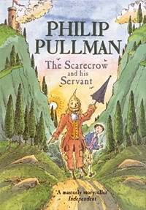 | 8+ | Struck by a sudden bolt of lightining, Scarecrow comes alive. A young boy called Jack hears the Scarecrow's call for help and, overcoming his initial shock, is persuaded to become his servant. The latest in a long line of literary masters and servants, Jack and Scarecrow are strongly reminiscent of Don Quixote and his servant Sancho Panza in Cervantes' timeless classic, as they too set off on a series of madcap adventures - some funny, others dangerous and exciting - often saved only by Jack's endless resourcefulness.  Set in Italy, this fairytale adventure is perfectly complemented by Peter Bailey’s atmospheric illustrations, which give life and shape to the characters and touchingly depict the story's climax.
 | 10+ | Lyra and her animal daemon live a carefree life amongst the scholars of Jordan College, Oxford. Yet the destiny that awaits her will take her far from her home, to the magical frozen lands of the Arctic, amongst the witch-clans and ice-bears. Here, she will discover the truth about her identity, which will have immeasurable consequences reaching beyond her own world.  This extraordinary fantasy is the first book in Philip Pullman's multi-award-winning His Dark Materialstrilogy. Exciting, original and enormously powerful it is an incredible feat of imagination, and one of the classics of 20th century children's literature.
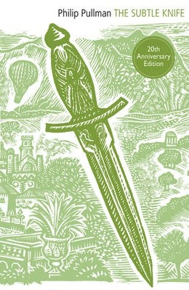 | 10+ | On the run with a man's murder on his conscience, 12-year-old Will stumbles upon Cittagazze, a mysterious parallel world where he meets the savage young girl, Lyra. Their two seemingly separate missions lead them on a dangerous and compelling fantasy adventure.  This gripping, atmospheric tale - the second book in the His Dark Materials trilogy - is hard to put down.
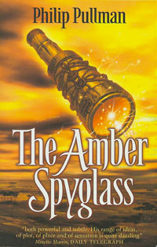 | 10+ | Lyra and Will, the two ordinary children whose extraordinary adventures began in The Golden Compass and continued in The Subtle Knife, are in unspeakable danger. With help from the armored bear Iorek Byrnison and two tiny Gallivespian spies, they must journey to a gray-lit world where no living soul has ever gone. All the while, Dr. Mary Malone builds a maagnificent amber spyglass. An assassin hunts her down. And Lord Asriel, with troops of shining angels, fights his mighty rebellion, a battle of strange allies—and shocking sacrifices.  As war rages and Dust drains from the sky, the fate of the living—and the dead—finally comes to depend on two children and the simple truth of one simple story.
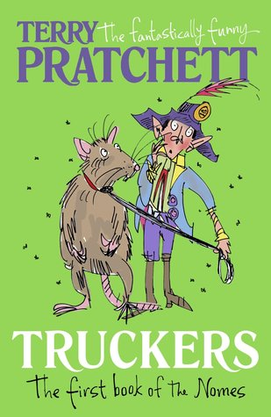 | 9+ | Outside! What's it like?' Masklin looked blank. 'Well,' he said. 'It's sort of big-'  To the thousands of the tiny nomes who live under the floorboards of a large department store, there is no Outside. Things like Day and Night, Sun and Rain are just daft old legends. Then a devastating piece of news shatters their existence: the Store - their whole world - is to be demolished. And it's up to Maskin, one of the last nomes to come into the Store, to mastermind an unbelievable escape plan that will take all the nomes into the dangers of the great Outside...  The first title in the Bromeliad trilogy, this is a funny and enchanting fantasy from favourite author Terry Pratchett. Young readers will be captivated by the world of the nomes and eager to follow their adventures after they leave their underground home in the sequels Diggers and Wings.
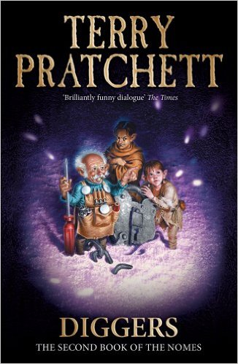 | 9+ | 'And Grimma said, We have two choices.  We can run, or we hide.  And they said, Which shall we do?  She said, We shall Fight.'  A Bright New Dawn is just around the corner for thousands of tiny nomes when they move into the ruined buildings of an abandoned quarry. Or is it?  Soon strange things start to happen. Like the tops of puddles growing hard and cold, and the water coming down from the sky in frozen bits. Then humans appear and they really mess everything up. The quarry is to be re-opened, and the nomes must fight to defend their new home. But how long will they be able to keep the humans at bay - even with the help of the monster Jekub?  Diggers is the second title in a hugely inventive and hilarious fantasy trilogy about the nomes, a race of little people in a world of humans.
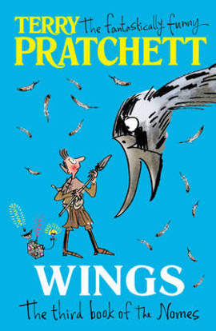 | 10+ | Somewhere out there, the ship is waiting to take them home . . . Here's what Masklin has to do: Find Grandson Richard Arnold (a human!). Get from England to Florida (possibly steal jet plane for this purpose, as that can't be harder than stealing the truck). Find a way to the "launch" of a "communications satellite" (whatever those are). Then get the Thing into the sky so that it can call the Ship to take the nomes back to where they came from.  It's an impossible plan. But he doesn't know that, so he tries to do it anyway. Because everyone back at the quarry is depending on him -- and because the future of nomekind may be at stake.
Q
R
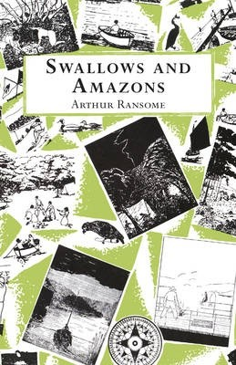 | 8+ | It's the summer holidays, and the Walker children - otherwise known as Captain John, Mate Susan, Able-Seaman Titty and Ship's Boy Roger - are excited to set sail on their boat Swallow and camp on Wild Cat Island. Exploring their new territory, camping in the open skies, swimming in the lake and fishing for their dinner would be adventure enough - but then they meet two fierce Amazon pirates who challenge them to a war.  Arthur Ransome's classic Swallows and Amazons stories begin with this first book, a delightful evocation of a wonderful summer of adventure, discovery and friendship. Inspired by the author's own real-life sailing adventures in the Lake District as a child, this enchanting story is accompanied by Ransome's simple but characterful black and white illustrations.
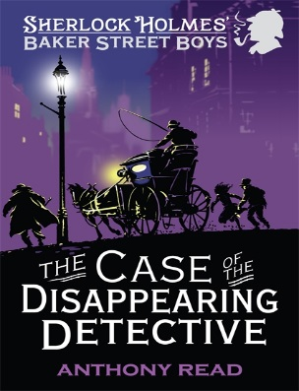 | 10+ | The first title in a thrilling, fast-paced adventure series about Sherlock Holmes's gang of street-urchin detectives.  It is 1897, Queen Victoria’s diamond jubilee year, and the Baker Street Boys are helping Sherlock Holmes to solve a case involving a mysterious American when Holmes himself disappears. Only the Boys realize that he hasn’t gone undercover but has actually been kidnapped by a Fenian gang from Boston who are planning to assassinate the Queen…
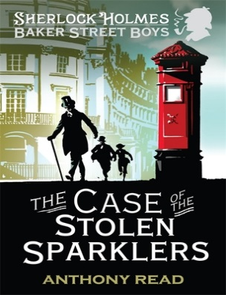 | 10+ | When Lady Mountjoy’s diamond tiara goes missing, Polly, one of the maids, is accused of the theft. But Polly didn’t do it. Discovered by the Baker Street Boys, out of a job and with nowhere to go, Polly begs them to help her – and so they find themselves with another mystery to solve. Wiggins hits upon a plan: why doesn’t Queenie apply for the newly vacated job, infiltrate the house and see what she can find out? It seems there are certainly things to be discovered: (1) Lady Mountjoy is broke and in desperate need of money, (2) she has a wastrel brother living with her as a hanger-on, (3) both of them know Professor Moriarty…
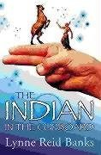 | 9+ | At first, Omri is unimpressed with the plastic Indian toy he is given for his birthday. But when he puts it in his old cupboard and turns the key, something extraordinary happens that will change Omri's life for ever.  For Little Bull, the Iroquois Indian brave, comes to life...
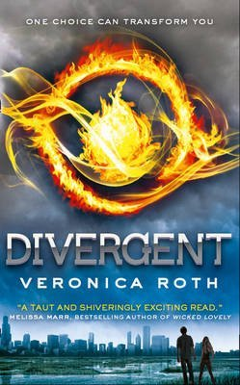 | 10+ | In the future there is no war. Humanity is divided up into factions, each serving others through knowledge, truth, selflessness, protection or peace. In this way man's natural war-like tendencies are addressed.  Tris does not fit into any faction, she is Divergent. Nevertheless she leaves the selflessness of her Abnegation faction and becomes a Dauntless - a fearless defender of the new order.  Man's lust for power and control will surface regardless, however. Tris uncovers plans for war. She must halt the conflict, save her family and find her place in the world.  Often violent and disturbing, the novel is concerned with becoming an individual, facing your fears and finding your place in the world - and there's a teenage romance too.
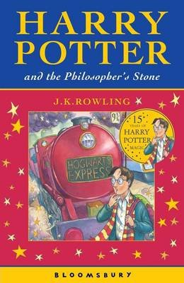 | 8+ | After the misery of life with his ghastly aunt and uncle, Harry Potter is delighted to have the chance to embark on an exciting new life at the Hogwart's School of Wizardry and Witchcraft. Learning about magic and making new friends, he has the chance to use his new-found wizarding skills to unravel some of the mysteries of his own past - and to uncover some shocking secrets about his teachers.  This brilliantly inventive, award-winning adventure story is the first in the phenomenally successful Harry Potter series. With shades of Diana Wynne Jones, Enid Blyton, Roald Dahl and Jill Murphy's The Worst Witch, this contemporary classic of children's literature is beloved by children and adults alike.
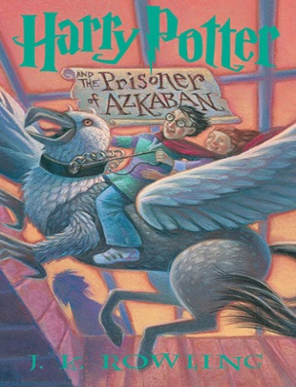 | 8+ | Harry Potter is lucky to reach the age of thirteen, since he has already survived the murderous attacks of the feared Dark Lord on more than one occasion. But his hopes for a quiet term concentrating on Quidditch are dashed when a maniacal mass-murderer escapes from Azkaban, pursued by the soul-sucking Dementors who guard the prison. It's assumed that Hogwarts is the safest place for Harry to be. But is it a coincidence that he can feel eyes watching him in the dark, and should he be taking Professor Trelawney's ghoulish predictions seriously?
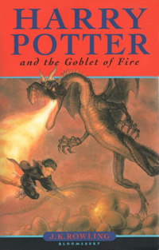 | 9+ | Harry Potter is midway through both his training as a wizard and his coming of age. Harry wants to get away from the pernicious Dursleys and go to the International Quidditch Cup with Hermione, Ron, and the Weasleys. He wants to dream about Cho Chang, his crush (and maybe do more than dream). He wants to find out about the mysterious event that supposed to take place at Hogwarts this year, an event involving two other rival schools of magic, and a competition that hasn't happened for hundreds of years. He wants to be a normal, fourteen-year-old wizard. But unfortunately for Harry Potter, he's not normal - even by wizarding standards.  And in his case, different can be deadly.
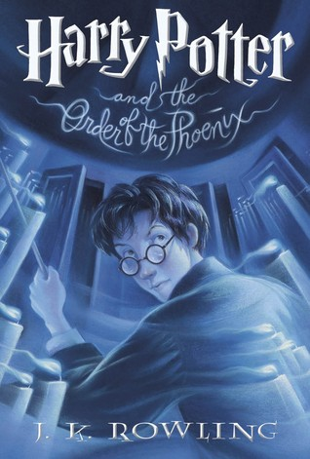 | 9+ | Harry Potter is due to start his fifth year at Hogwarts School of Witchcraft and Wizardry. His best friends Ron and Hermione have been very secretive all summer and he is desperate to get back to school and find out what has been going on. However, what Harry discovers is far more devastating than he could ever have expected...  Suspense, secrets and thrilling action from the pen of J.K. Rowling ensure an electrifying adventure that is impossible to put down.
 | 9+ | The war against Voldemort is not going well: even Muggle governments are noticing. Ron scans the obituary pages of The Daily Prophet looking for familiar names. Dumbledore is absent from Hogwarts for long stretches of time, and the Order of the Phoenix has already suffered losses. And yet... As in all wars, life goes on. Sixth-year students learn to Apparate, and lose a few eyebrows in the process. The Weasley twins expand their business. Teenagers flirt and fight and fall in love. Classes are never straightforward, though Harry receives some extraordinary help from the mysterious Half-Blood Prince. So it's the home front that takes center stage in the multilayered sixth installment of the story of Harry Potter. Harry struggles to uncover the identity of the Half-Blood Prince, the past owner of a potions textbook he now possesses that is filled with ingenious, potentially deadly, spells. But Harry's life is suddenly changed forever when someone close to him is heinously murdered right before his eyes. With Dumbledore's guidance, he seeks out the full, complex story of the boy who became Lord Voldemort, and thereby attempts to find what may be his only vulnerability.
 | 12+ | Fourteen-year-old Alex Rider finds his life turned upside down on discovering that his late uncle wasn't a mild-mannered banker, but instead a field agent for MI6. Soon, Alex himself is dragged into the world of espionage and intrigue.  This well-written and action-packed story is the first in the bestselling Alex Rider series about a daring teenage spy. Cleverly plotted and full of excitement, the combination of spy gadgets and undercover escapades will ensure this story is completely irresistible to young fans of action and adventure.
S
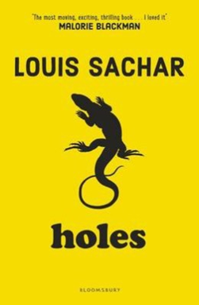 | 10+ | Stanley Yelnats' family has a history of bad luck, so he is not entirely surprised when a miscarriage of justice sends him to the Camp Green Lake Juvenile Detention Centre in the middle of the Texan desert. There is in fact no lake there at all and not much green either. Stanley soon discovers that his work at the camp will be to dig a deep hole each day, and to report back about anything he finds there. Stanley gets to work - but he soon discovers there's more to the task he's been given than merely an exercise in character-building.  This witty, inventive and utterly compelling novel from Louis Sacharis a must-read for children and adults too. A deft mixture of seriousness and humour, it is told in a direct, simple style that belies the clever construction of Sachar's powerful narrative.
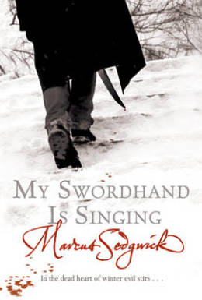 | 11+ | Woodcutters Peter and his father Tomas arrive in the lonely village of Chust.  Peter doesn't understand why his father carries a long wooden box around with him, or why he has dug a deep ditch around their hut. But he is increasingly aware of malevolence about the place. Menacing shadows, villagers missing and people murdered only to reappear.  With the help of Sofia, a travelling gypsy, Peter sets out to conquer the evil threat to the village and uncover the secrets of his father's past. Set in the seventeenth century amid the bleakness of winter in Eastern Europe, and inspired by vampire folklore, this is a superbly crafted, dark and menacing tale.  A sense of hardship, bitter cold and fear penetrates the text, resulting in a chilling page-turner.
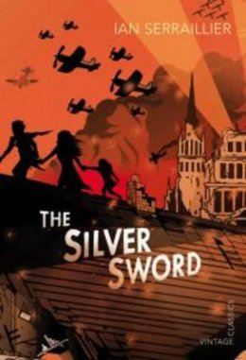 | 9+ | In the chaos of World War II, Ruth, Edek and Bronia are separated from their parents, and left alone to fend for themselves, hiding from the Nazis in the ruins of their city. But when they meet orphan Jan, who treasures a paperknife in the shape of a silver sword that he was given by an escaped prisoner of war, it becomes a powerful symbol of hope. The children realise that the escapee was their father, and the silver sword a message that he is alive and searching for them. Together with Jan they begin a dangerous journey across Europe to the safety of Switzerland where they hope to reunite with their parents.  This story of a courageous group of Polish children whose lives are torn apart by war is a true modern classic. Ian Serralier's moving account of the hardships the children and endure, and the self-knowledge and maturity they gain through their ordeal will speak to young readers as powerfully now as it did on its publication in 1956.
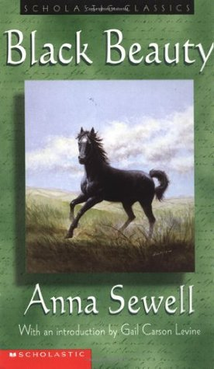 | 9+ | Black Beauty tells the story of the horse's own long and varied life, from a well-born colt in a pleasant meadow to an elegant carriage horse for a gentleman to a painfully overworked cab horse.  Throughout, Sewell rails - in a gentle, 19th-century way - against animal maltreatment. Young readers will follow Black Beauty's fortunes, good and bad, with gentle masters as well as cruel. Children can easily make the leap from horse-human relationships to human-human relationships, and begin to understand how their own consideration of others may be a benefit to all.
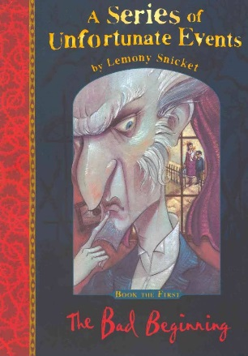 | 11+ | A Series of Unfortunate Events is a series of thirteen children's novels by Lemony Snicket (the pen name of American author Daniel Handler), which follows the turbulent lives of Violet, Klaus, and Sunny Baudelaire after their parents' death in a fire.
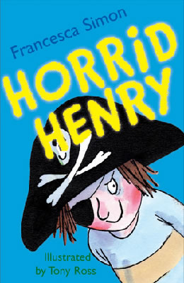 | 6+ | Stories about naughty characters have been told for centuries, and Horrid Henry is a modern-day rogue in the tradition of Dennis the Menace, Pippi Longstocking, Just William and My Naughty Little Sister.  The first in the hugely popular Horrid Henry series introduces us to Henry and his brother, Perfect Peter. The four stories it comprises are long enough to satisfy early readers, yet are short enough to be manageable, with plenty of laughs along the way. Tony Ross's mischievous illustrations are the perfect accompaniment - and children will have great fun comparing their own behaviour to Henry's, hopefully coming out on top!
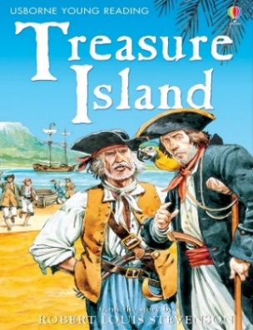 | 9+ | The most popular pirate story ever written in English, featuring one of literature’s most beloved “bad guys,” Treasure Island has been happily devoured by several generations of boys—and girls—and grownups. Its unforgettable characters include: young Jim Hawkins, who finds himself owner of a map to Treasure Island, where the fabled pirate booty is buried; honest Captain Smollett, heroic Dr. Livesey, and the good-hearted but obtuse Squire Trelawney, who help Jim on his quest for the treasure; the frightening Blind Pew, double-dealing Israel Hands, and seemingly mad Ben Gunn, buccaneers of varying shades of menace; and, of course, garrulous, affable, ambiguous Long John Silver, who is one moment a friendly, laughing, one-legged sea-cook . . .and the next a dangerous pirate leader!
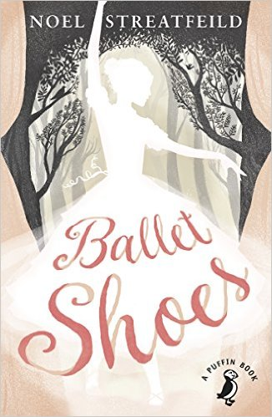 | 9+ | Pauline, Petrova and Posy are orphans adopted by eccentric fossil collector and explorer Gum ('Great Uncle Matthew'). Leaving them in the care of his niece Sylvia, and Nana, her old nurse, at his London home on the Cromwell Road, Gum goes off to continue his exploring, saying he'll be back in five years time. But after five years come and go, and there is no sign of Gum, Sylvia's money begins to run out.  When the family take in an engaging collection of lodgers to help make ends meet, one of them suggests that the three girls should attend Madame Fidolia's Children's Academy of Dancing and Stage Training, so that they can learn to support themselves and earn money on the stage. After some excitement, intense competition, occasional disappointments and some hard lessons, Posy proves herself a gifted ballet dancer and Pauline discovers a talent for acting, but Petrova - who loathes dancing and acting - remains true to her passion for mechanics and her dream to become a pilot.
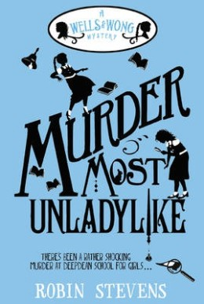 | 10+ | There's been a rather shocking murder at Deepdean School for Girls - but luckily, young detectives Daisy Wells and Hazel Wong are on the case!  When Hazel discovers Science Mistress Miss Bell lying dead in the Gym, she thinks it must have been a terrible accident - but when she and Daisy return a few moments later, the body has completely disappeared. The girls realise a murder must have taken place, and soon discover that there's more than one person at Deepdean with a motive. Determined to get to the bottom of the crime, Hazel and Daisy put their detective skills to the test - but can they uncover the truth before the killer strikes again?  Agatha Christie meets Malory Towers in this 1930s-set mystery, which will delight fans of boarding school stories. Debut author Robin Stevens deftly blends plenty of old-fashioned 'jolly hockey sticks' spirit with a contemporary sensibility that will ensure this lively romp has plenty of appeal for young readers today. Neatly plotted with plenty of surprises and an especially endearing narrator in Hazel, this is a gloriously fun first outing for schoolgirl detective duo Wells and Wong.
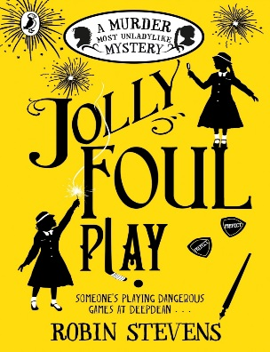 |  | Daisy Wells and Hazel Wong have returned to Deepdean for a new school term, but nothing is the same. There's a new Head Girl, Elizabeth Hurst, and a team of Prefects - and these bullying Big Girls are certainly not good eggs. Then, after the fireworks display on Bonfire Night, Elizabeth is found - murdered. Many girls at Deepdean had reason to hate Elizabeth, but who might have committed such foul play? Could the murder be linked to the secrets and scandals, scribbled on scraps of paper, that are suddenly appearing around the school? And with their own friendship falling to pieces, how will Daisy and Hazel solve this mystery?
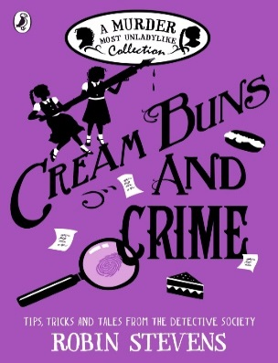 | 10+ | Daisy Wells and Hazel Wong are famous for the murder cases they have solved - but there are many other mysteries in the pages of Hazel's casebook, from the macabre Case of the Deepdean Vampire, to the baffling Case of the Blue Violet, and their very first case of all: the Case of Lavinia's Missing Tie.  Packed with brilliant mini-mysteries, including two brand-new and never seen before stories, and peppered with Daisy and Hazel's own tips, tricks and facts, this is the perfect book for budding detectives and fans of the award-winning, bestselling Murder Most Unladylike series.
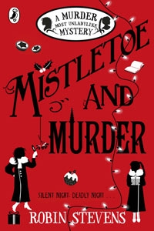 | 10+ | Daisy Wells and Hazel Wong are spending the Christmas hols in snowy Cambridge.  Hazel has high hopes of its beautiful spires, cosy libraries and inviting tea-rooms – but there is danger lurking in the dark stairwells of ancient Maudlin College. Two nights before Christmas, there is a terrible accident.  At least, it appears to be an accident – until the Detective Society look a little closer, and realise a murder has taken place.  Faced with several irritating grown-ups and fierce competition from a rival agency, they must use all their cunning and courage to find the killer (in time for Christmas Day, of course).
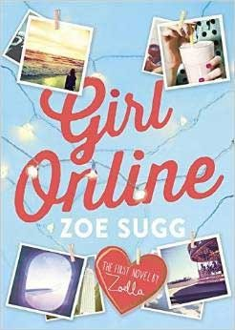 | 11+ | Brighton teenager Penny writes a blog under the alias 'GirlOnline', covering everything from school dramas, friends and boys, to the panic attack she's been suffering lately. After a particularly humiliating incident at school, an unexpected trip of a lifetime to New York offers a welcome distraction - especially when she meets gorgeous young musician Noah, and falls head over heels for him. But there's trouble ahead, when she discovers that Noah has surprising secrets of his own, and Penny's real-life and online identities are soon set for a collision course.  This is the first book from Zoe Sugg, better known as Youtube star Zoella. Dealing with many issues that will be familiar to Zoella's millions of fans - including the ups and downs of social media, and the challenges of dealing with anxiety - this is a sweet and warm-hearted teen tale. There are some funny moments (told that Penny is going 'viral', her dad says: 'I thought you looked a bit peaky… Do you want a Lemsip?'), and whilst the story might perhaps be a little predictable for older teen readers, this is certain to be a hit with younger teens and pre-teens in search of a gentle story of friendship and romance.
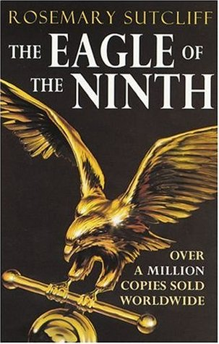 | 10+ | First book in the Series  Set in Roman Britain this story is of a young Roman officer who sets out to discover the truth behind the mysterious disappearance of the Ninth Legion, who marched into the mists of Northern Britain and never returned.
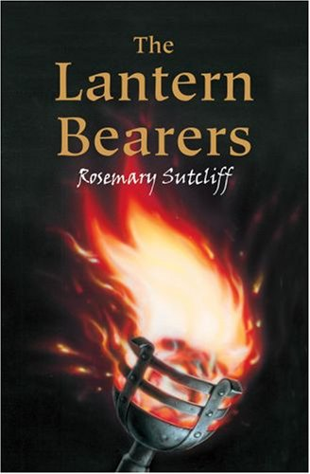 | 10+ | Fourth book in the Series  The Romans have abandoned Britain, leaving it open to the twin threats of civil war and Saxon invasion. When his home and all he loves are destroyed, Aquila endures years of torment before deciding to put some meaning back into his life.
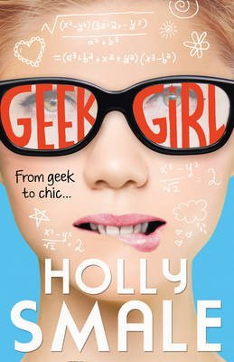 |  | Everyone at school knows Harriet Manners is a geek – she’s always spouting random facts, has zero fashion sense and can often be found in a tangled heap on the floor after falling over. But Harriet just can’t see why this means everyone seems to hate her. Her nemesis Alexa goes out of her way to trip her up, point out her flaws and make her life miserable. At least she has best friend Nat to keep her sane. But when the class takes a trip to the Clothes Show Live and Nat is desperate to get spotted as a model – only Harriet does instead – she has to choose between the reinvention she believes will change her life at school, and stealing her best friend’s dream…
T
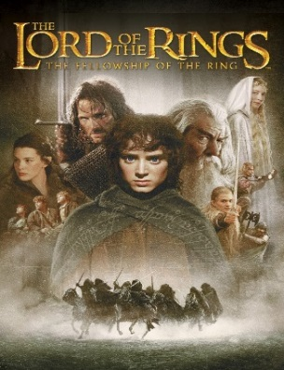 | 11+ | The first part of J R R Tolkien's epic masterpiece The Lord of the Rings, this is the story of young hobbit Frodo Baggins, who finds himself faced with an immense and terrible duty.  Sauron has gathered to him all the Rings of Power, and intendes to use them to rule Middle-earth. All he lacks is the One Ring - the ring that rules them all, which through a series of coincidences, has fallen into unlikely hands - those of elderly hobbit Bilbo Baggins, of the Shire. When Bilbo entrusts the Ring to the care of the young nephew, Frodo must leave his home and undertake a dangerous journey to the Cracks of Doom to destroy the Ring and prevent Sauron realising his terrible plans. In this story, Frodo joins forces with Gandalf the wizard and a host of other companions - including some of his young hobbit friends - to undertake the first part of the journey towards Mordor.  This groundbreaking work of imaginative fiction has been described as both heroic romance and epic fantasy fiction. Set in a richly-detailed fantasy world inspired by myth and legend, Tolkien's spellbinding tale will captivate readers young and old. A true 20th century classic.
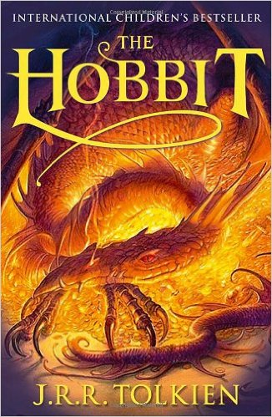 | 10+ | This is the classic story of Bilbo Baggins - a home-loving hobbit who enjoys a quiet and contented life in his cosy hobbit hole and has no desire to travel afar. But then the wizard Gandalf and a band of dwarves arrive unexpectedly and enlist his services, and soon Bilbo finds himself part of an extraordinary expedition to raid the treasure-hoard of Smaug the Dragon - and on the way becomes the possessor of a very unusual ring.  This well-loved fantasy has delighted both children and adults ever since its first publication in 1937. Full of magic, humour and adventure, it continues to offer plenty to entertain and engage today's young readers who are discovering it for the first time.
U
V
W
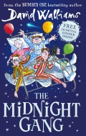 | 7+ | Poor Tom has been hit on the head by a cricket ball and wakes up in the Lord Funt Hospital with a big bandage on his head. In the children’s ward, though, he finds children with worse complaints: Amber’s got full leg and arm casts in a wheelchair; Robin has had an eye operation and can’t see; and poor Sally is too weak to get out of bed.  Worse, there’s a horrible kid-hating Matron watching over them and making sure they don’t have any fun at all – not that there is much fun to be had in hospital (or so you would think).  It transpires that the children are part of the Midnight Gang: an ages-old hospital tradition that makes dreams come true for sick children. But what will Tom’s wish be, and can the kindly hospital porter make it come true?  David Walliams’ tongue-in-cheek fun continues to amuse in this new adventure that also tugs at the heartstrings in just the right way. The Midnight Gang’s various ailments and conditions don’t affect them careering joyously around the hospital in the middle of the night, although Walliams still treats the characters and their conditions with dignity and respect where appropriate.
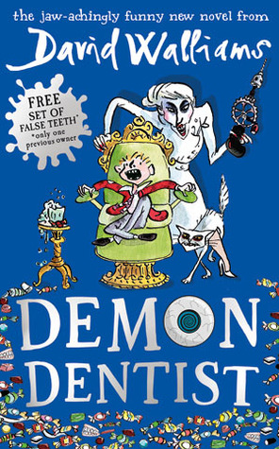 | 9+ | Strange things are happening in the dead of night. Children who put a tooth under the pillow for the tooth fairy wake to find... a dead slug; a live spider; or hundreds of earwigs creeping beneath their pillow. Evil is at work, but who is behind it? Could it be the Demon Dentist?  This delightfully dark offering from comedian-turned-bestselling author David Walliams is certain to entertain young readers. Tony Ross's illustrations work brilliantly with Walliams's text; there's plenty of fast-paced action; and the jokes are gleefully ghoulish (and often gross). The characters are well-drawn, in particular hero Alife, who is also a carer for his disabled dad, and the terrible villain really is truly demonic.  The dentist is a common phobia amongst children, and the more sensitive might find some of the more nightmarish scenes difficult to take, most notably when Alfie gets all his teeth removed without anaesthetic, his arms and legs held in place with metal cuffs. Yet whilst this book is unlikely to dispel any dentist fears, there's enough humour in the mix to prevent it becoming too terrifying for the majority of young readers.
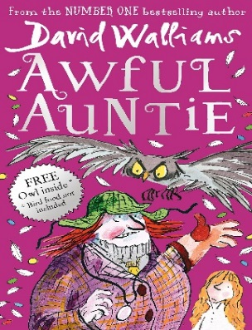 | 8+ | Aunt Alberta is the most awful aunt who ever lived. She is a pipe-smoking, monocle-wearing monster with steel toe-capped boots on her feet and a fearsome giant owl on her arm.  Little Stella Saxby is the only person standing between Aunt Alberta and ownership of Saxby Hall - which means Stella is in serious trouble. As Aunt Alberta and the owl develop ever-more-evil plots to get rid of her, Stella must use cunning tricks and a rather spooky secret weapon to foil their plans.  A conversational writing style and plentiful black-and-white illustrations draw readers into the story from the very first page. Awful Auntie is rude, witty, irreverent, just a bit scary and fantastic fun.
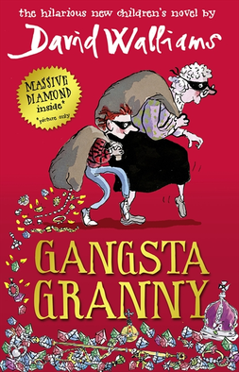 | 8+ | Ben is 11, an only child and a poor reader, whose ambition is to be a plumber. Every Friday he visits his Granny, while his parents go to watch ballroom dancing, and he hates those dull, smelly, cabbage-dominated evenings. Then he discovers that his Granny isn’t quite what she seems, and life takes a dramatic turn for the better.  Tony Ross's entertaining and funny illustrations are the ideal partner for David Walliams's outrageous, laugh-out-loud story. Walliams knows exactly what his readers want, and serves up humour filled with bums, farts and poo; but when Granny is taken into hospital the story takes a more serious turn, leaving readers to examine their own relationships with the elderly.
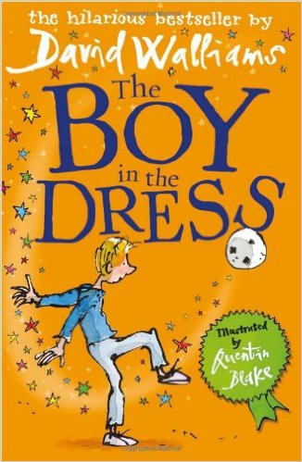 | 9+ | Dennis loves football but he also loves fashion and Vogue magazine. His lorry-driving father and laddish older brother don’t like or understand his fascination with dresses and since his mother left home, he has no-one to turn to. Then Dennis meets Lisa, an older, cooler girl who wants to be a designer and with her help he realises that it’s ok to be different.  Despite its sensitive subject matter, this book is filled with humour - the 1980s references to Neighbours and drinking Um-bongo will resonate with adults, while Dennis’ exploits with a host of quirky characters will amuse contemporary children. Fantastic illustrations from Quentin Blake complement the text perfectly.
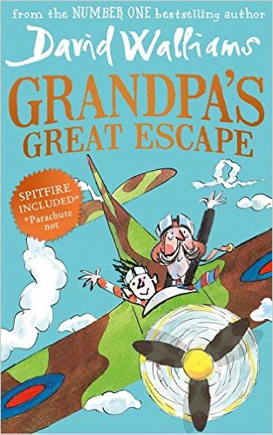 | 8+ | Grandpa is getting forgetful. But his memories of flying war planes are sharp as bayonets. Grandpa and Jack love watching World War II films, eating Spam a la Custard and visiting the Imperial War Museum. But when Grandpa goes missing and Jack finds him stowed away in the Museum's spitfire, Jack's parents decide it's time for him to move to Twilight Towers.  Sneaking in to visit Grandpa under cover, Jack spots the scary matron forging the residents' wills, discovers a room full of pills to keep them asleep and another piled high with ominous coffins, it's up to Jack to help Grandpa escape!  A daring, madcap, blockbusting adventure, full of humour, history, bravery, compassion and affection, from award-winning, best-selling David Walliams.
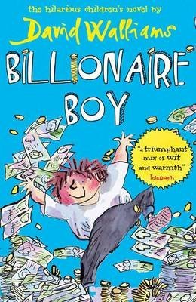 | 8+ | Having started from humble origins, Joe’s father is now a billionaire, and Joe has everything he wants, except true friends. To remedy this he enrols at the local comprehensive school, where he learns the hard way that you can’t buy them, and that family and friends are more important than any possessions.  Ross’s inimitable illustrations capture and extend Walliams’ style perfectly. Despite the book’s length, the large print would make it accessible for older but less keen readers, and the touches of satire could also attract that audience, as well as adults.
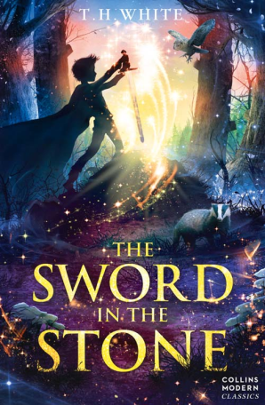 | 10+ | The extraordinary story of a boy called Wart – ignored by everyone except his tutor, Merlyn – who goes on to become King Arthur.  Collins Modern Classics are re-launched with gorgeous new covers bringing these timeless story to a new generation.  Come, sword, said the Wart. He took hold of the handles with both hands, and strained against the stone but nothing moved  When the wizard Merlyn comes to tutor Sir Ector’s sons, Kay and the Wart, studying suddenly becomes much more exciting. After all, who wouldn’t enjoy being turned into a fish, or a badger, or a snake?  But the Wart is destined for greater things and Merlyn’s magical teachings are only the beginning of his amazing future
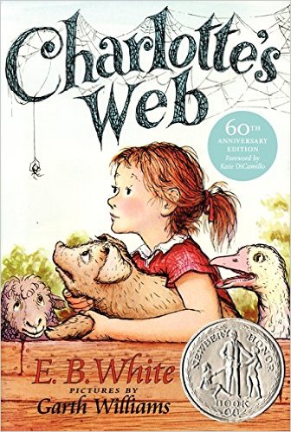 | 7+ | This is the tale of how a little girl named Fern - with the help of a friendly talking spider called Charlotte - saved her pig, Wilbur, from the usual fate of nice fat little pigs.  An unusual and witty story which provides a gentle introduction to questions of mortality, Charlotte's Web is a modern classic.

