Oliver Twist
Albert Lunn
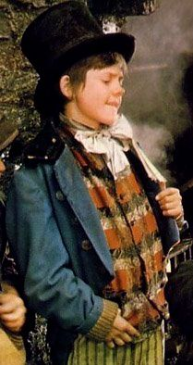

Kicking loose stones as he went, Jack trudged down the cobbled street confidently with Oliver and Charlie. Always on alert, he sneakily pilfered a bag of luxurious sweets for the gang. As they entered the town - his dirty, blue tailcoat stuck out like a sore thumb. His jaunty top hat threatened to topple as a grand horse and cart passed them, making the area smell like a wasteland. Horse manure was everywhere! Dominating the roads. Smoke curled above the rooftops, polluting the air, like a dark, raging storm, making it difficult to breath,
Suddenly, Jack spotted an elderly gentleman outside Albert Lane Bookstore, examining a dusty volume. Charlie spotted him too.
“Should I distract him or not?” Charlie questioned quietly.
“Ask for directions to Blackfriars Bridge.” Jack answered back. The cheerful boy hoped Oliver wouldn’t judge him for this. He really did want to be friends with him. Here’s to a meal he thought. His growling stomach agreed. Hopefully it would be routine. He’ll have spare money, Jack assured himself. He didn’t want anyone have to resort to thieving. Or the streets. Or the Workhouse. The dread of England.
Very carefully, Jack and Charlie slowly approached the gentleman. A greyhound raced inside his chest. The ragged boy turned his grimy head to make sure Oliver wasn’t approaching him. He carefully slid his dramatic hand into the gentleman’s elaborate overcoat. But no, wait his target had moved!
Quickly, Jack hunted for an excuse for being there. He began to look in a book but was in fact was looking at the gentleman in the reflection of the shop window.
“Clear? “Jack whispered.
“Clear.” Charlie affirmed.
Second try. As Jack crept towards the gentleman, an energetic boy shouted “Fire in the hole!” and threw the poo and wee out of the window, and splattered two grim Bobbies (who subsequently screamed an angry torrent of swear words and threats at the open window.) To Jack’s surprise, the man (his target) gave a small chuckle at this. Jack quickly took the wallet, feeling guiltier than ever.
As they ran, the man turned round and found Oliver standing there (with no evidence) and accused him of stealing his wallet! At least Oliver had the sense to run. Jack and Charlie unwillingly joined the chase, so as not to arouse suspicion upon themselves. They hid Oliver in the meat casing at Spittlefeilds Market. As tasty as it sounded, it did not work. The smart lad that was Charlie picked up a few bangers for good measure. He really was coming on well. Unfortunately, nothing worked. The pair of poo-covered Bobbies got Oliver. Jack and Charlie walked back in dismay…

