The crafty pick pocket

By Alexander Carruthers
‘Best book of the month’ The Times.

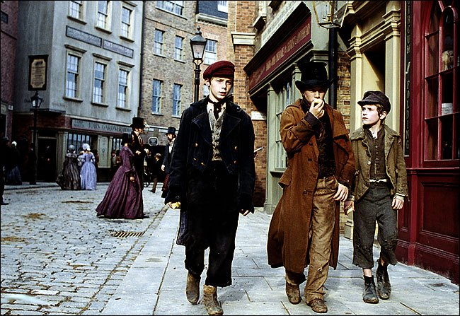

The Crafty Pick Pocket
Jack Dawkins kicked a pebble. He was walking with Oliver in a rich part of London. His clothes were too big for him, he had a navy blue coat down to his knees. It was actually meant for a man. He was fourteen years old and a foot taller than Oliver.
Jack punched his stomach, a big growl came from it. He and his friends worked for Fagin, they only got food if they brought a good loot home. If you worked for Fagin he gave you good clothes.
It was Oliver’s first time outside with Jack (who was also known as the Artful Dodger.) Oliver and Jack could see the dark shape of the dome of St Pauls Cathedral. Jack was wondering when they would find a suitable person to pick pocket! He didn’t know that Oliver didn’t know what they were doing. He thought that Fagin had told him.
Around the bend, there was a smart gentleman standing outside a small library. He was the perfect man to pick pocket. Jack brought Oliver to the rich man to pick pocket. His hand shot out to put his hand into the man’s pocket. But it missed. The man had stepped into the shop and out again - he had forgotten to bring the book. Now was Jack’s chance, he pushed his hand into the man’s pocket. In a flash, it was out in a fist and clenched within it was a wallet.
In a second, he ran. He didn’t know if Oliver would stay his friend. Soon, the man found out that his wallet had been stolen. The man found out by putting his hand into the pocket to get it to pay for the book. Unfortunately, at that moment, he saw a boy wandering past. It was Oliver!
At the top of his voice he started shouting “STOP THIEF! STOP THIEF,” to draw attention to the police. Oliver ran. He wasn’t very fast but he was small. Oliver ran through some iron bars, he knew that the people chasing him couldn’t get through. In the distance, Jack Dawkins could see Oliver looking at a ladder which led to the railway.
In a second, he saw Oliver climb the ladder. The police had now seen Oliver too. At the top of the ladder, Oliver stumbled along the tracks. The sharp pebbles biting into his soles. Within a second, a train came down the curving tracks. Oliver lay down on the tracks as the train went over. There was a whole crowd watching.
One of the policemen went up the ladder to get Oliver. Now it was easier to get him because he was lying down. The policeman dragged Oliver down the ladder and away to court.
Back at base, Fagin asked the Artful Dodger where Oliver was. He replied, “Oh, he just ran away from the police so they would think he did it that was so I didn’t get caught. By the way the police by now have probably found out that Oliver didn’t pick pocket the man.”

