OLIVER AND HIS TWISTS
By Alfie hull

+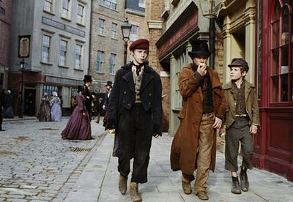
‘Best book of the year’

Oliver Twist

Oliver stumbled down the street kicking a bottle from foot to foot. Eventually it cracked and the bottle split into tiny shards of glass. Glass which was as sharp as a knife, and began to cut his shoe as he kicked the bottle.
Suddenly, Jack mysteriously saw a pocket watch hanging out of a white haired man’s pocket so Jack looked around to make sure no one was looking. Then, Jack sneakily put his hand into the man’s pocket to retrieve his watch. Without warning, the gentleman swung behind his arm back (almost touching Jack’s arm). Fortunately, he quickly resumed browsing the books. Jack seized his opportunity and ran into an alley. Obediently, Charlie followed him, and when the man went to get his pocket watch… it was gone.
The gentleman turned round and saw a little brown haired boy behind him.
“Give it back,” the gentleman demanded. Then he said it again, “give it back,” followed by a “stop thief,” then even louder “STOP thief!”
Oliver (the innocent brown haired boy) ran as fast as he could. Jack and Charlie ran after Oliver. Oliver could almost imagine that they were having a race. Jack got in front of the police and he hid Oliver in a butcher’s casing but the butcher came storming out of the shop and ripped the white casing off Oliver. Within a second, Oliver was off running again.
He climbed a rusty ladder onto the train tracks. He was being as careful as he could. Just then, he heard a steam train coming full speed so he crouched to the floor immediately and hid under the train but when the train passed.
When the police caught Oliver, the police asked the white haired gentleman, “is this the kid that stole your watch?”
The gentleman responded with, “well I saw him running off.”
Jack and Charlie went back to Fagin and told him, “Sir, Oliver sacrificed himself to save us.”
“What do you mean?” replied Fagin.
“The police caught him Sir,” responded Jack.

