Happy times for Oliver Twist
Sad times for Oliver Twist

By Blubelle Curtis

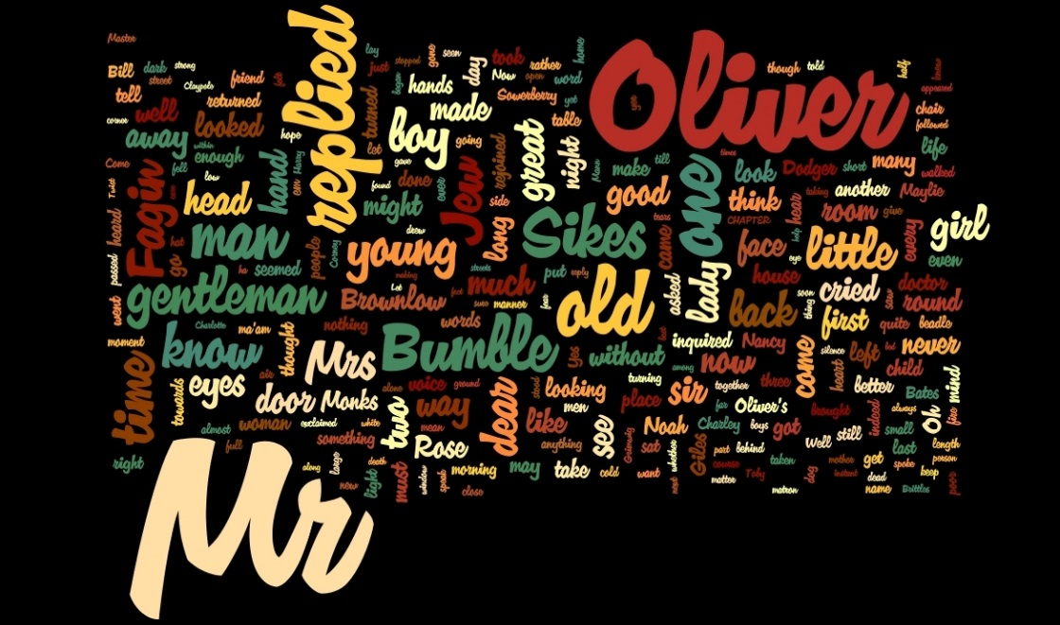

Tito - ‘I enjoyed the book it made me smile and laugh and it is very interesting I want a second part.’

Oliver trotted down the grey pavement, kicking the big rock which he had found down near the ironmonger. He was humming to a song he had learnt, it was Twinkle Twinkle Little Star. Jack was with him. Then, they saw Mr Brownlow, who was their mutual enemy. He was looking for a book for his boss, because it was his birthday. When they were walking past him, Jack saw a lovely silver pocket watch hanging out of his pocket. Jack pretended to look at the book Mr Brownlow was looking at. He was actually trying to find the right time to steal the pocket watch. So he told Oliver to stand on look out. Then, Jack went back and crept up on Mr Brownlow and … the wonderful pocket watch was gone! Jack had a quick look at it before it was in his chest pocket. When he saw it, it shimmered in the sun as the sun shone down on it. And Oliver stood there still humming in his itchy grey top and silky trousers with rips and stains in them.
Jack ran away, deliberately deciding to leave Oliver to take the blame. Jack ran and hid behind the barrel, but then got up and tried to alert the police. Oliver was standing there looking innocent, because he didn’t know what Jack had done. Mr Brownlow’s evil laugh echoed through the street.
Then he said, “Ha I’ve caught you boy, no escaping! You stole my watch!” Oliver looked at his evil smile.
Oliver whispered “I didn’t do it.” He started to run.
Mr Brownlow said, “Get that boy!” Then the police noticed what was happening and started to chase him.
Oliver ran through butcher markets, train stations, until he finally got caught by the dreadful police. They put him in some rusty metal handcuffs. They put him in a jail cell, but at night because he was so skinny, cunningly, he managed to escape. He found some food on the street, but as the weather started to worsen, he decided to sneak back inside his cell and eat the horrible food. He had to eat it because he was starving to death before he ate it. Oliver sat there in the cold, dusty jail cell waiting for the sun to rise, or at least for the rain to stop.

