Oliver Twist

By Daniel Barbashin

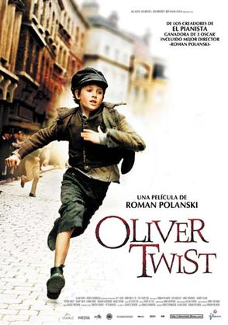

One cold windy morning, Jack was waiting for his breakfast to be served. Whilst he waited for his food, Jack brushed his dusty shoes and brushed his brown fluffy hair. Then, he went to put his shoes on. Jack then went to the rusty table and started to eat his food. Once he had finished his food, he wiped his mouth and called Oliver and Charlie down to go outside. He said, “C’mon boys! Let’s go outside!”

The boys came down and went outside. Then Charlie was about to tell Oliver what he was going to do but decided not to because Oliver might not like them anymore. So instead of telling Oliver, he whispered quietly to Jack and said, “PSST! Hey Jack! Let’s rob someone over there!” So off they went and walked down as if they did not know what to do.

Then Jack said, “Hey Charlie! Do you see that man over there?

Charlie said, “Yes I see him. Wait do you mean….?”

Jack said “Yes!”

Charlie then replied “But with Oliver????”

Jack said “Don’t mind him, just let him stay.”

Jack and Charlie went up to the man and looked innocent. They looked over the man’s shoulder and pretended to look at the paper that he was reading.

Jack put his hand into the fine rich gentleman’s pocket and took his hands out. Quickly, Jack then ran away and left Oliver to get the blame. The man then turned around and saw Oliver. The man cried out, “COME BACK YOU THEIF!” and Oliver started to run away and then Charlie and Jack ran away into the distance in the opposite direction.

Oliver started to go a different way very fast and then the man said out loud, “CHASE THAT BOY HE STOLE MY WALLET!!”

Then all the people started to run after Oliver then they went past a bobby and called him to come with them and then he shouted, “STOP THERE THEIF!” but Oliver ran onwards and ignored them.

Eventually Oliver came to a dead end with a bridge over him. Then Oliver climbed up the bridge and then there was trouble a steam train coming. “TOOOOOOOOOOOT! “TOOOOOOOOOT!” Oliver thought this is the end of this I guess. Quickly, he lay down under the train and waited for it to pass over him. After this, the bobbies got on the bridge and then got Oliver and then took him down.

Charlie and Jack had been captured too and were being dragged down the road. The bobbies took them all to the police station and then the police station master said, “Ey you boy speak to me did….-”

Then Oliver suddenly interrupted and said, “No sir I didn’t do it!”

Then the bobby said, “Don’t talk over me young boy!”

Then they took Oliver into the hall of prisoners but then Oliver said “B…u…t I did not do it was Ja….ck Dawkins not me sir.”

“Oh really? Then take me to him and we will ask him questions alright boy?” offered the kind policeman.

Oliver said, “Alright then, but we need to be quick because it is nearly the evening and I want to get home after this and relax and read the news.”

Off they went to go find Jack, near the bridge and around the corner. Jack and Charlie then looked around and saw the policemen and Oliver coming. Then they walked up to them and then Jack and Charlie said, “Sorry that we stole it. We did not mean to do it. Please forgive us and we won’t do it again? We promise right Charlie?”

But it was too late - Charlie ran off to his home to leave Jack to take all of the blame. Jack said, “Charlie??? Where are you??”
Then the bobbies went away and left Oliver and Jack to themselves. Oliver and Jack walked down the road in friendship. Then they saw Charlie and said, “why did you run away from us and we could have solved it out and went home together?”
Then they walked home all together and then knocked on the old wooden door. Someone from the inside the door opened up, just as Jack said, “I don’t think Oliver should come outside with us to rob someone again, unless we teach him one time.”

