The story of a missing street boy

By Ellah Nabuwufu Kyembe

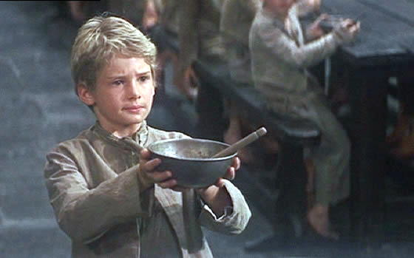

Mr Brownlow (a wealthy man) wanted to buy a book for his mother’s birthday but it was so misty and so windy that he couldn’t find his way!
Mr Brownlow wore a long brown waist coat and it went all the way down to his knees, his trousers all clean and straight and his hair all shiny and shampooed. He always loved a good laugh.
The book shop keeper came outside and went to help Mr Brownlow pick a book. He couldn’t find the right book to give to his mother for her birthday. He searched and searched and searched and searched but he couldn’t find the right book. He felt really devastated. Mr Brownlow had a very good image in his head about what would happen if he turned up at his mother’s without a gift: “Henry where is my present?!”
Mr Brownlow felt ashamed with himself. He felt an explosion in his head like something bad was going to happen. He was frozen with fear…
A few minutes later, two mysterious boys arrived in town and found Mr Brownlow trying to pick a book.
“Hey Charlie!” whispered Jack.
“What?” asked Charlie interestedly.
“Our prey!” said Jack.
“What prey?” asked Charlie.
“The man’s wallet!”
“Uuhhh, we hit the Jack pot!”
The two boys reached into the man’s pocket but, Mr Brownlow turned around.
“Oh hi boys what are you up to?”
“Er- um- we are just getting a book just like you sir.”
“Oh, okay have a nice day bye.”
“Bye.” They both said normally.
“Hey Oliver keep us company will you?”
“Okay,” Oliver said confused.
The two boys reached into Mr Brownlow’s pocket while he wasn’t looking. The Bookshop keeper saw everything that happened but didn’t bother to say anything to stop it from happening.
Charlie and Jack quickly ran away and left Oliver to deal with the situation. Mr Brownlow reached in his pocket to pay for the perfect book which he had just found. The book was called, The Magic Monkey and His Incredible Save! But just as Mr Brownlow was about to get his wallet out, he turned around saw Oliver, and felt his pocket. The wallet…was…GONE! Mr Brownlow huffed and puffed and shouted: “THAT BOY HAS STOLEN MY WALLEEEEEEEEEEET!
Oliver didn’t know what to do so he just started running with all his might thinking why his best friend did this to him? Oliver ran and ran and ran and ran through bars, windows, meat sacks and had to go in disguise at times. Mr Brownlow decided to call the police for this situation! “POLICE I NEED YOU RIGHT NOW THIS EVIL BOY HAS STOLEN MY PRESIOUS WALLET!
“Okay sir we will get your-“
“And it’s got really valuable stuff in it like my-“
“Okay we will get it in a jiffy sir.”
“Do you know who I am you do not-“
“LET’S GET THE BOY LADS!”
“Why is this happening to me?” Said Oliver
Oliver ran as quickly as a cheater (Well not really as fast as a cheater). Oliver was all out of breath so he was caught by the police!
“You are coming with us you little pest, give me that wallet you owe Mr Brownlow a big apology you are going to JAIL!”
Oliver could hear whispering in his head that he was going to be DOOMED FOREVER…

