Oliver twist story

By Esther adeko
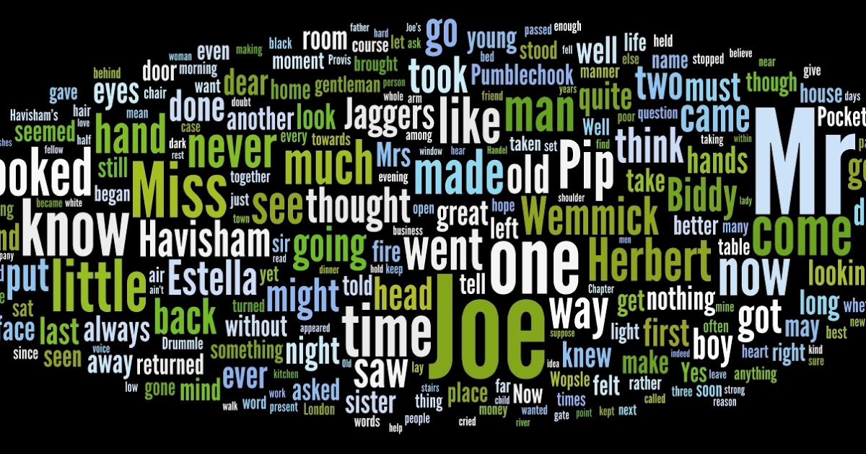

Blubelle: Esther this is an inspiring book it is like you’re on the edge of the SEAT. the story is interesting it has a lot of adjectives and fronted adverbial in it. if you love reading then I want to recommend this book to you.

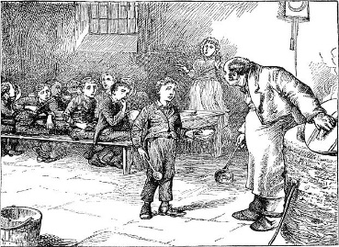

Jack was walking with Oliver and Charlie. He noticed Mr Brownlow who was looking at the books which the bookseller had put out on display.
Jack’s hand reached into Mr Brownlow’s pocket. At that exact moment, Oliver was walking past. Mr Brownlow felt somebody’s hand in his pocket, and realised that his wallet had been stolen! He turned and saw Oliver. He said ‘’stop thief STOP THEIF!’’
` Normally, Oliver would be sweating as he was forced to work hard, but as he began to run he started blubbering. At that time, Oliver face turned purple so dark purple. The sky was purple, green, blue, orange and pink - it was a mix of colours. Mr Brownlow’s hair was brown. Oliver was black. Jack’s hair was ginger and Charlie’s hair was blonde. Mr Brownlow stopped Oliver and Jack tried to help Oliver avoid getting caught.
The sky turned blueish, which was light blue with dark blue. Everyone that passed them was in a bustle skirt, top hat and tail coats. The metal for the hand cuffs was rusty was old. The bobby’s helped Mr Brownlow to catch Oliver and he was brave but a little sweaty. Oliver did not know what was happening. Jack and Charlie tried to help Oliver but it was too late. Oliver was glad to have Jack and Charlie on his side to help him but unfortunately they could do no more. Soon it turned so dark outside that you could not see anything.

