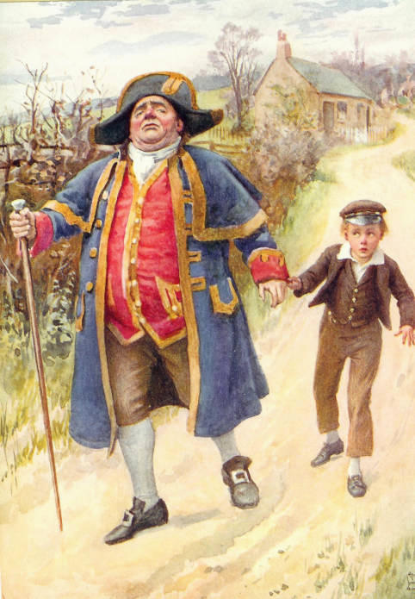
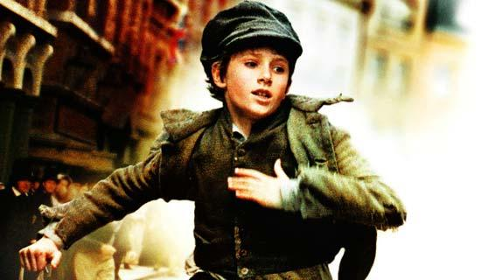
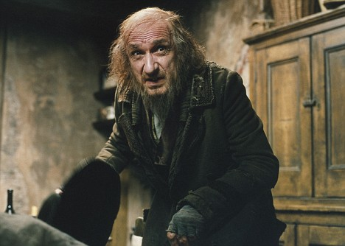
OLIVER TWIST:
MY VERSION
By Glennis Poku

Jack was in town all miserable and stressed. He quickly had a flash-back of what Fagin had said to him. Jack put his hands in his in his opened-spaced pockets, and sighed deeply. If Jack didn’t come back with anything valuable he would be kicked out. But Jack had nowhere else to go. Jack dressed really posh and he really blended in with all of the rich people. His top hat was nice and polished and covered a lot of his brown dirty hair. His navy blue waist coat came all the way to his ankles. It waved like the wind.
People were looking for the Artful Dodger (Jack’s real name). He used to wear itchy rags but in the end he changed his identity completely and apparently fitted in with the rich. Jack’s stomach seriously growled. He put his shovel-like hands on his stomach and squeezed his deep brown eyes. Oliver and Charlie looked at him but kept their mouth quiet.
Just then, Jack glanced at the town. He could hear the slight noise of carriages trotting along the cobbled streets. But in the distance his eye caught a man. It wasn’t an ordinary man. It was a man who had money. Jack thought if he sneakily stole the wallet and gave it to Fagin, then Jack wouldn’t be put on the streets. The man Jack wanted to steal from is Mr Brownlow. He had a brown top hat and had bags of money.
Jack suddenly put a smirk on his face and crept away to Mr Brownlow. Charlie followed as he always did. So did Oliver as well. As Jack got closer he could see a faint outline of Mr Brownlow’s golden wallet and as quick as a flash, Jack became drawn to it. At that very moment, Jack swiped the wallet. He gave it to Charlie to put it in his pocket. At first, they just stood there. Then simultaneously Jack and Charlie ran off to Fagin’s secret hiding place, leaving Oliver behind.
Jack and Charlie were finally at Fagin’s secret hiding place. Fagin had an over flowing white beard and that moment he was questioning them about Oliver. Fagin had committed many crimes so he had located a secret hiding place which he was now worried in case Oliver would show it to the police.
Eventually, Jack showed the golden wallet with so much cash that Fagin completely calmed down and didn’t care about Oliver anymore. But Jack didn’t give it to Fagin. Jack was moving out. After all, he was the Artful Dodger and he could always think of something.

