OLIVER TWIST STORY
By Imran Kuyateh

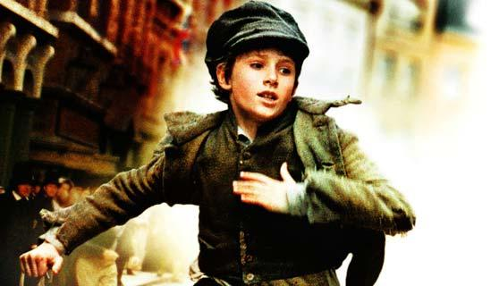

Jack walked down into the dusty old town with Charlie and Oliver. He knew he would be in big trouble if he didn’t bring anything back for Fagin. So he decided to scout the area for rich people. He saw a rich gentlemen and knew that he had quite bit of money for he was wearing a navy blue velvet tailcoat. The gentleman was peering in a bookshop window looking for a book to buy. Jack tried to blend in and browse against the selection of the books.
Suddenly, Jack’s hand crept into the man’s pocket like an ant and in the blink of an eye his hand went out again. Without warning, he ran foolishly and let Oliver take all the blame. He ran behind him he could see a tiny Oliver running in the far distance being chased. He decided to go and run over there and secretly help Oliver escape but he was going to pretend like he was trying to help the police to catch Oliver.
He ran in the blinding sunlight to go and help Oliver. It was like he was in Mission Impossible. It was like it was his mission to save his best friend or else consequences would happen…
They ran into the butchers shop and then Jack had an idea. He hid Oliver under some meat casing but the butcher pulled it off and found out it was him! Oliver was running but the bad thing was Oliver was not a very good runner. The police nearly caught him but he just managed to slip through and without looking he climbed up on some train tracks. He was too out of breath and too tired to notice. Then he made a big mistake… He just kept climbing not noticing that he was about to go on train tracks and still he kept climbing.
When he saw the train coming he just went out of control. He was panicking like crazy screaming ‘HELP HELP!’ The train got closer and closer and closer! Until…
Relief! Oliver was safe. However, Jack knew what would happen next. Oliver would be taken to prison FOREVER and it was all his fault that his friend was going. Jack could see Oliver being pulled down to climb down the train ladder. When they were finished pulling Oliver down, the gentleman knocked Oliver out with one almighty punch. They beat him so hard that blood came out of his mouth and nose. Oliver’s cuts were so big that the blood could fill a hot tub. Then Jack saw him being sent him to prison and that’s the last Jack and Charlie saw of their friend…
“I CAN’T BELIEVE YOU GOT OLIVER INTO THAT MUCH TROUBLE AND LET OLIVER TAKE THE BLAME FOR SOMETHING HE DIDN’T DO! WAIT TILL I TELL FAGIN WHAT KIND OF FRIEND ARE YOU?!” said Charlie
“IT SNOT MY FAULT OK? I didn’t mean to get him into trouble….” said Jack.
“Well you did! You blew it now! The innocent boy is in prison for nothing. Ohhh the beating Fagin’s going to give you ohhh!!”
“SHUT UP!”
“Okay, okay, Mr Angry! At least it’s not me going to starve to death! Hahaha!”
Charlie and Jack walked home slowly. Jack was sulking inside. He was not sulking because he was going to get beaten - he was sulking inside because he lost his friend who didn’t do anything wrong. They walked home disappointed. They returned home but not empty handed at least.
“Ahhhhh if it isn’t my favourite children! What did you children make today?” said the red haired man.
“Um I made a wallet,” said Jack.
“And I made a handkerchief,” said Charlie.
“Good… good…” said Fagin. “One last thing…”
“Yes?” said the boys together.
“Where’s the new boy?”
“Um… he… uh… he…” started Charlie.
“He took one for the team,” said Jack nudging Charlie.
“Oh well when are you guys going to break him out? That boy is strong and he deserves a reward when he comes back.”
“Yes Sir,” said Charlie and Jack. “We will break him out soon. I think I’ve got a plan,” said Jack with a smirk on his face.
“BRILLIANT! We will have a party when he comes back,” said Fagin.
“Yes sir,” said Jack and Charlie at the same time. “We won’t disappoint you sir!”
“I know you won’t,” threatened Fagin…

