THE HIDDEN CRIMINAL

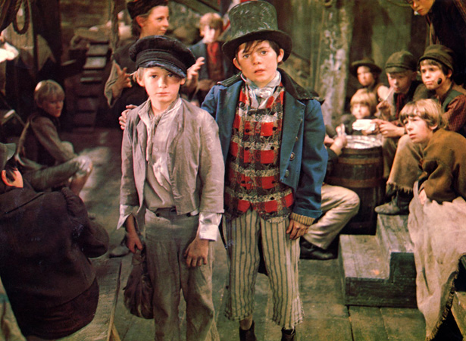

By Mollie Reed

THE HIDDEN CRIMINAL
Jack walked out of the strange room. With his dirty hands in his pockets, he strolled down the street, his feet kicking at a rock. He wore wrinkled trousers and a smart purple tailcoat that hung down to his knees. Him, Oliver and Charlie were walking down a poor alley way which they called Dump Alley. They were heading to a rich street called Victoria Lane. Victoria Lane was busy and was the best place to go pick pocketing. Rich people swarmed the market like bees around a flower.
Dump Alley was a small winding ribbon road. It stunk of rotten eggs and mouldy cheese. There was garbage bags and rubbish scattered all over the horrendous cobbled alley. In that part of the town the gas lamps flickered and smoke filled the polluted air. A red and black spotted ow tie wrapped around Jacks neck like a snake around its prey. His dark brown hair clung to his forehead with sweat which acted like glue.
Eventually, they saw a sign. It was not too far ahead and even though they were exhausted they carried on going. Once they reached the sign they took a break before going into Victoria Lane. Finally they carried on. Jack straightened his tail coat and dusted his trousers. Oliver did the same and then they set off again down Victoria Lane.
Suddenly Jack saw a wealthy man! He darted towards him pretending to read the book Mr Brownlow (the rich man) held, over his shoulder. The man had a smart black suit with a pleated shirt at the front. Hanging out of his pocket was a shiny, golden stopwatch ticking a rhythm.
Jacks eyes lit up. Just then Oliver’s happy expression changed, he looked shocked. Jacks hand darted into the man’s pocket. He carefully grabbed the pocket watch and threw it to Charlie. They both ran. Before seconds, Oliver turned around and began to run. The rich man discovered that his pocket watch had gone.
He turned around to see Oliver running for his life. “Stop! Thief”, roared Mr Brownlow furiously. He yelled again but this time a bit louder “Stop! Thief!”
In the blink of an eye, everyone was running and trying to catch poor innocent Oliver who had done nothing wrong. Oliver found Jack, and whilst Oliver ran left, Jack tricked everyone by telling them to go right. After everyone had ran past, Jack ran after the so called criminal.
Jack stuffed Oliver (who was tiny), into a meat casing so no one could see him. Unluckily the butcher found the sack with the boy in and told a bobby. Suddenly, Oliver was caught by a police officer and was taken prisoner. When Jack was back at his secret base, Fagin realised that Oliver was a hero and had sacrificed his life for them. Fagin was relived and worried and hoped Oliver might come back some day.

