OLIVER TWIST
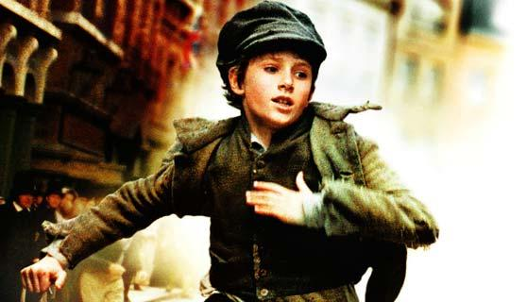

By Taym Ouriachi

Jack was walking through the town with Charlie and Oliver and messing about with a few rocks sitting there on the ground waiting to be kicked about by a few kids. He was wearing a nice blue velvet coat and he was very tall, although only thirteen, he seemed like a sixteen year old .His nickname was the Artful Dodger. He glared at the people browsing a few old dusty books at a book stand. Jack would not take his eyes of the elegantly dressed people. He he was mainly looking at their pockets. Most people’s pockets were empty with maybe a few shillings, but one or two had a wallet or two and a few other people had handkerchiefs. Oliver quickly understood what Fagin’s boys did for a living and Fagin’s treasure chest and why they worked long and hard.
Jack moved slowly like a predator attacking his prey. He was advancing a tall man wearing a nice long brown coat and a black top hat. His clothes were clean and his shoes were as polished and as smoothed as his nice shiny skin. Jack looked over the man’s shoulder. The man was reading through the pages of one very dusty book. The Artful Dodger seized the man’s pockets. He could see an orange handkerchief. He slowly moved his arm - aiming at the nice clean pocket and he took the handkerchief. He slowly moved back to his original place and quickly whispered something to Oliver and Charlie. However, Oliver was still daydreaming and he did not hear what Jack had said and the thing .What Jack had said was very important - he had said, “Start running when his face turns around.”
Oliver was a very big daydreamer and at that time he was thinking about what other things Fagin’s boys stole from the rich. Eventually, the man whose name was Mr Brownlow, turned around and the two boys left Oliver running away into the distance. Then, Oliver quickly understood what had happened in the whole minute that he was daydreaming. Rapidly he started running as fast as his little legs could carry him. But Oliver wasn’t a fast runner and he stopped to catch his breath.
In that time Mr Brownlow was catching up to Oliver shouting, “get the police! Get the police!”
Jack and Charlie had stopped at a market nearby. They were trying to think of how to help Oliver. Coincidently, Oliver quickly ran past without seeing Charlie and Jack. When the police and Mr Brownlow went past they asked Charlie and Jack if they had seen a boy wearing a raged cap and a brown dirty waistcoat. They said yes and they sent the police and Mr Brownlow the wrong way. They quickly ran around town trying to find Oliver but they had no clue where he had been or what he was doing right now.
Eventually they gave up trying to find him and went back to their job and at night they came back home to Fagin’s house and they found Oliver sucking on a nice juicy sausage and it wasn’t the end. Oliver quickly asked them if they wanted to go out tonight they said no so Oliver went out by himself.
Oliver was very lucky - he escaped seven booksellers and three chiefs and a few famous and very rich men. They were as angry as ever as Oliver went for a last try on a man who was very famous and who went by the name of Abraham Samera. He felt very proud of himself for going out pickpocketing by himself and Abraham had loads of wallets and goods and loads and loads of handcherchiefs.
Oliver’s objective was to get six wallets and fifteen handckerchiefs. Oliver however was feeling very tired and he was thinking that he could only get half his objective but he was determined to get all of them. He slowly approached Abraham and quickly checked his pockets for what kind of goods were there. In his pocket there was even jewllery! First, Oliver picked up two wallets hanging out of his right pocket and he got an orange handckercief from the left one. His joy was already unimaginable he was so delighted with what he had got that night.
He decided to quickly run to a place that now he called home and when he returned to Fagin the first thing he said is “we’re rich!” then he showed the boys what he had stolen that night and he really really wanted to go back out tomorrow and get more than he got tonight.
The next day came and Oliver woke up really early. Fagin was already up then Oliver started daydreaming about if Fagin ever slept. Fagin told Oliver to go wake the boys but still Oliver never heard but he decided to go wake them by himself. Five minutes later and the only one that woke up was the one and only Artful Dodger.

