MISTAKEN

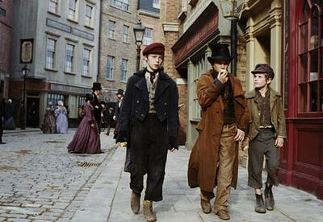

By Victory Edogun

“The name is Jack Dawkins”, he said proudly. Oliver had ran away, with a complete stranger.
“Oliver”, he said. “The name is Oliver Twist”. Trying to copy Jack.
Secretly, Jack Dawkins worked with a robbery company. So he did not tell Oliver because there are Bobbies everywhere. There was a rich man named Mr Brownlow. He turned around, as he was enjoying the nature. Whilst he was doing this, Jack sneaked into Mr Brownlow’s pocket, and took his wallet. When he turned around Oliver was there.
“Where is my wallet?” he said. “Where is my waaallleeettt?!”
Oliver ran for his life but then the bobbie’s came. He was very confused.

