How to make a horse and cart
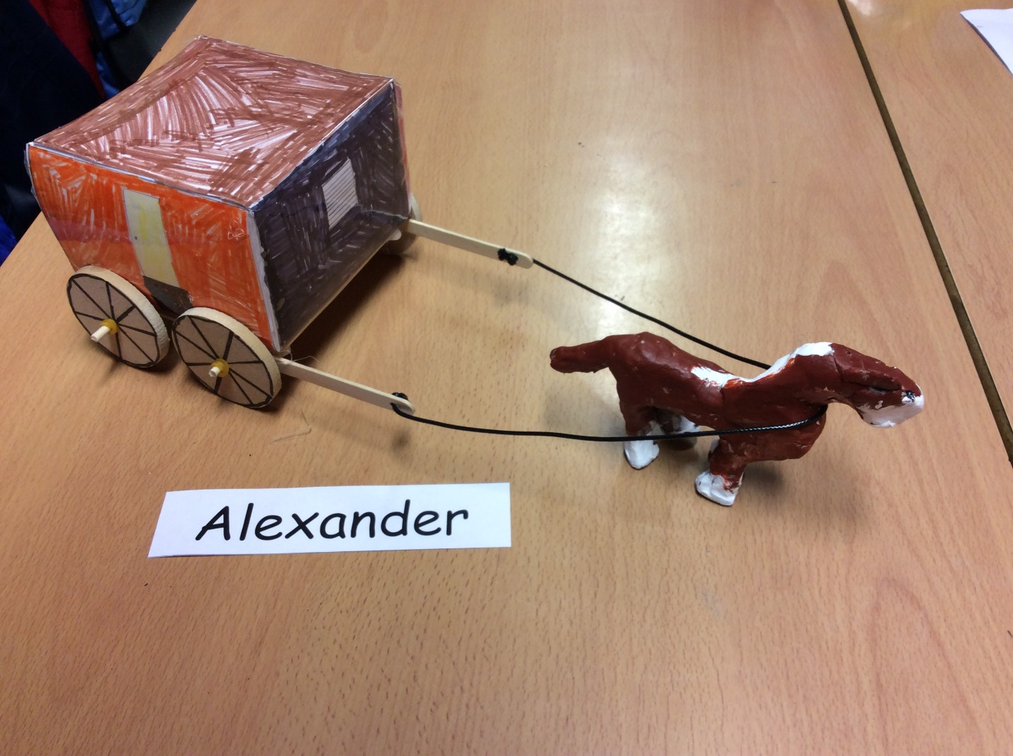
Resources
- Lolly pop sticks
- Glue gun. .
- Clay.
- X2 Dowels.
- X4 wheels.
- X6 elastic bands.
- A3 sized paper.
- Acrylic paint.
- String.
- Leather string.
- Scissors.
- Colouring pencils.
- Ruler.
- Tape.
- Felt tip pens.
- Wire.
- IPad

Instructions

Firstly, get your A3 sized paper, ruler and pencil.
After that, get your IPad, download your net and draw it on the paper.
Thirdly, steadily cut out your net and draw on the windows. (Colour them in)
Fourthly, with force, get your pencil and ruler then score the folds.
After this, fold the folds outwards. (You might need some help)
Next, get the tape to stick the sides together with confidence.
Now, mindfully get your dowels. Slide a rubber band on one side, then a wheel and a rubber band. (Also do it on the other side)
Tenthly, get your other dowel and slide a lolly pop stick then a wheel and rubber band. (Do it on both ends)
Now, cautiously get your clay and make your body, (for the horse) don’t make it too big or it will be higher than the carriage. (Use about half of your clay)
Twelthly, make the legs. Be careful that you smooth the joints down or when they are dry they will fall off.
After, make the tail. (Do the same as the legs)
The head is more difficult, you have to smooth everything down.
Once the clay is dry, paint it, don’t do it with pressure or it will break!

