HOW TO MAKE A HORSE AND CART
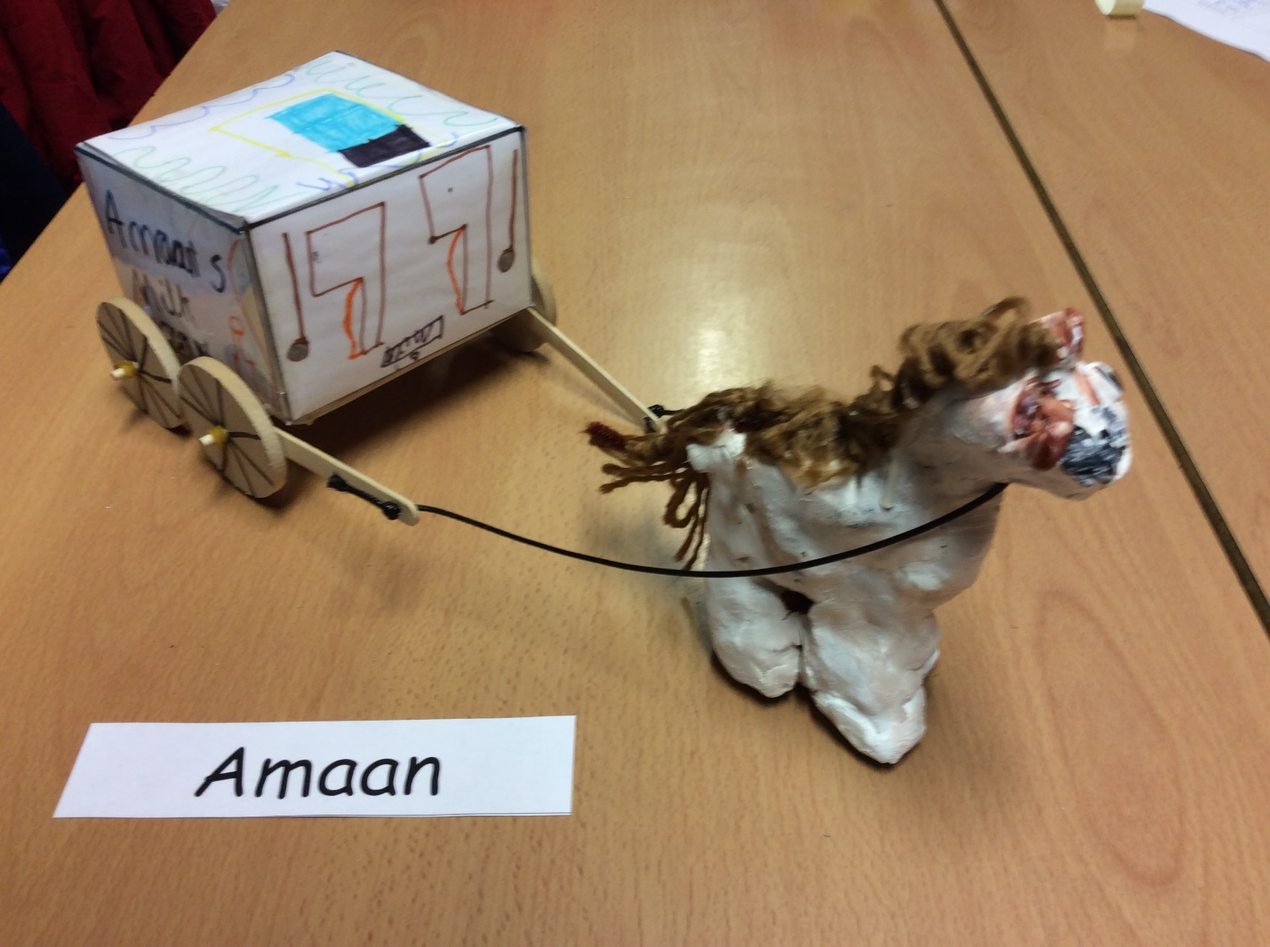

You will need:
- Glue Gun
- Stick
- String
- Lolly Pop Stick (2)
- Dry Clay
- Dowels (2)
- Wheels (4)
- Glue Stick
- Loom Bands (4)
- A3 Paper
- Laminator
- Net
- Leather string
- White Board Pen
- Paint brush

1. Firstly, make a net out of paper you use the A3 paper and draw and scored the paper. Then, you get your white board pen and go over the scored part.

2. Next you got colured pencil. After, you can design you cart you can laminate it. WARNING DO NOT DRAW UPSIDE DOWN.
3. We scored the paper to fold it and make nets.

4. After, you use clay to make the horse. If you can’t connect it together.

