How to make a Victorian Horse and Cart
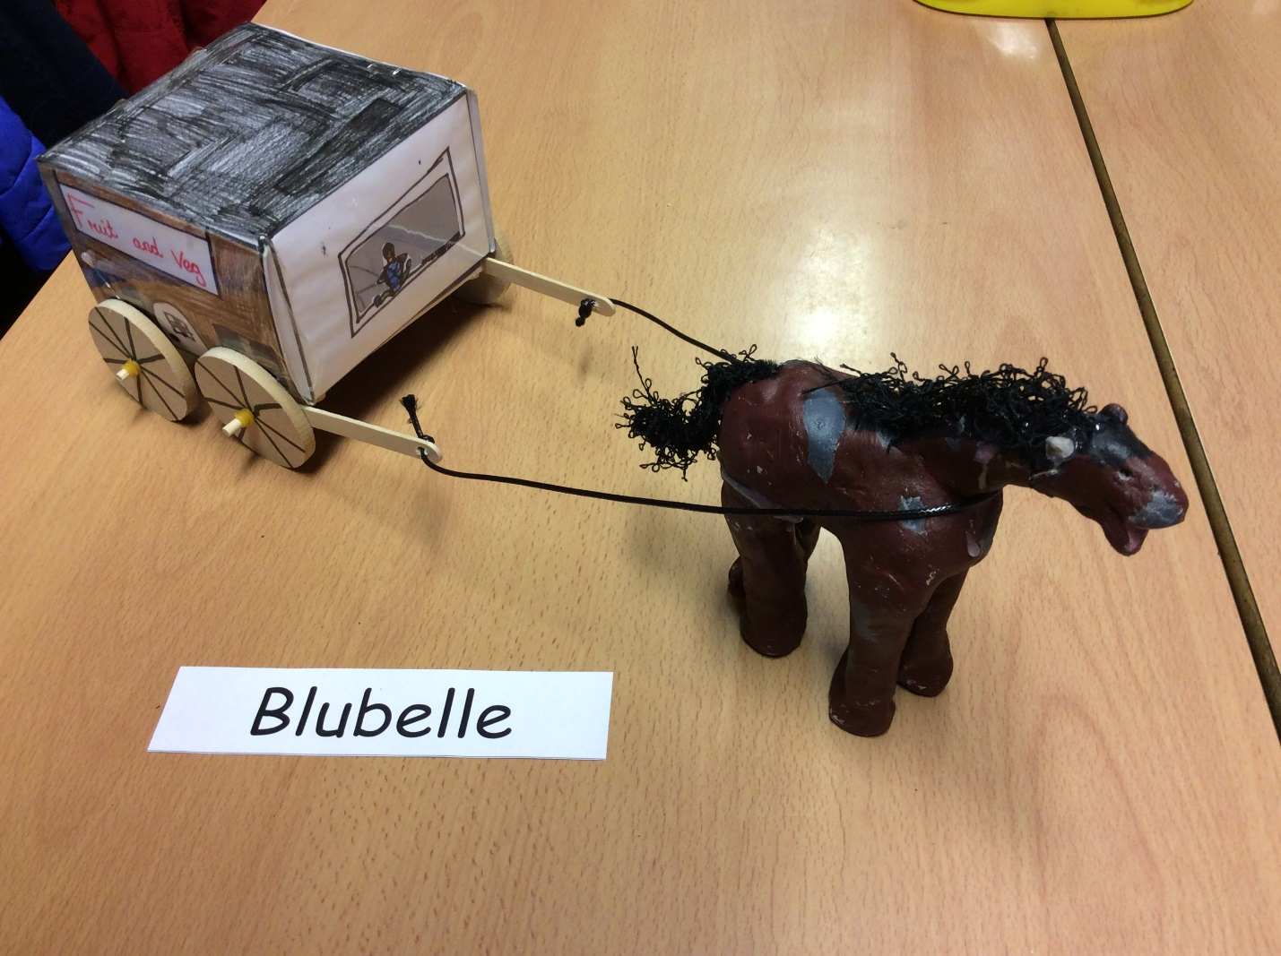

You will need:
- Paper (A3)
- Dowels
- Clay
- Glue gun
- Pencil
- Lollypop sticks
- Ruler
- Elastic bands
- Wheels
- Acrylic paint
- Colouring pencils/pens
- Nets
- Leather string
- Tape
- Plastic(laminator)
- Apron
- Clay tools

1. Firstly, download the copy of a net online.
2. Next, you cut out the copy. (Also the wheels). Score the lines with your ruler and pencil so you can fold them outwards.
3. Now you decorate it using your colouring pencils. Make sure you decorate it Victorian style. Check your drawings aren’t upside down too.
4. Afterwards, fold the lines and tape it quickly together so it doesn’t unfold itself.
5. You need to buy some clay tools to help mold it to look like a horse. Don’t worry if it doesn’t look like one just try your best with it. When you are happy with the shape of your horse let it dry for two or more days.
6. Now you will need to get the cart and stick the lollypop sticks to the bottom of the cart and let it dry by using hot glue so be careful. You may need an adults help. When it is dry get the wheels and put the dowels through the holes in the wheels. Put the elastic bands on before and after.
7. Then, you glue the dowels to the bottom of the cart.
8. Next, paint your horse and cart with acrylic paint. Wear an apron so it doesn’t stain your clothes.
9. Now you put the string around the horse.
10. Finally play with the horse and cart.
That is how you make a horse and cart.

