Resources You Need:
- Lollypop Sticks (x6)
- Clay
- Wheels (x4)
- Dowels (x2)
- Wires
- String
- Scissors
- A3 Paper
- Glue Gun
- Laminator
- Small bit of water
- Clay tools

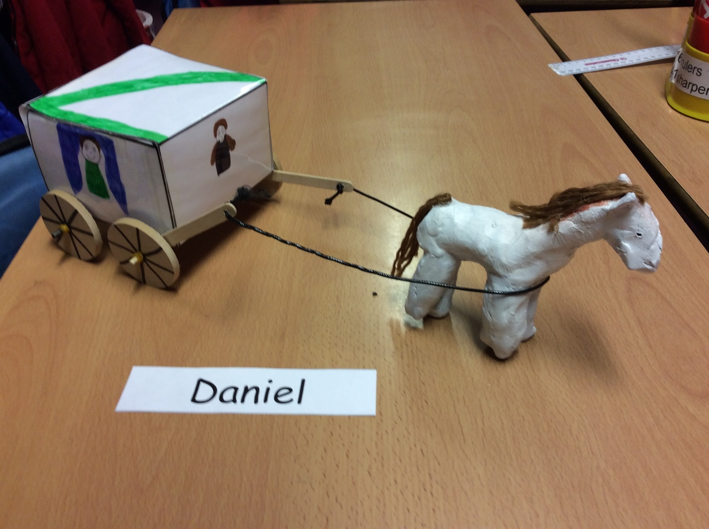

- First, get you’re A3 Paper (Link on our School Blog) then start drawing your design you want to draw onto the A3 Paper. (NOTE: all of the people on the carriage must fact inwards and should be the right way round.)

- Secondly go to your laminator (or the schools.) Then make sure everything you want is correct and then you can start laminating your design. Afterwards you can start to take your design of A3 laminated paper and leave it on the table.

- Next get your clay board and put it down on the table, get out your carving tools and start to make your design with the clay and then start moulding the clay into a horse but before that you need to make a head for the horse and then start to mould the body and then make the shape of the feet and ears (Not necessary for the eyes to be added or the mouth and nose to be added on to it so.) start sculpting the legs out and then sculpt the ears and nose out for the horse. Then leave it to dry for 4 days or less then leave it to dry.

- 4 Days later… Get your acrylic paint and start painting the legs and the body like ( Brown, Black and white etc.) I did mine with the colour white it looked so beautiful when it was painted. Then once the paint has dried get your four wheels and a small elastic band and put the wheels onto a stick and add elastic bands attach them onto the wheels and make sure the wheels are secured on it. Then draw the spokes onto the wheels and get a piece of string and get your horse and attach the string to the front of the horse and make it secure.

- If you have spare clay you have left over you could make something else like a decoration onto the top of the cart or you can add a saddle onto the horse and paint it brown or your choice of colour.

