How to make a horse and cart

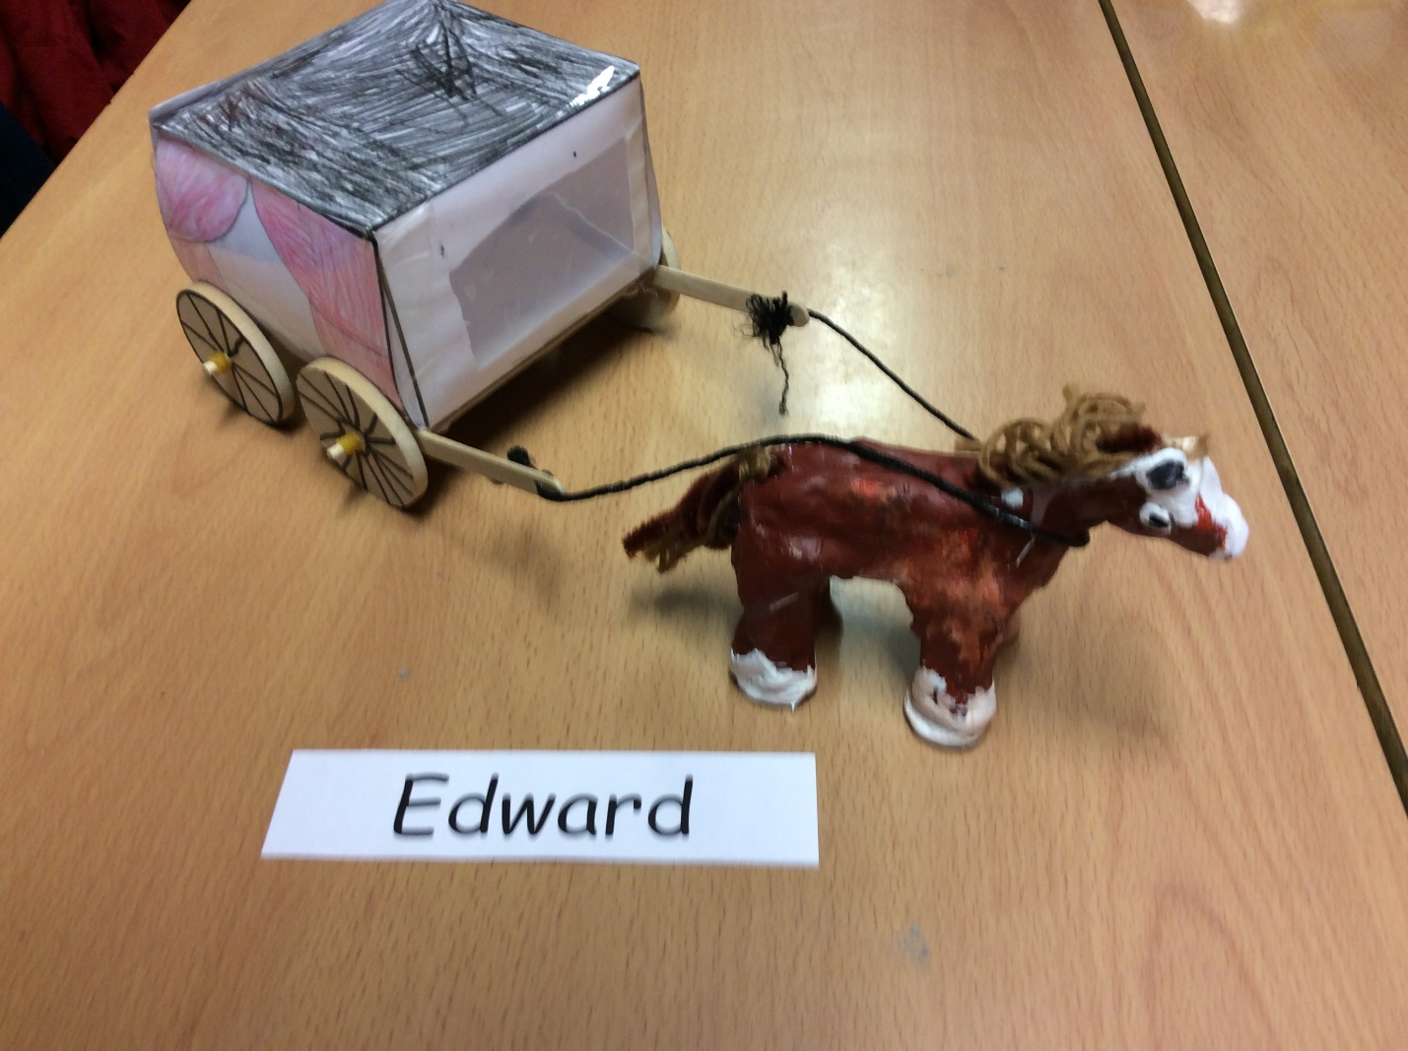
For these instructions you will need:
. Lollypop sticks (6)
. Glue gun
.clay
.Dowels (2)
.wheels (4)
.elastic bands (6)
.laminator
.colouring pencils
.string
.paint
.brushes
.clayboards
.claytools
.paper (A3)
.ruler
.led pencil
.ipad
.scizzors
.sellotape
.leather string

Carriage
1. Get your paper and ruler, then get your pencil and search on the internet for ‘How to draw a net’ on your ipad or computer.
2. Once you have finished drawing the net, draw lines hardly each flap. (scoring)
3. Make sure that your flaps are very crisp. Fold each flaps to shape into a box.
4. Once that’s done, turn the box upside down. Get your six lollypop sticks and stick them with a glue gun down in a square line. Now you will have two lollypop sticks left.
5. Get your two dowels and stick them on the back of the carriage and the front of the carriage.
6. Pick up your wheels. Get two wheels and push them through one end of a dowel.
7. Grab your two lollypop sticks and
Horse
- Slap your clay onto the table and dump it or slam it onto the clayboards.
- Take a quarter of clay away from the main clay, then take a medium sized part from the clay.
- Make your main clay and shape it into a horses body. If you do not know how to do it, look on the internet to see horses bodys.
- Once that’s done shape your medium sized clay into a tail. (split the clay into two quarters)
- Use one of your quarters and turn them into fat, tall legs.(make sure that its secure for the body weight)
- Finally shape the rest of the clay into a nice head.
- Then smooth every part of the body onto the body. Then you have a perfect Horse and Cart.

