How to make a horse and cart
To make this project you will need:
.clay (quit a lot)
.acrylic paint x4
. Wool
. A3 paper
.wooden wheels x4
. Elastic bands x6
. Colouring pencils
. Leather string x1
. Paint brush x2 (big and thin)
. Glue gun
. Dowels x2
. Clay tools x3
. Laminator
. Sellotape
. Paper plate
. Lolly pop sticks x6
. Black pen and ruler x1
. Apron
First, you have to get a big lump of clay and make it into a shape of a horse it needs to have a very straight back and a neat head if you wanted to you could add two little ears to it.
You can smooth legs on to your horse or carve it in.
WARNING: make sure you tell your adult first and do it on a table which is not your dining table!

Next, you have to let it dry for 4 days or more.
4 days later, when your horse is dry you can paint it but…
You can only use acrylic paint
WARNING: be careful, acrylic paint can easily go on your clothes, AND WILL NOT COME OFF! When you’ve Finnish
You can go on to your carriage.

CARRIAGE
First, you need A3 paper and a black marker and a ruler and a laminator. Before you start you need to laminate your paper, ask a parent to do it for you because it is really dangerous!

Use your marker and ruler to draw this diagram below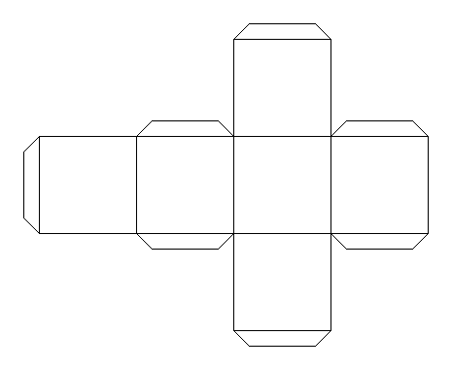

For the cube you need 12cm each.
Decorate your cube before you put it into shape and be careful because one side has to be upside down and one has to be facing normally.

Get 4 lolly pop sticks as a base and stick it at the bottom of get two lolly pop sticks and drill two holes to it and get your leather string and knot it to the holes to make a harness. Put two dowels under the base and leave a big gap between them.

Lastly, get four wheels and draw spokes to it then use your 8 elastic bands and put the wheels on your dowels then put each wheel in front of it and put another elastic band in front of the wheel.

