How to make a Victorian horse and carriage

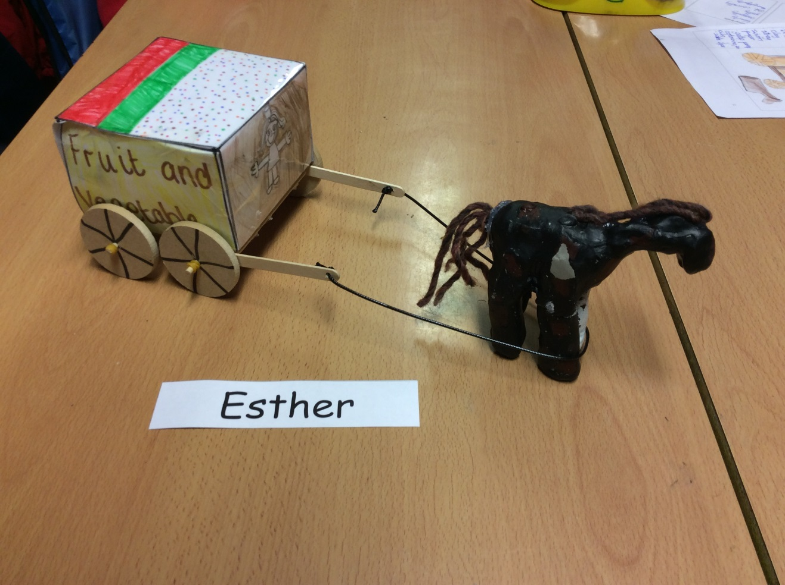

Things you will need:

-scissors

-water

-felt tips

-whiteboard pen [black]

-rulers

-net

-lollypop sticks

-glue gun

-A3 paper

-colouring pencils

-clay tools

-dowels [2]

-Elastic bands [6]

-wheels [4]

-Acrylic paint [Different colours]

-spokes

-laminator and clay

How to make a carriage

You use a A3 piece of paper you use a ruler to draw a line on the paper which was first 1cm,8cm,12cm and then turn it landscape and do it 1cm,8cm,12cm and then when you have finished it you have to colour it in.

Secondly, you will need to laminate the net and you have to score it with a ruler and a pencil on each line.

Thirdly, you need to fold your net into a carriage in a box carefully.

Next, you need to get two pairs of lollypop sticks and also four pairs of wheels and two more lollypop stick if it breaks.

After, you will need elastic bands carefully forcefully put the wheel on the dowel and then get the string on the hole of the lollypop stick.

Attach the two lollypop sticks on the wheel and add one elastic band

How to make a carriage

Firstly, get the clay and use your hands to make horse so then you use your hands to make a model of a horse if you are a bit stuck you can make a big tummy then make four legs and then do a head and put eyes and a mouth on the face. Then, you have to use a tool to push it all together so it looks like a horse.

Secondly, let it dry

Then , when it is dry paint it and when the paint is dry use some furry string for the mane and tail .

