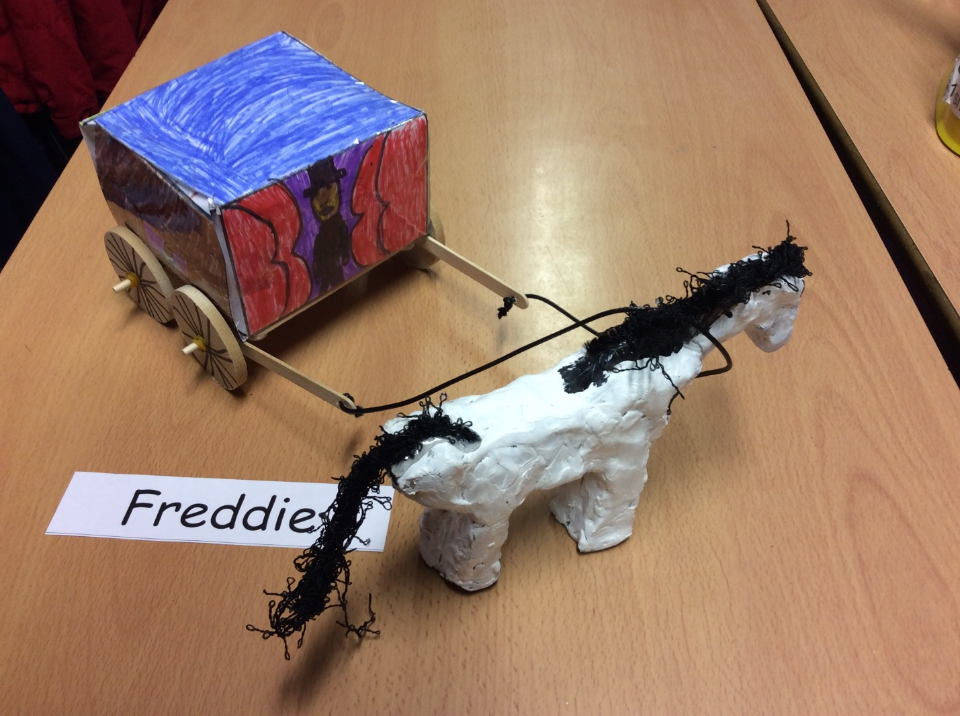
How To Make A Horse And Cart

Resources
piece of leather string, 4 wheels, felt tips, 2 spokes, ruler, white board pen, pencil, paint brushes, paint, water, paint pallets, clay boards, sellotape.
Method
Firstly, you go onto a website and download a net if you cannot make it yourself or if you can you have to do it very accurately.
Secondly, draw a design on it but make sure to put them the right way up or else they will be upside down and do not mistake the bottom for the roof. WARNING do not cut off the flaps or you will not be able to stick the carriage together
After that, score the lines where the flaps are with a ruler and pencil so they are nice and floppy so the flaps can get stuck on to the cart. When you have done that stick it together with sellotape and make sure it is stable.
Next, carefully force the wheels onto the dowels secure it with an elastic band.
When you have done that tie the piece of leather string through the holes of the lolly pop sticks. Next, divide your clay into sections and take a piece and shape it into a body. Then create legs and smooth them onto the body then carefully moled a head and use a pencil to poke in eyes.

