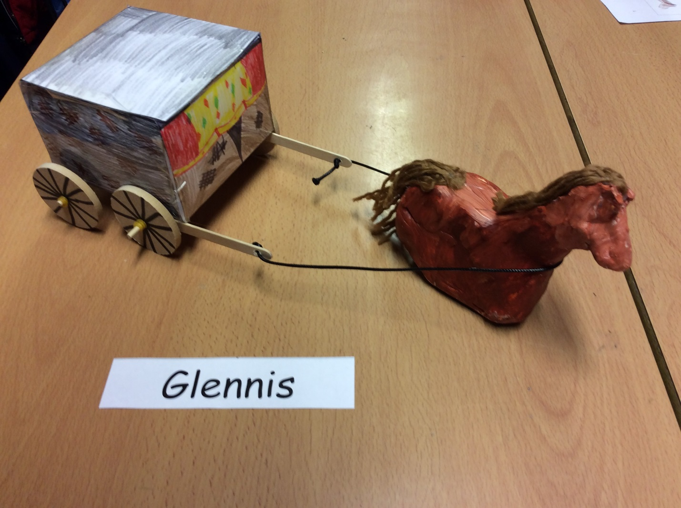
How to make a Victorian horse and cart

Resources
Lolly-pop sticks
Glue gun
Air-dried clay
Dowels
Wooden wheels
Elastic bands
A3 paper
Acrylic paint
Leather string
Scissors
Optional: colouring pencils
Pencil
Ruler
Tape
Optional: felt-tip pens
Wire

Instructions
1. Firstly get A3 paper and ruler and pencil.
2. After this download a cube net online and copy it on your A3 paper.
3. Mindfully cut out your net and be careful not to cut off the flaps.
4. Steadily use your pencil and ruler to go over your folds also, do that to the flaps as well.
5. Optional: colour in your piece of paper but don’t colour the bottom because it won’t be seen.
6. Then fold your paper outwards and carefully glue or tape to stick the sides altogether.
7. After this get a dowel and put a elastic band on the dowel make sure the elastic band is all bunched up then put your wooden wheel on top of the band and put an elastic band on top of your wheel do this to the other end of the dowel.
8. Next do the step7 again
9. Glue lolly-pop sticks on the side on your first two sets off wheels.
10. Get leather string and tie it on the first side of your lolly pop sticks.
11. using your air dried clay create it into sections I advise you to get half of your clay to make it into thirds first make your legs for the horse. Make the legs really big because if it isn’t it can easily snap off. As you finish the first leg make three more. Next, using half off your clay make a big body. Finally make a neck and a head and its optional to make a tail for your horse.
12. Lastly, attach your horse on the leather string and you’re done.

