How to make the horse and cart
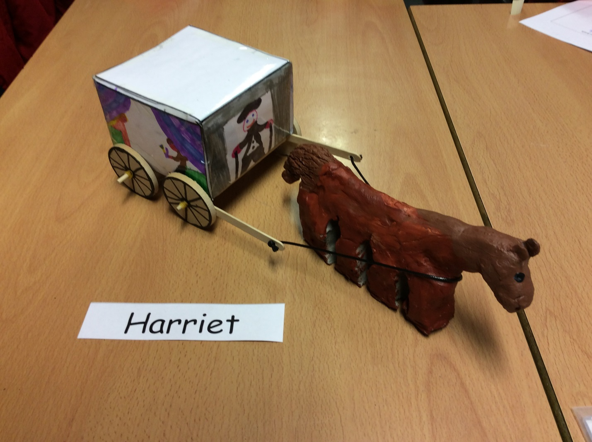

To make a horse and cart you will need:
. Lolly pop sticks x6
. A lump of clay x1
. Dowels x2
. Wooden wheels x4
. Elastic bands x6
. Colouring pencils/pens
. Leather string x1
. A3 paper x1
. Glue gun x1
. Glue sticks to put in the glue gun x5
. Clay tools X3
. Sellotape/stapler X1
. A laminator x1
. A bundle of wool (optional)
. Paint x4 (brown, red, white and black are best) and a paper plate x4
. Paint brushes x4
. Biro or sharp pencil x1
. Ruler
. White board marker
Here are instructions to make the cart:
Firstly, gather all the items on the list and cover the table you were sitting at with newspaper because this might get a bit messy.
WARNING! Don’t forget to make sure your mum’s best shawl is not on the table before you
start.

. Down load the net from the internet.
. Next, with pens and pencils colour the net, make sure your drawings aren’t upside down.
Laminate your drawings while there still on the net.
Cut out your net so you’ve got a wired shape.
Fold the edges outwards and sellotape or staple to make a cube.
Stick 4 of the lolly pop sticks onto the bottom of the cube to make a base. (Use the glue gun)
Now, stick the two dowels on the base and wrap an elastic band around the end back ones to help you later on in the task.
With the white board pen and wooden wheels so they have spokes.
Put the wheels onto the dowels and secure with another elastic band but leave enough space for the wheels to move.
Tie the leather string to the lolly pop sticks.
Now put the cart to on side.

How to make the horse:
Carefully, take out the clay and put it onto the newspaper.
Warm up the clay by rolling it in your hand.
Model the clay so it is a horse with eyes, ears, a tail and a nose or even a main.
Add texture with the three clay tools.
Leave it to dry in the sun for maybe about 4 days.
Put paint onto the paper plates and carefully paint your horse.
Leave it to dry for about 1-2 days to dry.

How to connect them together:
Simply, put the leather string around the ears so they will stay there.

