How To Make A Victorian Style Horse And Cart
You Will Need:
- Air Drying Clay
- Dowels
- Glue Gun
- Lollipop Sticks
- Elastic Bands
- Wooden Wheels
- Acrylic Paints
- Felt Tips
- Internet
- Leather Strings
- Wool
- Laminator
- Pencil Sharpener
- Sellotape
- Ruler
- Pencil
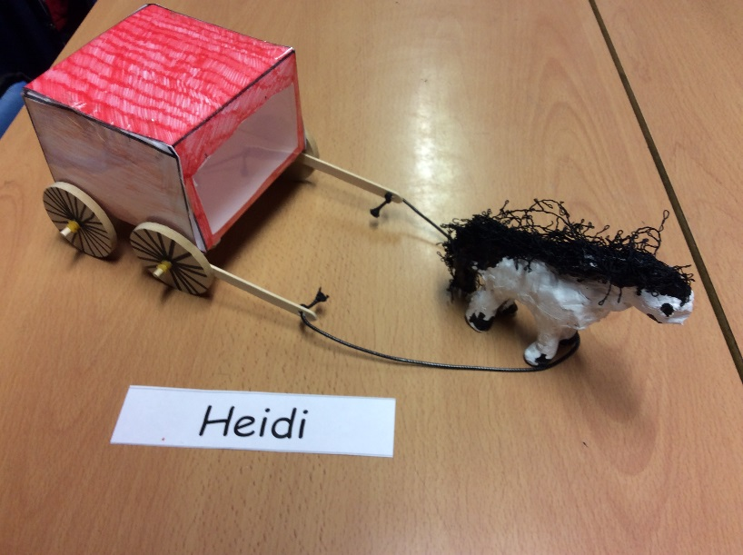

- Firstly, you need to download an A3 copy of the net of a cube.
- Then, you colour it in using felt tips.
- After you have done that, use a laminator to laminate your net.
- You have to score the lines with a ruler and a pencil before folding it, but once you have, you can fold it into a cube. Sellotape the edges together.
- Fifthly, you put two lollipop sticks on the ends of a dowel. The lollipop sticks have to have holes in them. If they won’t go through, use the pencil sharpener to sharpen the dowel, and then they’ll go through.
- Next, put an elastic band on either side of your dowel.
- Before attaching your wooden wheels, use felt tips to draw spokes on them.
- Slide your wheels on and sandwich them in with another two elastic bands.
- Glue gun the dowel on and make another dowel, elastic band, wheel, elastic band pattern – then glue it on.
Warning! The glue gun is hot. You need help from an adult.
- Take a chunk of air drying clay, and sculpt a horse. Remember to include the ears, mane, and tail. You need to make sure your legs are stable enough to hold the weight of your body. This will take approximately two days to dry.
- Meanwhile, tie your leather string through the holes in your lollipop sticks.
- When the clay is dry, use acrylic paint to paint them.
- Afterwards, (when your paint is dry) use wool to add extra tail and mane. You will need the glue gun.
- Put the leather strings around the horse’s neck so it can be pulled along.
- Finally you can use it!

