How to make a horse and cart out of clay
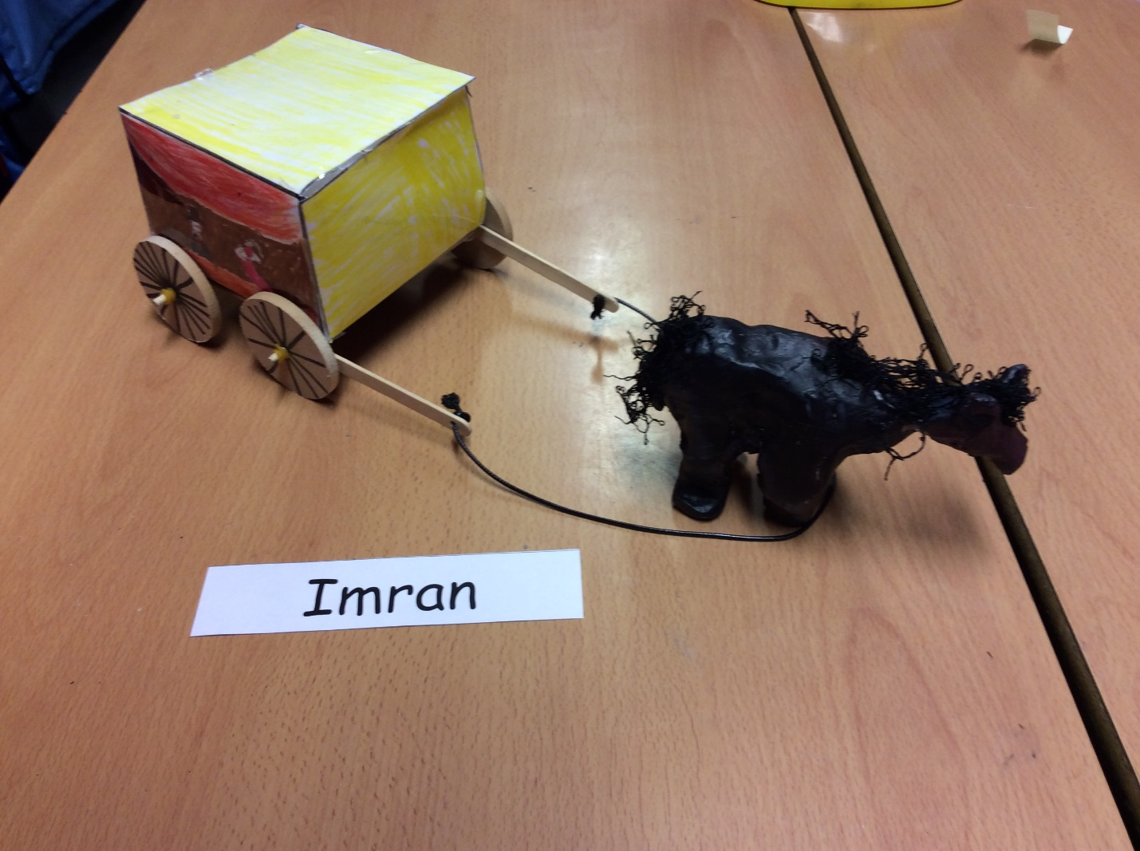

Introduction
These are a few instructions on to make a horse and cart but before that lets tell you the thing you will need to make your horse and cart

You will need
- Ruler
- Net
- White board pens (this is only if you want to)
- Felt tips and colouring pencils
- Pencils
- Scissors
- Glue gun
- Dowels
- Lolly pop sticks
- Elastic band
- Aquatic paint
- A3 paper
- Air dry clay
- Spokes
- Laminator
- Leather string
- Water
Now were on to the part on how to make your horse and cart let’s start we shall?

Step one: Firstly you will need A3 paper and a ruler and a pencil. After you’ve got all of those draw lines on the paper. I really can’t explain this part very well because it’s very tricky I diddent get it either so let’s skip this part. After you’ve done your lines score the lines and then fold the sheet of paper into a box that looks a bit like a minecraft chest.
Step two:
Secondly (for this part you will may need an adult of some kind or a person that’s old enough to know how to use a glue gun or and a laminator. Colour your box with felt tips or colouring pencils then Ask someone to help you laminate your chesty box
Step three: Thirdly you need 2 lollypop sticks 2 dowels 4 elastic bands leather string and 4 wheels carefully force the wheel into the lollypop sticks and use the elastic band to secure it and put the dowels on after
Step 4: get some air dry clay and make your horse any way you want to use water to smooth it and after you’ve made your horse in a few days paint it with Aqulick paint. After that just get some leather string and force it into the dowel And there you go you’ve made your own horse and cart

