VICTORIAN HORSE AND CART

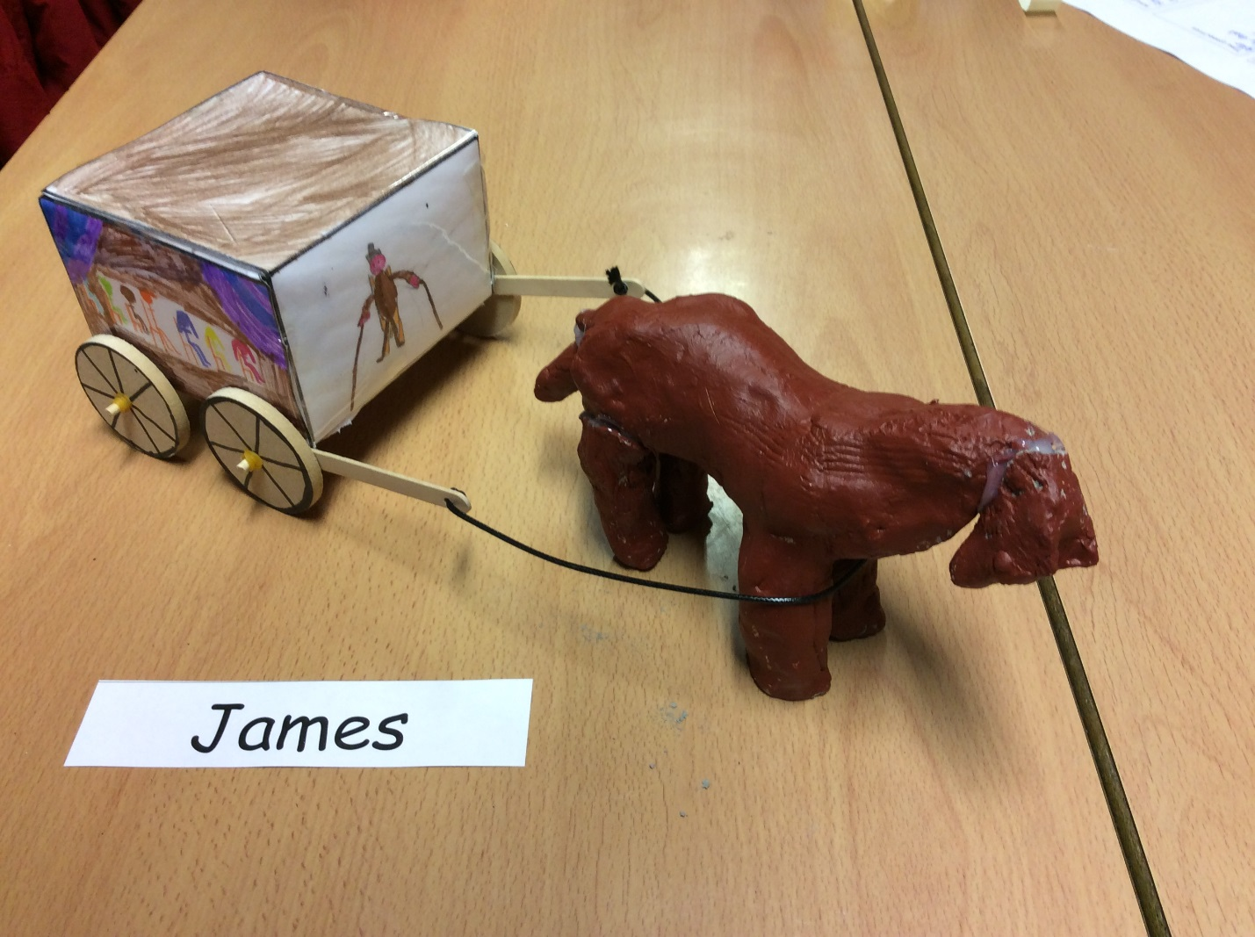

You will need:
- Ruler
- Nets
- Dowels
- Clay
- Glue gun
- Pencil
- Lollypop sticks
- Elastic band
- Wheels
- Acrylic paint
- Leather string
- Laminator
- Paintbrush
- Apron

Method:

- Firstly, get your net and laminate it.
- Then, draw some people on your net (optional).
- Next, make the net into a cube and tape the sides together so that it stays the same shape.
- After that, you need to make the horse out of clay. I would recommend splitting the clay in half. One side for the body, the rest for the other parts. Make sure that the legs hold up the body, but if you want you can just carve out the legs.
- You will then need to get your wheels and put them on them on the dowels. Make sure that you have an elastic band on each side of each wheel so that it doesn’t fall off. Make sure it’s not too loose!
- Stick your dowels onto a lollypop stick and put the lollypop sticks at the bottom of your carriage so that it moves. Use a glue gun so that it is secure.
- Next, carefully paint your horse with acrylic paint so that it dries quickly. Try not to put spots on it because it could end up looking like a cow! (Warning, if you get paint on your clothes it will stain, so always wear an apron).
- Get your leather string and somehow find a way to connect it to the horse and cart.
- Now your Victorian horse and cart is ready to play with!

