How to make a Victorian styled
Horse and cart
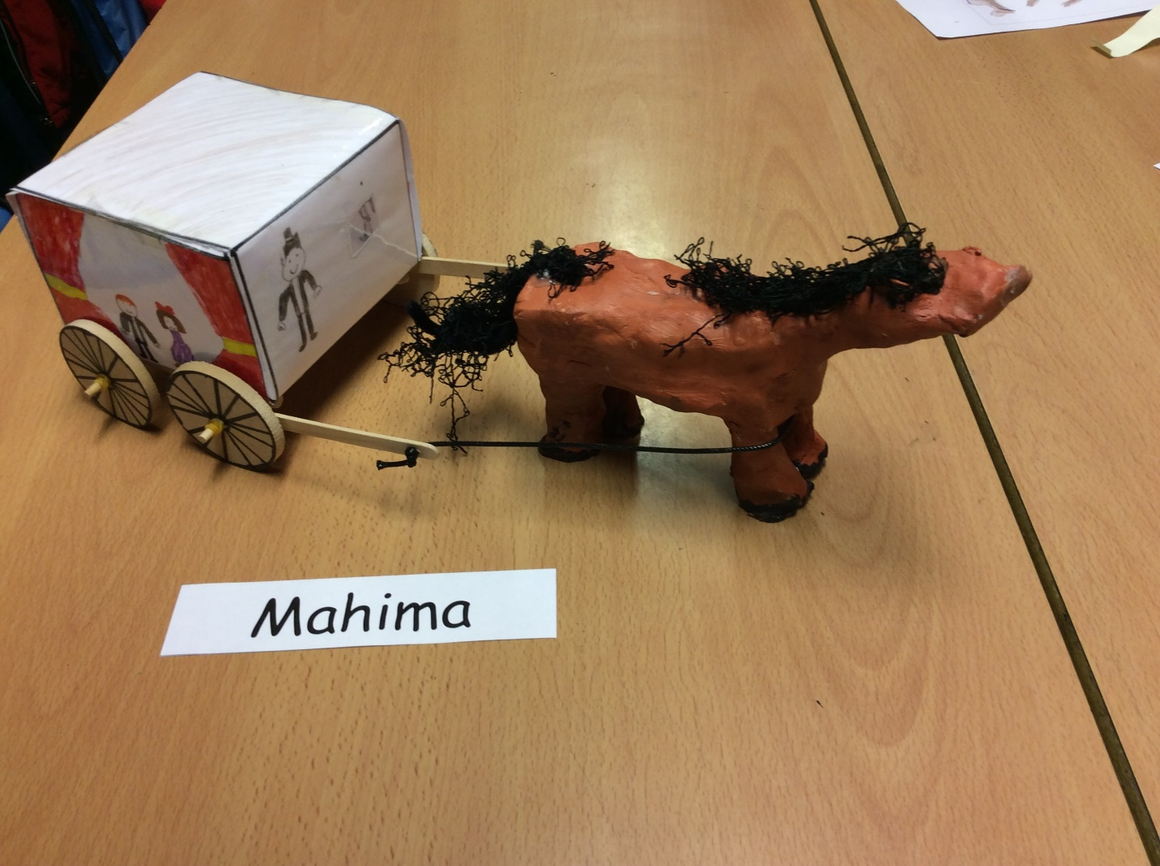
Resources
. Clay .pencil .paint brushes
.paint .water .paint pallets
.White board pen .clay board .sellotape
. Scissors . 8 rubber bands .2 spokes .ruler
. Clay tools (e.g. a clay smoother tool)
. Glue gun
. A3 paper
. 2 dowels
. 6 lolly-pop sticks
. 1 piece of leather sting
.wheels .colouring pen or pencils
. Laminator

Method
- Firstly, get your ruler and your A3 paper and draw lines vertically and horizontally. Some 8cm, 12cm, and 1cm lines. Then cut flaps on the sides
- When you have finished doing that, you can colour it in. (You could draw some Victorian people sitting in there. Optional)
- Next, get your laminator and laminate the A3 paper.
- When you have laminated it, start folding the flaps and the other lines. Make the lines with your pencil and ruler so that you can score them and make the as sharp as you can.
- After, sellotape the bits you have folded.
- To make them more secure, use your glue gun. WARNING: GLUE GUNS ARE HOT!
- Then leave it to dry
- When it is in the process of drying, start making your horse with air drying clay.

Tips:
. Try join the horse’s body parts so it can stay nice and secure.
. Also don’t make the body parts so thin otherwise it could snap.
.always make the horse smooth so it can connect and it when you paint it, you don’t have a bumpy surface.
- Leave it to dry
- When your carriage has dried, get your 4 wheels and draw spokes (wheels) on each one.
- Then tie the rubber bands on to your 2 dowels, 4 on each side then connect the other 2 lollypop sticks.
- Then connect your wheels and on top of that put your rubber bands on top. (One on each side.
- Then make a hole in 2 lolly sticks which are in front and then weave the leather string and tie 2 knots so it stays there.
Now you have made your cart!

You horse will dry in a few days
- Now it’s time to paint your horse.
- When you have painted it leave it to dry.
- When its dried then you have made your horse and carriage!

