RESOURCES
Lollypop sticks,dawels, glue gun, elastic bands , chunk of air dried clay, A3 paper, wooden wheels, acrylic paint, celetape,scisors and felt tip pens
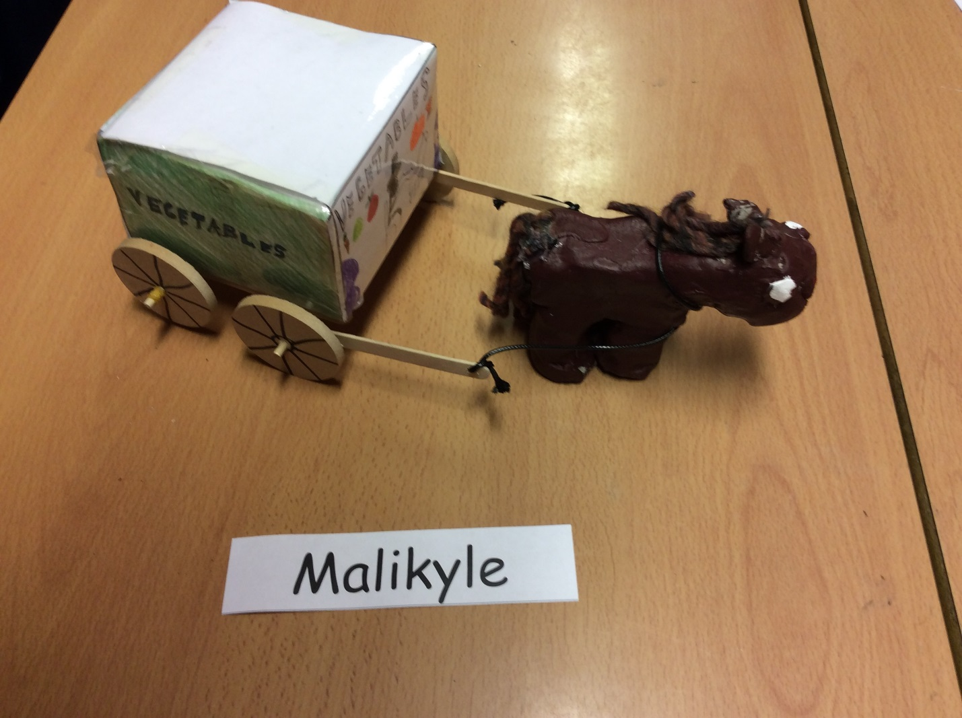

1) First of all, you will need to get your net and start folding the flaps into a cube (before folding it into a cube you will need to score it to make the folding easier)
2) After, you folded the net into a carriage, you can add decorations onto it like adding a driver and on the back you can add a licence plate, and a ladder.
3) Next when you have created the cube you should glue gun the lollypop sticks into a square on the bottom . Then add the two dowels in the holes on the lollypop sticks (use a drill to make holes-remember parental supervision)
4) After you add the two dowels to the lollypop sticks, you get your small wooden wheels and add them on. Once you add them on put an elastic ban there so the wheel does not fall off.
5) When, you connect the wheels, connect a piece of leather string on it and you will find out what you use the leather string for.
6)Next when you have done all that you have created your carriage, so put that to the side somewhere where you can find it and get your piece of clay out.
7) Once you get your clay, out cut half of it and start moulding it into a body of a horse.
8)Then, when you have done that start moulding a quarter of it into legs and attach them to the bottom of the body you can use water and put it onto the part of the leg you are attaching to the body to make it easier to attach.
9) After, you done that use the rest of the clay to create a head ears and eyes.
10) When you have done that you can paint your horse using acrylic paint.
11)Then you connect the horse to the leather string

