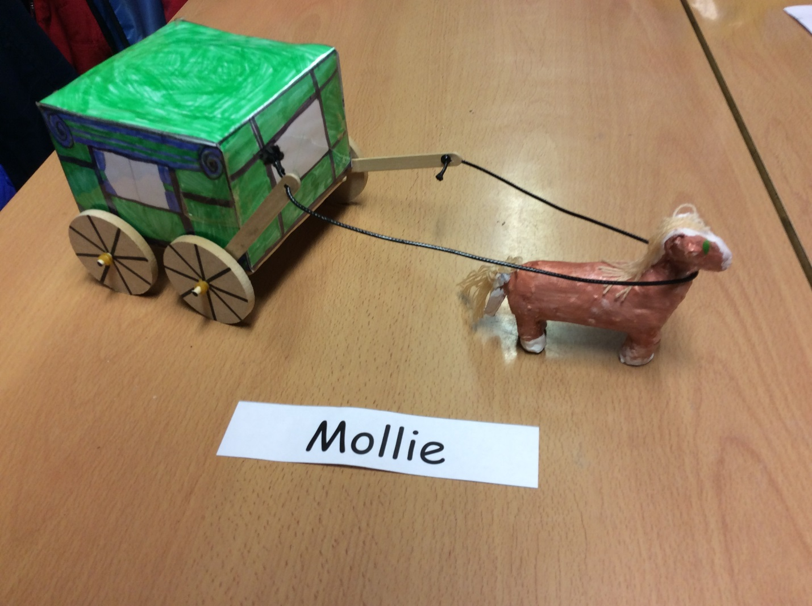
HOW TO BUILD A HORSE AND CART

If you want to learn how to make a horse and cart please read on.
Resources:
- Some clay
- A pair of scissors
- 6 elastic bands
- Some clay tools
- A glue gun
- A sheet of A3 paper
- 2 dowels
- 4 wheels
- 6 lollypop sticks
- A piece of leather string
- A laminator
- Some felt tip pens
- A white board pen or permanent marker
- Some colouring pencils
- A ruler
- Some paint
- Some paint brushes
- 2 cups of water
- A paint pallet (a paper plate will do)
- A clay board
- A computer
- A roll of tape
- A ball of wool
- A printer

Method:
- Firstly, draw a net of a cube, but if you can’t draw it as it needs to be very accurate just print it off from the internet.

- Secondly, draw a design on your net.
Make sure it is the right way up!

- Next, laminate the net and carefully cut it out only along the outside lines.
Be careful not to cut of the flaps!
- After that, carefully score the lines where you will fold it by getting a ruler and lining it up with the lines and score it with a pencil. Once you have done that fold where you have scored.

- Then, tape it together making sure it is a secure cube shape.

- Now, put spokes on the wheels and forcefully push 2 wheels onto the first dowel and wrap an elastic band to each side next to the wheels.

- Afterwards, powerfully put 2 lollypop sticks on the second dowel leaving enough room for the cart to fit in the middle. Add on the other 2 wheels to the side of the lolly pop sticks and secure it with another rubber band.

- After this, with a glue gun make a base with four lollypop sticks and connect it to the cart.

Two lollypop sticks need to be on the top and two on the bottom.
- After, glue gun the dowels with the wheels onto the base – Alert! Make sure the wheels turn.

- Whilst it is drying, tie the leather string onto the lollypop sticks – Warning! It is easy to fray and comes apart.

- Get your clay and make a horse by first making the head separate from the body and the legs separate as well. Join it with your tool and some water to make it smooth.

- Then let the horse dry and paint it with horse colours like grey, black, white or brown.

- Now enjoy playing with your wonderful horse and cart!

