Warning! If you do not want to know how to make a Victorian horse and cart, do not read on. Anyway, let’s get into it!
How to make a Victorian horse and cart
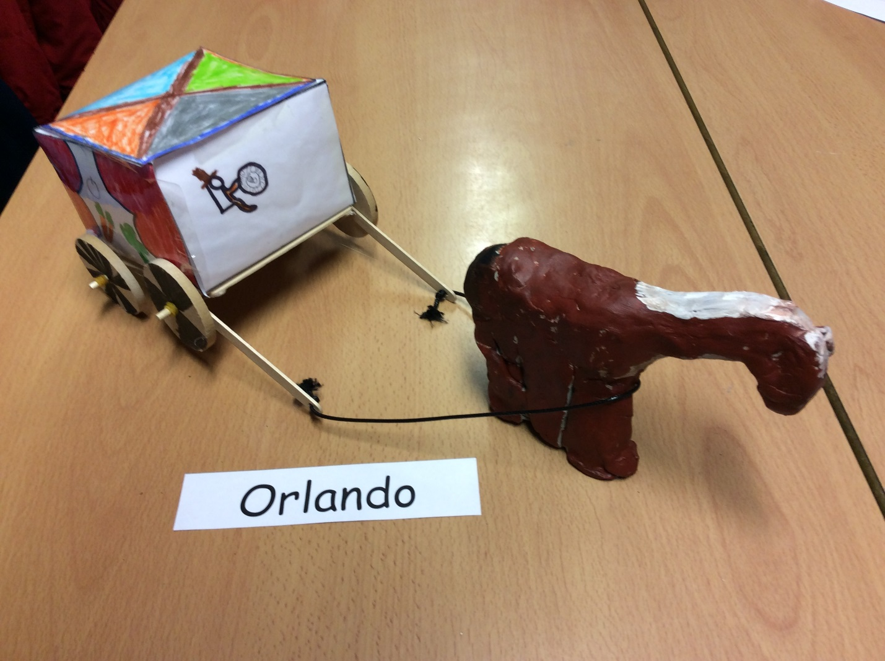
These instructions will be amazing and you will get a really good result.

You will need:
- 4 lollypop sticks
- 2 dowels
- 1 glue gun (just in case anything snaps or breaks)
- 6 elastic bands
- A chunk of air-dried clay
- Acrylic paint
- Celetape
- A piece of paper which is a3 size
- Scissors
- Felt tip pens or colouring pencils(maybe both if you want to)
- Carving tools
- 4 wheels(wooden ones)
- Sunlight(if you want it to dry quickly)
- Laminating machine
- Laces(does not have to be from a shoe though)
- Whiteboard ben(which has black or brown ink)
- A ruler
- A pencil

Now that you have everything, let’s start making the horse and cart.
How to make the cart
First of all, you get your a3 sized paper and your pencil and ruler and draw a net. (Look on the school blog and download the instructions of how to draw a net). Ask an adult if you need help with this.
Once you have done that, draw some pictures of anything you wish to be on your horse. Make sure your drawings are not upside down because when you fold it, your drawings might be upside down and you will have to start all over again. Ask an adult if you are not sure which way your drawings are meant to be. If your adults say it correct, give it to them and ask them to laminate it with a laminator. Do not do it yourself. It is extremely dangerous!
After it has been laminated, download then instructions on the blog of how to score the lines and how to fold your net correctly into a cube shape. If you have folded it and your people are the correct way up congratulations! But if they are upside down, I am very sorry but you will have to start all over again.
If you have completed that correctly, celetape it together.
Now you have completed that, it is now time to do something else. Congratulations you have completed your cube!
Get two of your lollypop sticks and one of your dowels. Once you have got your stuff ready, you put your lollypop sticks onto your dowel. Yes it will make a hole but it does not matter at all.
Now get 2 elastic bands, 2 wheels, a lace and a whiteboard pen. Draw spokes however you like on the wheels you are about to use.
Once the wheels are complete, get your elastic bands and tie them onto your dowel. Get your lace and put it at the front
Do that again and then glue gun it together.
Then you get your clay and download the instructions of how to make the horse. Don’t forget that the horse needs to stand up.
I hope the instructions were useful.

