How to make a Horse and Cart
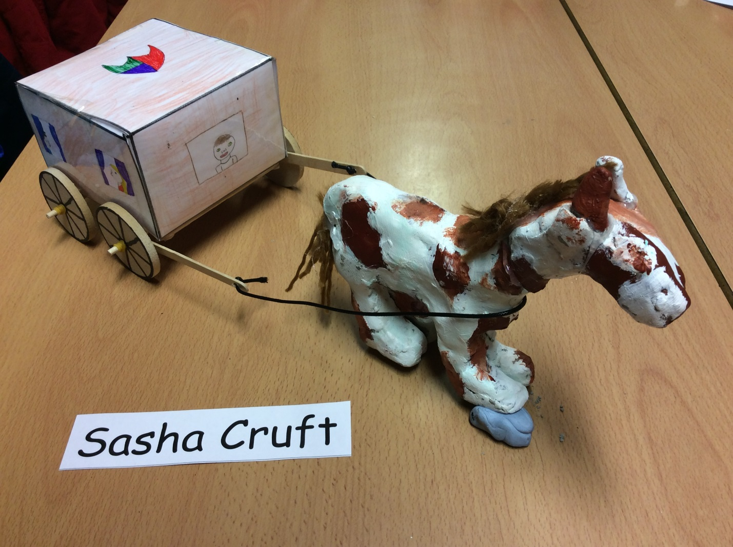

You will need:
- Lollypop sticks(with holes drilled in both ends)
- Glue gun
- Clay
- Dowels x2
- Wheels x4
- Elastic bands
- Laminator
- Colouring pencils
- Leather string
- Acrylic paint and paint brushes
- Clay-boards
- Clay-tools
- Paper
- Ruler
- lead pencil
- iPad
- Scissors
- Sticky-tape
- Printer
- Wool

- First collect all you resources.
- Next, search on the iPad for an example of a cube net and print it out.
- Then, colour it in (Make sure if you are drawing people that they are the right way up!)
- Now, use your laminator to laminate your print out.
- After this, you must score the lines of the net.
- Then, you use your sticky-tape to put your cube/cart together.
- Now, get 4 lolly-pop sticks and glue gun them into a square shape and attach this to the bottom of your cube while the glue gun is still hot.
- Then, get one of your dowels and put and an elastic band about 2cm down one end of your dowel, repeat this step on the other end of the dowel.
- Now get your other dowel and attach one of your lolly-pop sticks to each end and then attach one wheel onto each end of all your dowels then, go back to your first dowel and put elastic bands on the ends of the dowels to secure the wheels in place.
- Now use your glue gun to glue your dowels to the cart.

Horse
- Now get your clay and cut it in half.
- Put one of your halves aside and cut the other half into thirds one of these is going to be your legs, so separate that into four pieces and make them fat sausages.
- Next get your other two pieces and fashion one of them into a horse head like shape (if you don’t know what a hose head looks like use the iPad).
- Now, get the other third and make a neck.
- Use, the half and make a body.
- Next, use your clay-tools to smooth the body parts together.
- Leave that to dry for 4 days.
- Then get your acrylic paint out after it has dried and paint your horse.
- Now you can glue gun your tail and mane onto your horse
- Next attach your leather string to the holes in the lolly pop sticks and put your horse under the “reins”.
- Here is your finished product!

