HOW TO MAKE A VICTORIAN HORSE AND CART IN ONLY A FEW EASY STEPS
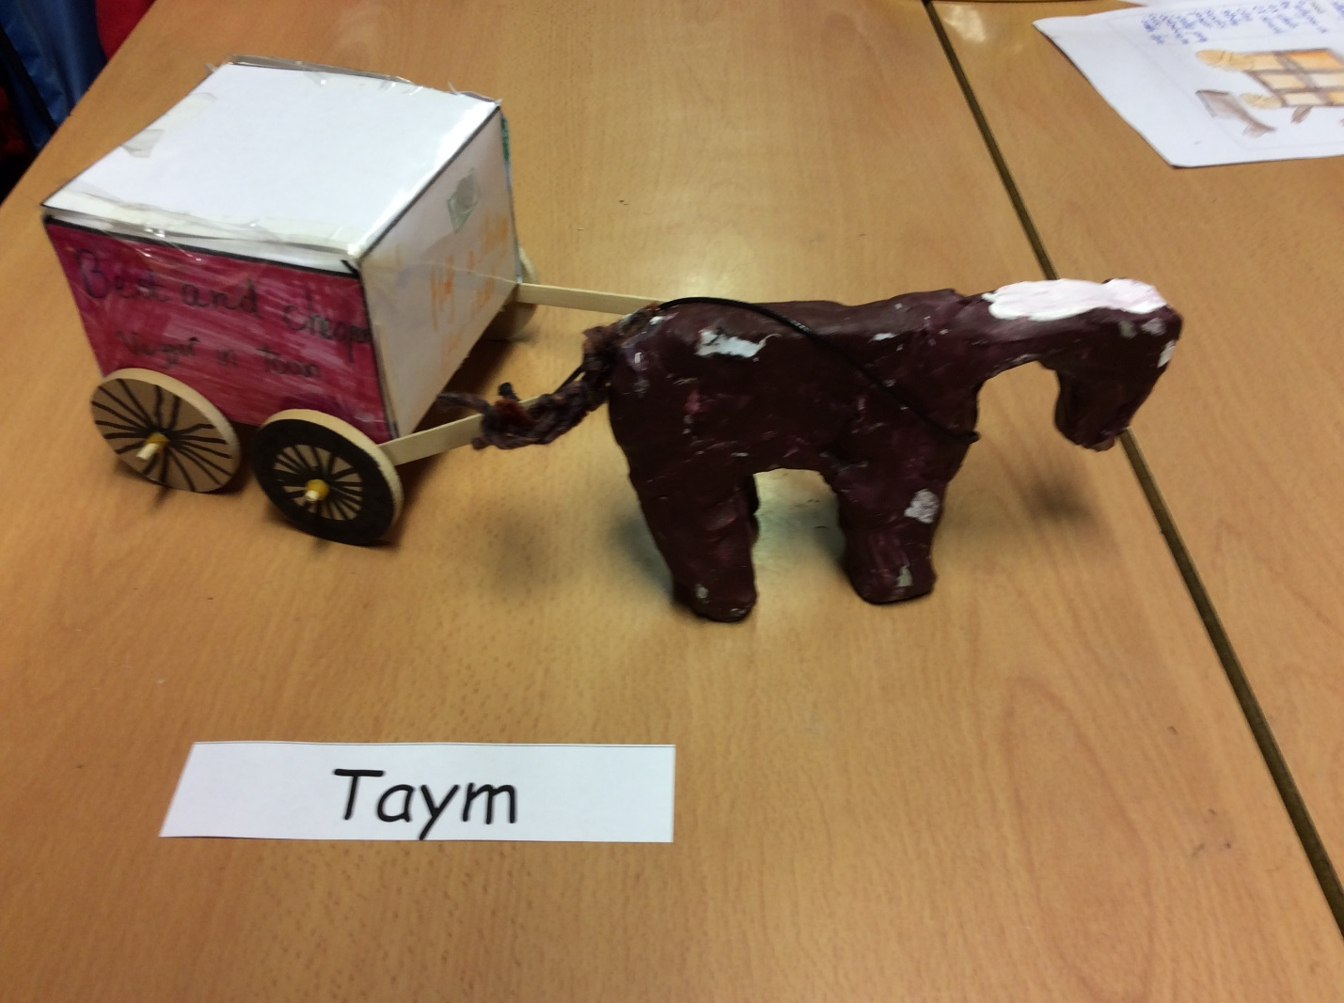

To make your horse and cart you will need:
- Glue gun
- Lollypop sticks (2)
- Air dried clay
- Paint brush
- Acrillic paint
- A3 paper
- White board pens
- Dowels (2)
- Wheels (4)
- Elastic bands (4)
- Clay tools (optional)
- Colouring pens and pencils
- Selotape
- Leather string
- Laminator (laminating machine)
- Net
- Pencil and ruler

Step 1: Firstly get a piece of A3 paper and draw a net on it.
Step 2: After you have drawn your net you can colour it in.
Step 3: Then laminate it and once you have laminated it cut it out neatly.
Step 4: Next get a ruler and a pencil and start scoring it where there is lines then fold it out.
Step 5: Now you start by getting a lump of clay for the horse and take one third of the clay for its body and the rest of the clay for the rest of the horse.
Step 6: Then sculpt your horse and try and make it as realistic as possible.
Step 7: Then fold your A3 piece of paper where you have scored it.
Step 8: (if it looks like a square box you have done it right if it doesn’t look like a square box try again).

