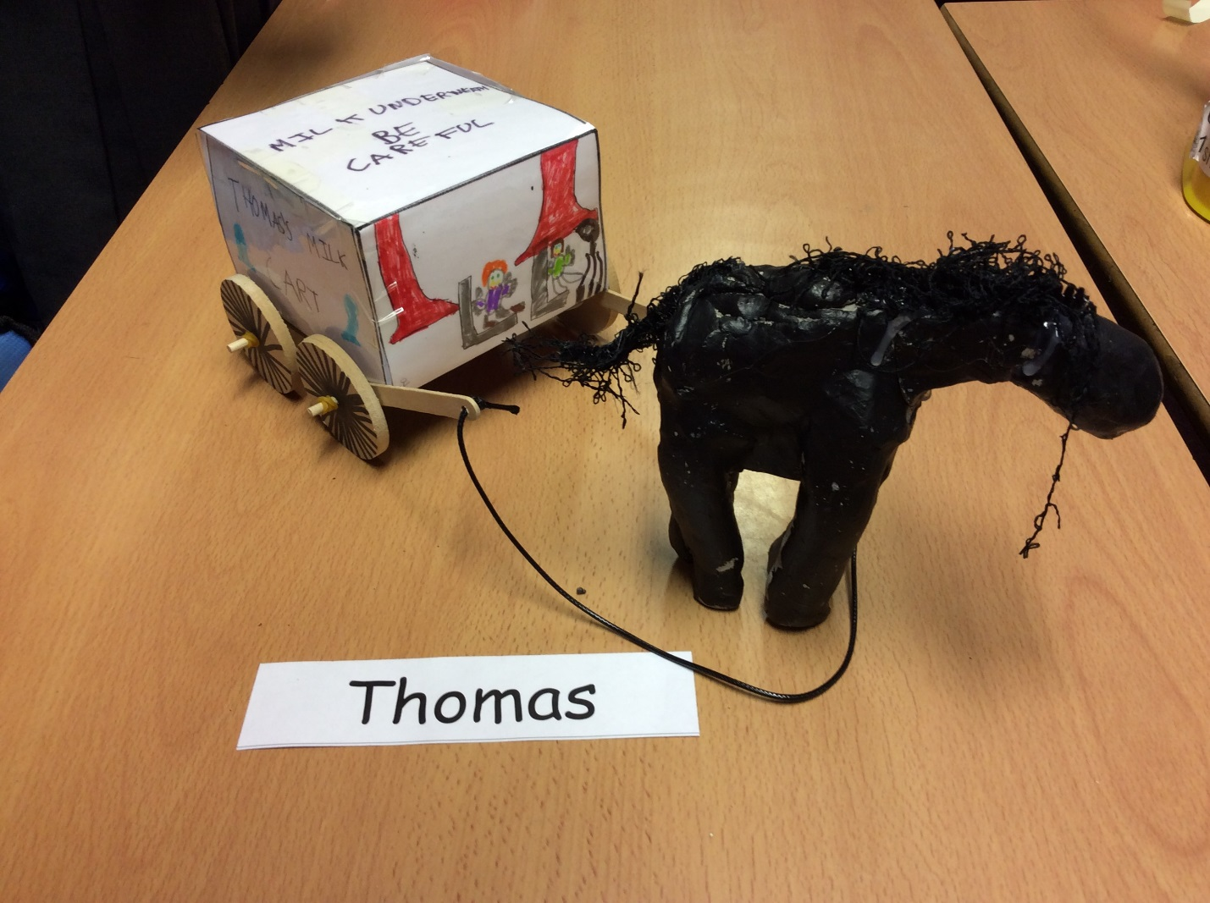

If you want to make one of your own, read on for equipment and instructions.

You Will Need:
- Some clay
- A ruler
- A pencil
- A3 paper
- 6 elastic bands
- 4 wooden wheels
- A box of felt tips
- 2 dowels
- A pair of scissors
- A glue gun
- Some wire (optional)
- 4 lollypop sticks
- Carving tools
- A lace
- Acrylic paint
- Sun
- And a laminating machine

Instructions
Part 1
Firstly, get your A3 piece of paper.
- Then get your pencil and ruler and then draw a STRAIGHT 1cm line away from the end (landscape). The n 8cm away from the end then 12cm away then 8cm away again and finally, another 12cm line.
- Then do the same but portrait.
- Once you’ve finished that, neatly cut along the lines.
- Now colour in your net inside the lines.
REMEMBER
It is not a car. It is a horse and cart. No steering wheels.
- After that, fold your net to make a cube.
- . Cautiously, laminate your cube.
WARNING
If 6 or younger, let an adult do it for you.
7. If successful you would have completed part 1: the carriage. Now part 2: the horse
Part 2
8. Get your clay, carving tools and (if you chose it) wire.
9. Use the optional wire to chop the clay in half. No wire? Just use your hands.
10. Use 1 half to make the body and the other half to make the rest of the horse.
11. Once you’ve made the body, put to the side you’ll need this later.
12.Use the wire or your hands(depending on what you’ve got)into 2/3 and 1/3.
13. Use the 1 third to chop again into another 1/3 and2/3 to do the head and neck. 1/3=head. 2/3=neck.
14. Once you’ve made them, join the head and neck together using the carving tools.
15. Now connect the neck to the body.
16. Then use the other 2/3 for the legs.
17. Chop the 2/3 into quarters.
18. Then roll them all up and smooth them into the body.
19. Now paint your horse.
20. Let your horse dry on the next sunny day in the sun.
21. Now that you have finished your horse, you have completed part 2.
Part 3

22. Now that you have done part 2, do this step. Stick your lollypop sticks onto the bottom of the carriage with the glue gun.
23. After, glue the dowels to the lollypop sticks.
24. Attach the threading to dowels and thread the lace through the threading.
25. Get 2 of your wooden wheels and put them on the front dowel.
26. Then use 2 of your elastic bands to tie around the wheel to make it fully secure.
27. Now do the back dowels in this order: elastic band, wheel, elastic band on both of them.
28. If succeeded, you’ll have a horse and cart. Well Done!

