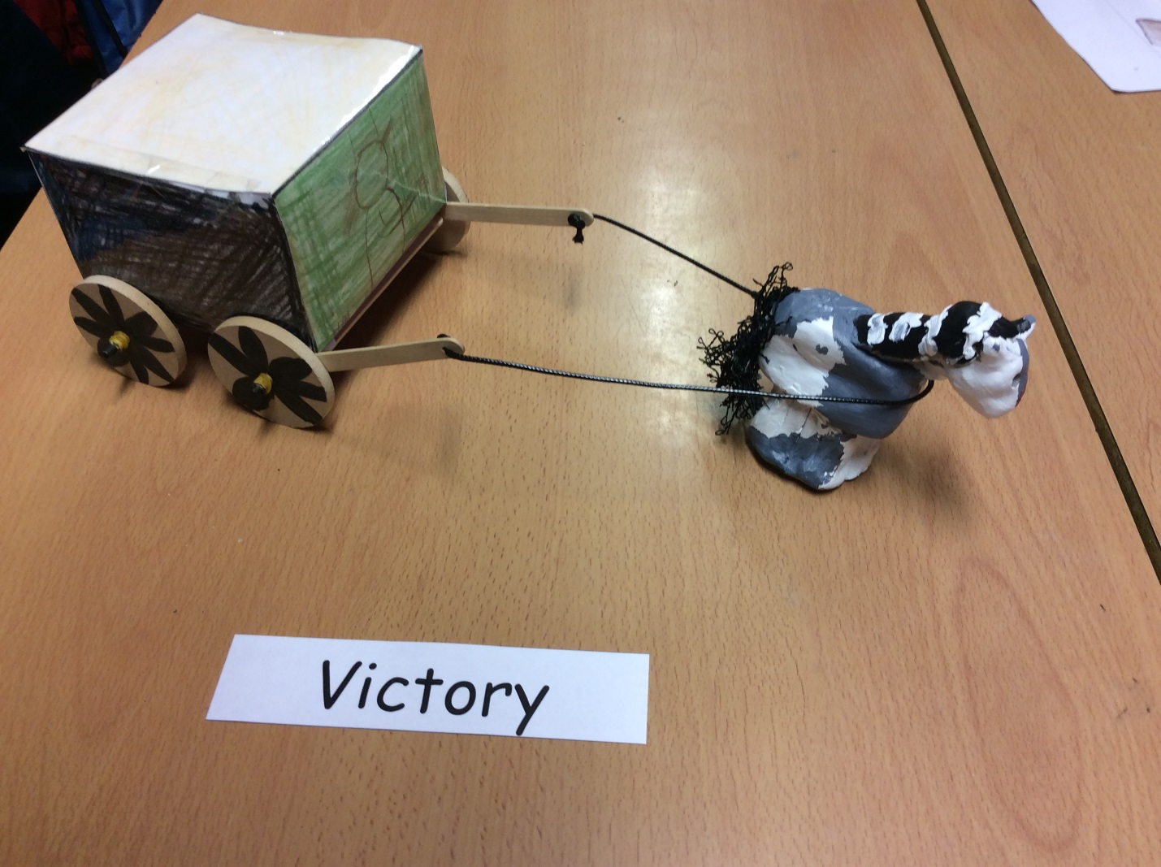
How to make a clay horse and carriage!
Equipment:
- Ruler
- Paper
- Dowels
- Clay
- Glue
- Lollipop sticks
- Elastic Band
- Wheels
- Paints
- Colouring pencils
- Net
- Leather string
- Lamination/Plastic
- Sharpener (for dowels)

1. First, you upload the copy of an A3 paper net.
2. Next, you cut the net out within centimetres.
3. Then, you ask an adult to laminate the net.
4. After, score the net through.
5. Now, you fold the net into a cube and then sellotape it together.
6. Then, mold the clay into a horse.
7. Connect the dowels to the wheels.
8. Ask an adult to use a glue gun to connect the dowels to the carriage.
9. Secure the wheels with elastic bands.
10. Go back to your horse and paint your horse with acrylic paint.
11. The next day, when it dries you can now attach the string.
12. Finally, enjoy your moving horse and carriage.

