Horse and Carriage Instructions
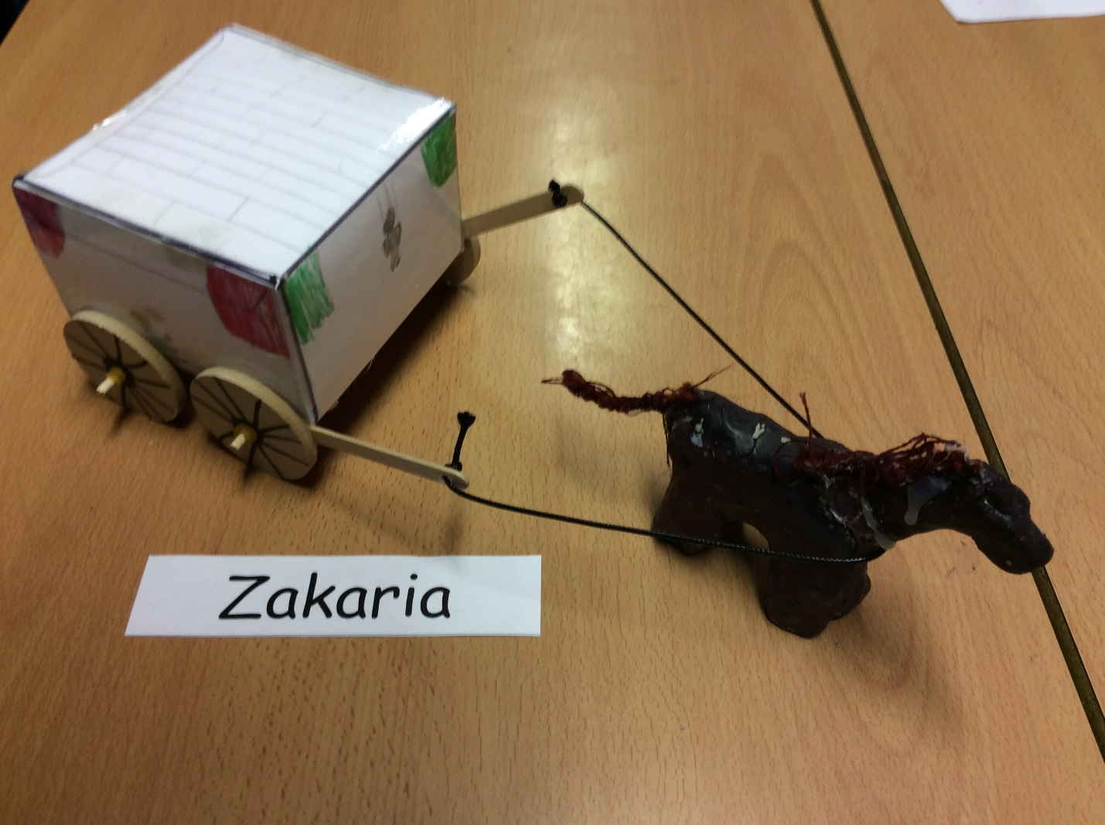

1) Firstly, purchase an amount of clay.
2) Try and model a horse and remember to make the body and legs strong enough to withhold the balance.
3) Carefully, try to form a head by making a ball of clay and put your finger on a side (make it cut through) and try to make a neck on the opposite side.
4) If the horse can balance perfectly, (it’s wise to conjoin the two legs for more stable balance) you can then proceed and move onto the Carriage.
5) Add on some coloured rope for the tail and hair (optional).
6) Gently get a 30cm paper (try not to crumble it when you get it).
7) Get a ruler and a sharp pencil (get a sharp one precisely so you avoid possible struggles).
8) Draw these lines in order (start from the last line you drew when doing another line) but before I show you, perhaps you can go online and search for a net and copy that instead, 1cm, 8cm, ,12cm 8cm, and 12cm.
9) Search online for a net and where to draw the people and wheels in.
10) Laminate it (or leave it if you don’t have one) which should make it a bit like plastic.
11) Cut out the areas of the wheels completely and those 1cm lines on the side of the squares including the small triangle shaped corners on the ends.
12) Fold the pieces of paper left but leave the driver’s seat and roof.
13) Then fold the roof and driver’s seat and tape it together making a neat cube.
14) Then get 2 ice lolly sticks and drill a hole on the top and bottom and stick one wooden stick that fits perfectly (purchase some wooden sticks instead of going through the trouble of finding one) pick one lucky stick to get the wooden stick through them.
15) Purchase 4 wheels and drill hole out of them right in the middle the middle.
16) Get the 2 ice lolly sticks and put the wooden sticks through and put the 4 wheels in front of them and get 6 elastic bands but only use 2 to trap the wheel by putting them on the front and back.
17) Carefully glue the carriage the wooden sticks onto the carriage, then you should get 2 sticks pointing out.
18) Put lace around the holes and tie up the ends of the lace.
19) Have fun and enjoy!

