My life in WW2
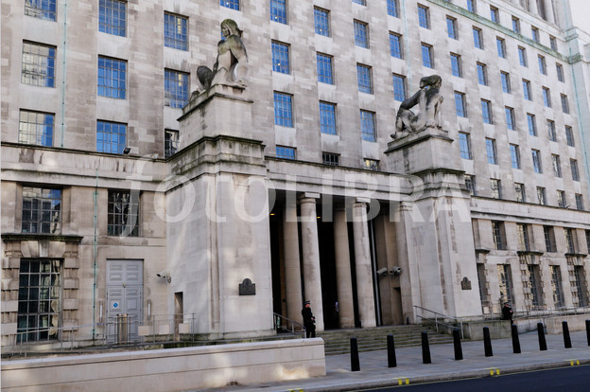

Lieutenant Collin Harris,
Your service to your country has not gone unnoticed. You are hereby invited to join the elite Special Forces group named SAS- Special Air Service. If you accept this proposition you must be present at the MOD West Wing conference room 49 at 1100 hours on 20.3.41. This Tuesday. You will be debriefed there. If you breathe a word of this you will be tried and executed as a Nazi spy. Your family’s new home will be a body bag.
Consider this.
Signed,
Minister of Defence/Prime Minister
Winston Churchill
Collin’s breath mingled with the thick, sooty air. Could he really do this? He decided that he would… accept. And that was that. His family would not see the inside of a grotesque body bag.
His heavy body trod through the thick snow as he passed rubble caused by the fascist Nazis that he was going to stop. Men rushed around him but Collin paid no attention. He was going to stop them worrying about those destructive unexploded bombs that fell regularly fell on the blitzed London. Hopefully, when he was done, they would stop worrying about them and more like where there next custard tart was coming from.
Collin pushed through the large oak doors and stepped into the briefing room… “Bobby!” he exclaimed, rushing forward to meet his old friend.
“D’you get a letter too, boyo?”
“Yep. Come on, it’s starting.”
A bear-like General then began to speak. “As you may know you are to make up our little band of brigands known to the top brass as the SAS. Now. Some of the high-ups don’t like us and see us as a bunch of girls that is a waste of guns and ammunition. We’re going to prove them wrong. Or instructions are to parachute into Africa and cause some havoc there. Generally, we’re going to help out my dear friend Montgomery and his Eighth Army. Then we cross to Europe and do more sabotage over in German territory. And that my Friends, is basically it. Your postings are over there on the board.”
I slowly drew myself over to the board and began to read:
Bobby Richmore= Radio Operator
Burbidge Stanmore= Explosive expert
Collin Harris= Sniper/backup radio operator
Jeffery Williams= Breaking and entering
Etcetera, etcetera.
“Follow me. You need a guide in the sniper armoury.” Startled, Harris turned around. There he found the muscled commander. “We’re allowed to pick our weapons?”
“Of course!”
“It’s just that… we are given them and don’t complain.”
“Come on,” he grunted.
As Collin and the Commander strode through the humongous building Collin told him a bit about himself. “All three of my brothers are at the front line. I’m the only one that was already in the army. Although, I expect you already know this.”
“We’re here.”
Then Collin saw how many favours had been pulled to even create this organisation. That was … a lot. Hundreds of weapons were allocated in the dusty armoury. From pen guns – an SOE invention – to rocket launchers. Commander Wilfred led him through.
Finally, they reached the snipers. Instantly, the Lieutenant fell in love with a beautiful bolt-action sniper with a scope that was as clear as the Caribbean. This was his. He was taken it to Africa for sure.
After that, the anxious general said “and of course, you’ll get parachute training.”
“Will I!” he exclaimed
“VROOOM” went the engine of a nearby Lancaster. Collin’s clothes rippled in the robust wind. “Come on, Harris!” beckoned Bobby from a tin hangar. Collin strode towards him, adrenaline pumping in his legs.
“You have come here to learn how to jump into fortified Africa. There, no mistakes will go without consequences.”
“Bit dark isn’t he.” whispered Bobby
“The war is dark.” I pointed out.
“You there,” the trainer shouted, “the one in the hoody!” he scolded, pointing at my friend. Then we started our training.
I sat huddled in the cold Lancaster as it flew over the rural Scottish highlands. This test would determine if I was ready… or not. “Go, go, go!” screamed the co-pilot. Then, we started to drop. I would be last out. After I left the plane; I flew. Thankfully, I had been given a cap to put on; or my hair would be flying everywhere and I wouldn’t be able to see. This was what I had been trained for. This was a test I would be passing.
At last, I opened my parachute. I felt it jolt my back as it unravelled with a crack like a whip. Eventually, I hit touchdown. My training was over. I would start my mission officially on Sunday.
The old Halifax bomber trundled over the isolated deserts of Africa. The navigator finally told us we were over the drop zone. 11 men jumped into the cool night air accompanied by over 20 equipment cases. Collins face embraced the strong wind and as he fell he noticed a small group of buildings about 2 miles east with a swastika flying high above. He made a mental note to tell Commander Wilfred of their chilling presence.
“Sir.”
“Don’t call me that. Call me Wolf.”
“There are some Nazi barracks about 2 miles east,” he reported.
“Well, we’d better sort them out them. I’ll alert the others at dinner.”
“Very good sir… Wolf I mean.”
The next day, we were going to take care of those Germans and their weapons for them. Or at least, what was left of their weapons. The hardened soldier fell to sleep imagining the events of tomorrow.
“Boom!” went the terrific explosion. I imagined the shock the evil Nazis would be getting. Suddenly, I noticed a black uniform from my sandy cover. I let him fill my sights… and fired. A headshot. He wouldn’t have felt a thing. Hundreds of Germans must have died in the explosion. Then I noticed the ominous presence of a tiger tank. And the crew were preparing to fire. Its aim was to fire at our temporary camp. It was now or never. I decided to choose now.
Quickly, I strode forwards and approached the destructive vehicle from the back. Silently, I bravely unclipped a grenade and climbed onto the large beast… and dropped in the hated thing. I only just got out of the way.
Later that day, I was scavenging in the rubble. I picked up a charred gun. This was probably where the armoury had been situated, at the heart of the compound. I knew this since I had found about 1000 of them around about him. All hope had been lost when we inspected how well Burbidge had done his job. They had annihilated the opposition.
“Come on, Collin,” a voice hailed, “we’re moving!” I slowly put down a charred black helmet and set off down the tiresome road.
At last I was in position. My job was to snipe into the chaos of the plane factory when the expertly placed plastic explosive detonated. The detonation sequence began. I fired of as many accurate shots as I could. I noticed a large group of guards hiding behind a group of metal fuel canisters. The worst cover imaginable. Instead of saving them- as they thought it would- it would end up killing them. I fired, and they exploded. In fact, nobody on our side had suffered injuries but Sargent Malory, who had been hit by a freak ricochet. Thankfully, it was only a graze. We quickly secured the area and set the place to blow. This would be a barren wasteland in 1 hour. Off we went on our dangerous trek.
After a few days we finally reached Normandy. This had been the mission of a lifetime. There was no doubt that we were heroes. This would be the end of Nazi rule in occupied France. I and the SAS would make sure of that.
A pair of binoculars were trained on a group of Nazis. Little did they know about it? I chose to put a silencer on the gun and aimed at the miserable guard at the back and then he dropped like a sack of potatoes. At the same moment someone threw a grenade. They were blasted to smithereens. But the resulting bang caused all hell to break lose. I spotted a man with a machine gun. But he was already knocked down. There was also a man with a rocket launcher. I took care of him. I salvaged the destructive weapon, and cleared the way for the invasion.

