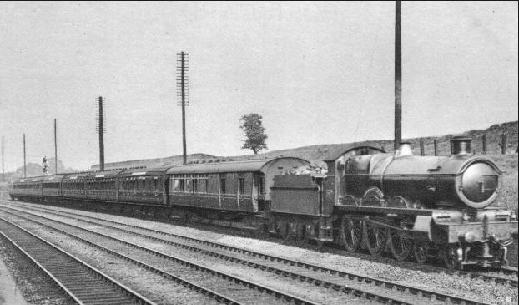Daniel’s Story!
John enters the dark, gloomy station and all he saw was a flickering light from the ceiling. John is aged thirty five, he has dark brown hair and he is a secret spy agent who works for England. But, he has worked for the army for seven years.
Anyways, back to the story. John walks into the ticket hall and as soon as he was near it he noticed the barriers were open. Nobody was in the control room for the tickets. John immediately saw a sign saying Signal Room, Security Room. Next, he walked to platform 15 or what was platform 15.
John then saw a person sitting on the bench and decided to walk to the stranger. Suddenly, he noticed there was only one train on platform 14, the stranger said “Hello.” And John replied by saying “Who are you?” the stranger said “My name is Jack I work for the DB railway as a station master.”
John said “Ok, can I find any weapons here?”
Jack replied “Uh, I don’t know why?”
John said “Not good anyways I’ll be back hold the train please.”
Jack said “Ok.”
John then started to walk back to the big bay and then decided to investigate the Security Room.
He started to walk about and found some cloaks for the security guards, he simply ignored them as it was not what he needed as he was looking for a gun to use in case the Germans would try to attack them.
John suddenly discovered an old entrance to the station which was abandoned and no longer used as an exit / entrance.
He found some guns (which were a Pistol and a Glock.) He picked them up and hid them in his jacket. Jack then crept out of the secret staircase / entrance, then he saw a Security person and he hid in the shadows and hid himself under the table and waited for the person to pass by.
Jack heard him say to another person “If you find any person who looks suspicious, tell me and they will know what it feels like to be mine! Hahahaha” it was the man’s evil laugh that gave Jack a suspicious face.
When the people had gone, jack slowly got out of the table and slowly peered over the wall and when they were no longer to be seen jack walked down the stairs and went to the bay and ran to platform 15 and went on aboard the train that was going to a German camp when he was on the train jack heard the doors close and heard the guard blow the whistle to depart and got on the back.
He rode the train to the German camp via Tanquer Station and when they go to Tanquer Station a strange passenger comes onto the train and comes to the seat in front of him and the passenger said “Hello, how are you?”
Jack said “I’m good”
When it was five minutes past six Jack was arriving into the station and the signal turned red, when it turned green again the train started to slowly move into the station and the doors opened out into the platform and some passengers got on the train then the guard got off and got ready to dispatch the train.
2 Minutes later…
The guard went to the front of the train and then dispatched it. He got on and the train started to move out of the station and suddenly came to a halt because the driver got out and went to the switch and changed the points to the track leading to the German camp (Known as the Alfaro Line)

Although they were in the countryside there were public services running past the countryside and back to the city terminal, it was like 13:00 P.M and there was a rough landscape on the right, but on the left there was a farm as well as another track on the left with a tunnel ahead of them but before they could reach it they passed a level crossing and then came to a halt, The reason why is because there is a single line operating from Terminals 15 & 16 platform 15 is for trains to the camp and platform 16 is for terminating trains but Platform 17 and Platform 18 never get used during the war.

And there was a returning train to the Terminal, night services were grounded to a halt which means no night freight services to factory’s like fahaquer factory which made trains to transport delivery’s from fahaquer branch from fahaquer station to the countryside and then to the Terminal platform 1, 2 or 3 when the train passed the points switched to the fahaquer line – single line – and it was already two in the afternoon and the train was nearly at the camp with half a mile to go.

But on the way a signal was broken and trains had to do like 30 MPH no matter if there was a plane or a bomb dropping they had to obey it. Later down on the line there was a station which is only open from 10:00 A.M – 15:00 P.M (5 Hours open) it was 14:10 P.M, and the next station was Fanterqueue Road Station when they reached the beginning of the station there was a switch and the station only had 2 platforms but previously had 3 platforms but the third platform and the tracks that lead there are now abandoned and the switch for it has been removed and the track to platform 3 (ABANDONED PLATFORM) was overgrown and they started to slow down for the station and they stopped at the security base where they go to eat and play.

It was 14:34 P.M and the station was abandoned like nobody was there but only security guards and nobody got off so the train moved on from the station and departed. In two minutes time the train already was near an abandoned depot and an abandoned platform which trains no longer serve but used to anyways the train was passing another bridge on the line and in 2 minutes they were just sure to be there and when the two minutes were over the train was already at pantersquare station (which was the camp!) and the Germans were ready to escort the passengers out of the train and into the camp but instead of jack going to follow them he went to the coupling rod and unchained the coupling rod so when the train was to next move it would have moved the only first cart when the train would go backwards because it would just shove the cart back all the way to the turning table and would be stuck.

When everyone got off and the coast was clear jack snook into the bush and placed a bomb on the wall and it exploded open then the alarm went off for a second and Jack snook into the base and untied the solider and took all the England Soldiers back to the train carefully and got on then a English soldier said

“I know how to drive a train ill drive us back to the main terminal and swap us back for a train back to England just get onto this train and we’ll be outa here! In no time we will be there!”
Down the line there was a faulty switch and the trains were warned and they were approaching and went on the single towards terminal 18 and they arrived and waited for the train to come and pick them up to go to the London Camp to get warm and safe as well as warning the whole soldier team of what happened on that exact day and the driver who drove then back on the train got a reward of saving lives of people.

