Esther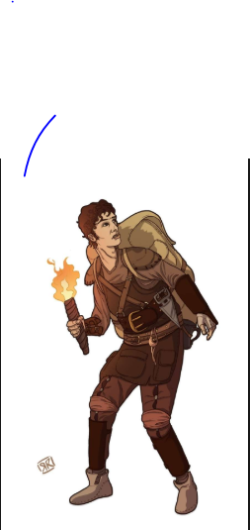

Wolfgang has an adventure
Wolfgang sets off the floor was rocky and had some bugs on it. They were lots of British soldiers and then one came out. Then he pretended to be a British soldier then he met a boy called Wilhelm he was nice and friendly. Wolfgang always likes his uniform because it was comfy and neat. Then Wolfgang started to act like a British soldier it was like in a low voice.
“Hello your name is called………..Wilhelm? Exclaimed Wolfgang.
“Hi my full name is called Wilhelm Albert Royal.” Said Wilhelm.
“Oh my name is Wolfgang.” Said Wolfgang.
“I have two sisters called Violetta and Clarica.” Said Wilhelm.
“Same I have two sisters called Sybill and Heidi.” Said Wolfgang.
“See me tomorrow midnight ok Wilhelm.” Said Wolfgang.
“Ok sir see you tomorrow bye.” Said Wolfgang.
“Bye.” Said Wolfgang.

July 4th 1941

It was the next day, so Wolfgang met Wilhelm in the midnight.
“Hi glad I met you today.” Said Wolfgang.
Wolfgang was thinking to kill Wilhelm.
“Hi Wolfgang.” Said Wilhelm.
Wolfgang was looking suspicious.
Wolfgang had been keeping a secret from Wilhelm which was to kill the British soldier. He was so funny to Wolfgang that Wolfgang was forgot about the secret. Then it turned into a fight so Wolfgang threatens Wilhelm. Then Violetta and shoots Wolfgang away.

