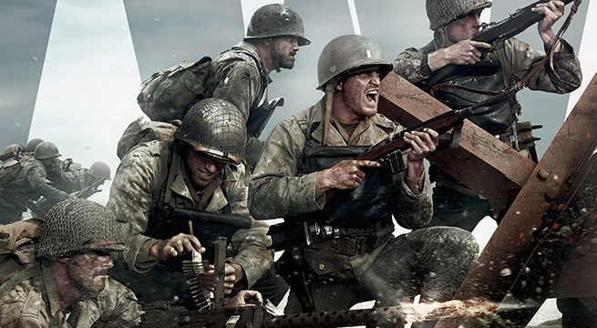
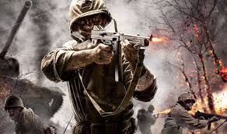
Suddenly, a bomb dropped and Josh turned. In the distance he saw a house crumbling to pieces. He started to race to it. Just then he realized that it was his house.
He climbed up the remains of his destroyed house. As he looked around he saw his wife and daughter laying still on the pile of rubble and brick scattered all over the place. He dropped to his knees in shame crying and weeping into his hands. ‘Wait,’ he said ‘Where is Bob?’ he thought to himself. Right now he did not really care but he convinced himself that he will find Bob. He rushed to the air force and joined the army because he was determined to get revenge for his family.
Later that month Josh was fighting the Germans. He was hiding behind a pile of sandbags with a rifle in his hands. Suddenly a bullet tore through one of the sandbags ‘AHHHHHHH!’ screamed josh. The bullet hit him in his left shoulder. Josh screamed in pain as blood poured out of his injured shoulder.
As he got up slowly, he realized that he had dropped into a trench. He looked around and saw he had been swimming in a pool of his own blood. Inside this trench was a bunch of bodies. Josh got up and walked to one off his team mates that was dead on the floor. He picked up the bandages and rapped up his big wound.
One day later, he returned to his house. He wondered into his back garden and strolled towards his Addison shelter. Slowly he began to open the door. Suddenly his face brightened. ‘Bob?’ he said. ‘DAD!’ The boy ran to Josh and hugged him. ‘Where have you been daddy? I’ve had to live off of one loaf of bread and one cup of water.’ He said as he pointed to the corner of the shelter. On the bed was a half-eaten piece of bread and a cup with about five drops of water in it.
‘Come on, I’ll take you to a house of one of my friends. She is very kind and she will look after you. If she does not, then try to find me. But do be careful.’ Josh said. ‘Ok. I will.’
Five minutes later they arrived at the house. Bob knocked on the door rapidly excited to be able to sleep on an actual bed and play with some toys. The door opened and a woman strolled out of the house. ‘Josh. What a pleasure,’ the woman said in a voice that sounded like she just woke up. ‘I was just wondering if you could look after my son, Bob,’ Josh asked. ‘Of course I will,’ she said in a quiet voice. ‘I’m sure he will have a great time. ‘
Josh set off, back to his captain Jacob. When he got there, they both ran to get in a spitfire. They set off into the air and zoomed to Germany. Just then a bomb hit his plane and it started to fall. Flames went up as josh opened the roof and made a huge leap onto Jacob’s plane. Josh was hanging on for dear life. His face turned pale, as a plane came right at him. The wing hit him and he fell backwards head first into a river. The current carried him and soon after he fell down a tall waterfall, and then. SPLASHHHH!!!
Suddenly, a hand grabbed Josh and pulled him out of the water. Two days later Josh woke up dizzy and dazed. ‘Where am I?’ he muttered to himself.
‘Dad?!’ a voice came booming down the room he was in. ‘Are you okay?!’ Footsteps came echoing down until they died down and an outline of a little boy came into view of Josh’s eyes.
Josh sat up sharply and looked around. Bob’s face was pale and was covered in dust. ‘I just saw a person who looks exactly like you. But he was just wearing a mask so I ripped it off a…a…and it was Steve!’ Bob exclaimed quickly.
Josh jumped off of the bed he was in and ran, ran down the corridor and burst through a door to his right. Suddenly, a gust of wind made him slip and it scraped his feet across the ground. A plane rose into the air and ate Josh knew once that Steve was inside. He started to run again each second getting faster. He turned a corner and saw the plane hovering above the ground. Josh rushed as fast as he could and jumped on to the plane. He quickly opened the top and punched Steve in the face and pulled him out of the plane roughly.
Steve’s foot must have hit the button that drops the bombs. Suddenly, a huge explosion came from below and the plane split in half. Both halves of the plane dropped and Josh fell off. He hit the ground and blood came from his head. He slowly grabbed his gun and shot into the sky. Suddenly, Steve dropped and landed next to him.
Suddenly a face popped into view of Josh, it was Jacob. He had picked up Josh and started to walk away. But just then, there was a bang and a bullet flew through Jacobs’s leg. He screamed and dropped Josh. Josh rolled across the ground and then looked at Steve struggling to keep his head up. He saw Steve aim his gun back at Jacob and then…he shot. Josh sprung up and ran. He jumped in front of Jacob.
‘Joshhhhhhh!!!’ Jacob pulled out his pistol and shot Steve. He turned round and looked at Josh who’s eyes suddenly closed slowly…
By Freddie

