Evacuee by Alexandra Cruft
Evacuee

16 May 1941
Hi, my name is Rosaline, Rosy for short, I am 15. And just now I overheard my parents arguing about if I should be evacuated or not. So now I’m seriously worried, what will happen if I’m evacuated? I shouldn’t worry too much, I guess…
17 May
I couldn’t write last night much it was just that I had to pack my suit-case for some reason? Oh god there’s mum again sorry got to go! Bye.
19 May
I am so sorry for not writing yesterday. Mum and dad just told me that I was being evacuated!! So that was one of my last days with them and I couldn’t miss even a second. I was distraught. But the upside is that I can take Nala with me. At least I will have company on the train. Apparently it won’t take too long and I will have some snacks and games. My suit-case is pretty big so it can fit a lot of clothes, teddies and books.
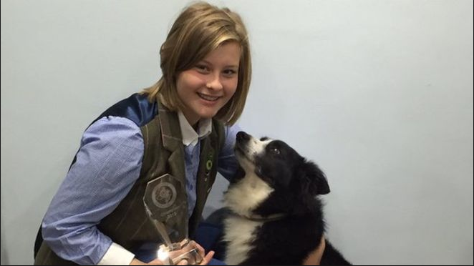
Me and Nala
19 May (20:00)
I have arrived and I am now with an elderly woman who is called Agatha Christie, but she insists on being called Aunty Agatha by me and I love her personality.
When she met me at the station said she to me very softly but audibly” are you Rosaline Woods?”
And I answered “Yes. You must be my minder.”
“Indeed I am.”
Would you like some help with those bags? “
I asked this out of pure kindness, even though I was struggling with my own.
But I like this woman, I think she will be an excellent “mother” for the next 3 years…
20 May
I’m loving it here. Aunty Agatha is being really nice to me and I’m trying to be as kind as I can back to her but I’ll tell you about her personality in a minute, first I’m telling you about the scenery here! It’s wonderful, I wish you had eyes sometimes.
Oh, the fields here are so green and the horses are lovely. The house is wonderful though, every time I look at it I feel amazed. The ivy, and the roses. It just feels like heaven already. By the way Aunty Agatha’s cooking is delicious last night she made “toad in the hole” It was delicious!
23 May
I know that I’m supposed to be keeping this diary up but I’m just having so much fun. So far Aunty Agatha has, let me go horse riding,( Nala didn’t like that) grocery shopping and gardening. Some of these things I’d never done before.
This is probably the best part of evacuation. I’m definitely going to enjoy my time here…

24 May
You could not guess what happened last night. No? Well I’ll tell you listen carefully….
It all started with Aunty Agatha tucking me into bed. After she left me a few minutes later (5-7), I heard a noise, but I ignored it as I knew that there were badgers and other night-time critters. Then, without warning Nala started to bark. Then she got up and started to scrape at the door. Bang! A bomb went off in the distance, now that got me worried. I got up and opened the door and Nala dashed into Aunty Agatha’s bedroom.
I looked at the bed she wasn’t there, but the bed was made neatly, that meant she hadn’t been in bed at all as she only made her bed like that in the morning and then leaves it like that until she goes to bed in the evening. Nala must have sensed that it seemed quieter as Aunty Agatha sometimes snores lightly, usually it doesn’t bother me at all.
Then I thought, I must find her. My first reaction to this thought was to find some of Agatha’s clothes suddenly I saw a small scrap of material that was snagged on the corner of the bed-side table it was part of a black jumper that Agatha had been knitting, at the time I asked her about the colour, she said that it was for walking in the wood (I forgot to tell you that there is a wood nearby!)
Well this’ll have to do.
I gave it to Nala to sniff and then I said into her ear” track.” Nala began to run out of the house
30 mins later, we arrived at a small back alley by the Bank. Seriously? Here? My guardian by a bank, and in a back alley to top that!
Then I spotted her, hunched up in a corner, her leg bleeding in the distance I heard a police cart in the distance. Doing what came to mind first I dashed over to Agatha and started to panic, I checked her wound, and thankfully it was just a flesh wound (I know this as my dad was a doctor before the war)I helped her to her feet and we started the not-so-very-long-way-home…
25th May
Last night was what seemed like the longest night of my life so far… I did end up asking about why Aunty Agatha was in a back alley in the middle of World War II at midnight. And so here was the answer (I was much longer than I expected)
“I am a secret agent. And I work for the WWSC* and there was a bank robbery last night and they sent me out to investigate after a few minutes I saw them coming out of the vault as you would probably know “if you can see them they can see you”, and so one of the two men charged at me whilst the other one got away, then they threw me down the rubbish chute and then you know the rest …
So that’s the story…
*World War Spy Committee
26th May
Some extremely aggravating news, my parents are dead. They were killed by a bomb at night.
27th May
Sorry last night I didn’t write much last night, but here’s some good news, I am now very, very happy Aunty Agatha just told me that she was given permission to keep me like a parent! Yay! Yay! Yay!

1st August
The last few months of my life have been amazing. Aunty Agatha’s leg is now healed. She is now out and about again witch is nice as we can do most of the things she could before. Also it’s my birthday today I am 16!
Well good bye for today!

