The Interrogation
Tom Jeckells

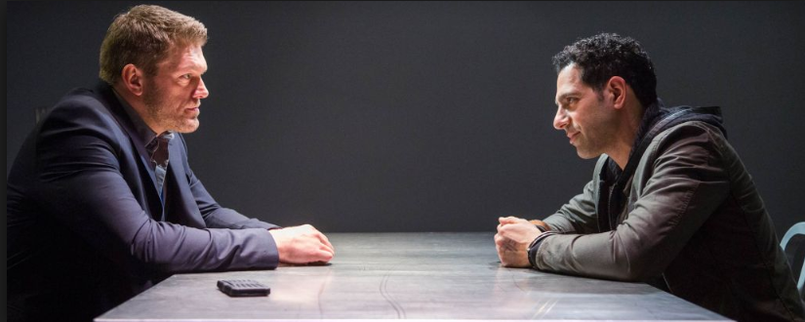

Suddenly Harry Grove stormed into the room. His fair hair was combed immaculately and he was wearing a dark navy suit. His polished shoes gleamed through the windows of Bletchley Park. ”Tom,” he said in his voice like ice, trying to hind the importance of what he was about to say but Tom detected it.
“Yes,” Tom answered quickly.
“Another message,” Harry said, he lowered his voice “It could be from Hitler.”
Tom gasped, ”Adolf Hitler?”
Harry nodded, “Okay laddie, I’ll let you get to it” he said raising his voice.
“Okay, bye harry,” I exclaimed still amazed that he was decoding from the Brits’ mortal enemy- Adolf Hitler! Suddenly, Tom realised the importance in Harry’s voice. Then Tom realised the head of MI6 had left the room. He had a knack of doing that; a minute he was there, the next he wasn’t. Tom started to get to work.
A few minutes later, a siren started wailing in Tom’s ears. It wasn’t an alarming one, it signalled for the blackout to begin. Tom huffed, got out my chair, trudged to the window, and closed the holey curtains. Any light would signal the Germans so the young decoder had to decode Hitler’s message in the dark! It was hard with any light. All he had decoded was:
Dear Wolfgang Stroud,
I am writing to inf
It wasn’t much for 3 hours. Tom thought he would only be able to finish the word that day.
In the morning, Tom travelled on the 36 double decker bus to Bletchley Park, like usual. He last remembered falling asleep in Bletchley Park. Someone must’ve escorted him to his house. He looked at Hitler’s message and disaster had struck. The message read:
DEAR WOLFGANG STROUD
I AM WRITING TO INFORM YOU THADYFRDERFTGTFRDERFTF
Oh no, Tom thought. Desperately, he tried to remember back to last night. He remembered 3 hours before he fell asleep:
Dear Wolfgang Stroud,
I am writing to inf
He thought hard…
Then 2 hours…
DEAR WOLFGANG STROUD
I AM WRITING TO INFORM you
1 hour…
DEAR WOLFGANG STROUD
I AM WRITING TO INFORM you Tha
Aha! As rapidly as he could, Tom backspaced the nonsense so it looked as it should’ve been. Just then Harry Grove entered the room. ”Hello, Harry,” he said,
“Have you decoded it yet,” Harry said with a blast of intensity.
Instantly, Bletchley Park’s atmosphere rose by a million degrees. “No. Harry, you know these things take ti-” Tom said, realising he had made a mistake.
“Time? We don’t have time!” Now Harry was blowing off with panic.
“Have a sit down, Harry,” Tom suggested with worry. ”And I’ll get you a glass of water.” He said it and dashed off like a cheetah to get Harry some water.
“I don’t want a glass of water.” he fumed. “I want you to decode the stupid message.”
“Okay, I’ll get to work straight away, Harry .I’ll meet you at MI6 Headquarters. Can you tell me where it is…?” Tom got in his chair and was left alone to do his work.
At the end of the day the letter was ready, it read:
DEAR WOLFGANG STROUD
I AM WRITING TO INFORM you that plan silent gun is ready.
From Adolf HITLER.
It wasn’t a long letter but it earned its attention. Tom acted quickly. His only priority was: was go to MI6 and warn Harry. Millions of question blazed into Tom’s mind but the main one was simple: What was Plan Silent Gun? With all the possible reasons, Tom was getting a head ache. It was then Tom found Bletchley Park’s exit.
Tom rushed down the dusk street. Then, he heard a voice. ”Yo, Homey. Where you goin’ mate”
“MI6 Headquarters,” Tom huffed. He had stopped speeding down the street to talk to this stranger.
“Huh,” he said. “Isn’t it interesting that I know where that is?”
“Really?” exclaimed the amazed Tom.
“Yeah,” said the Nazi soldier. Obviously, Tom didn’t know that. ”Come, I’ll take you there.” Fooled, Tom followed the Nazi soldier.
A few hours later Tom’s legs were hurting and he was getting suspicious. His suspicion was ended by the voice of the stranger. ”We’re here.” Tom was shocked. MI6’s headquarters was an abandoned workshop!
“Well it’s not what I imagined,” joked Tom.
“Its ugliness is to repel people away.”
“Of course,” Tom said suspiciously.
“Yes now tell your friend errr…. Harold was it?”
“Harry,” Tom corrected.
“Whatever, just tell your friend the news,”
“Okay,” Tom said “ but what’s the hurry?”
“Hurry? There’s no hurry I just thought the news would be critical news to beat the Germans, win the war. Huh?”
“Yes of course,” Tom exclaimed. “No more delay I need to tell Harry the news.”
“Or maybe not,” said the man in a darker, sinister voice. It was just then that Tom had realised that the man and was wearing a bandit’s mouth scarf as black as darkness. He lowered it like a sloth would but only sloths do it because they are incredibly slow a he was trying to intimidate Tom and was succeeding heavily. Tom was starting to wish he didn’t follow this mysterious man to a secret location where only agents knew where it was. Suddenly, the man pulled out a full-sized cricket bat from practically nowhere and swinged it against Tom as if he was a cricket ball. Tom lost all five senses and slowly fell to the ground and fainted.
When Tom regained consciousness, he was tied to a wooden chair around his belly and his ankles around the chair legs. “So, I hear you had news for MI6?”said a voice coming from everywhere. Tom gathered that he was in the abandoned workshop and was being questioned. But the question was who was asking the questions.
“I’ll answer your question if your answer mine,” Tom said coolly.
“We have three question each,” the voice compromised.
“Okay. Question 1: who are you?” said Tom.
“We cannot give away information like that.”
“No answers from you no answers from me,” threatened Tom.
“Okay. We are the Nazi party,” said the voice.
“Who’s we?”
“That‘s your second question,(Tom swore under his breath) come out boys,” Three bulky men came out from hiding. “Now for your last question.” Tom thought carefully. “What do you want with me?”
“We want answers!” shouted the bulkiest one.
“Now for our questions. Question one: do you have news for MI6?”
“Yes I do,” said Tom honestly.
“What is the news is our second question. “
“Adolf Hitler had sent a message to Wolfgang Stroud.”
“Our last question is what was the message!”
“He said that plan Silent Gun is a failure.”
“Oh okay. Thank you for your honesty. You may be released.” Tom ran to the real MI6, told the news to Harry and plan Silent Gun was thwarted.

